Analysis with Intervals

**Name: _________________________________________________________**

[Worksheet Playlist](https://open.spotify.com/playlist/12tEFuQKdB1k1zxYFdFSsa?si=oU8A4M_NS5KLS1Fp3L-Qiw)



# PART 1

Identify the interval created by each pair of adjacent notes.



|  |  |  |  |  |  |  |  |  |  |
| --- | --- | --- | --- | --- | --- | --- | --- | --- | --- |
| ordered pitch intervals |  |  |  |  |  |  |  |  |  |
| unordered pitch intervals |  |  |  |  |  |  |  |  |  |
| ordered pitch class intervals |  |  |  |  |  |  |  |  |  |
| unordered pitch class intervals (interval classes) |  |  |  |  |  |  |  |  |  |



|  |  |  |  |  |  |  |  |  |
| --- | --- | --- | --- | --- | --- | --- | --- | --- |
| ordered pitch intervals |  |  |  |  |  |  |  |  |
| unordered pitch intervals |  |  |  |  |  |  |  |  |
| ordered pitch class intervals |  |  |  |  |  |  |  |  |
| unordered pitch class intervals (interval classes) |  |  |  |  |  |  |  |  |

a. Sofia Gubaidulina, “staccato - legato” from *Ten Preludes for Violoncello Solo* (1974)*,* mm. 44–45

b. Sofia Gubaidulina, mvt. I of *Concerto for Bassoon and Low Strings* (1977)*,* mm. 64–65

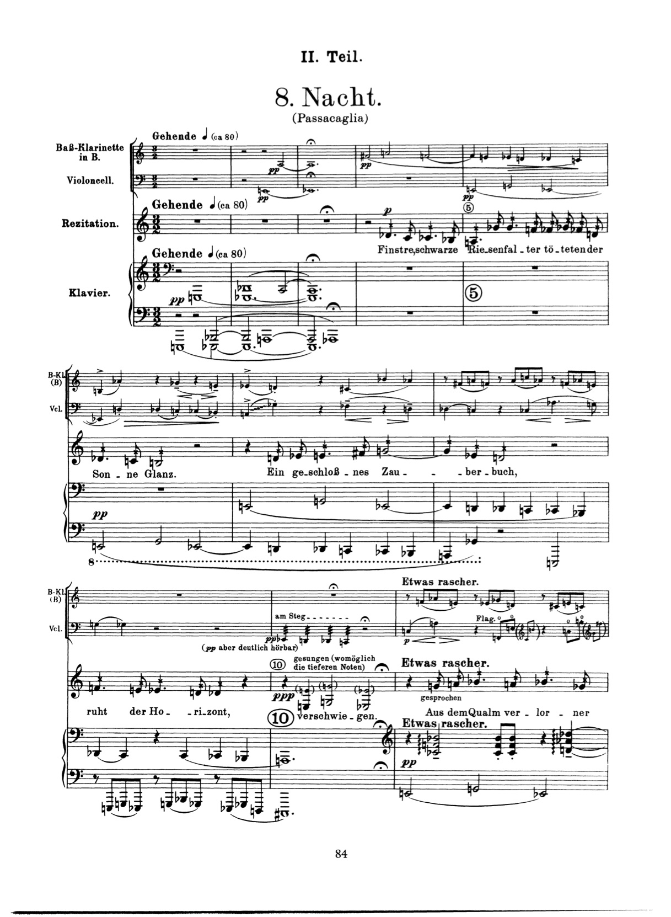

# PART 2

“Nacht” from *Pierrot Lunaire* by Schoenberg uses a motive: a succession of an interval that goes up three semitones, and then down four semitones (i.e., <+3, -4>).

Find 25 instances of this <+3, -4> motive. Circle the motives you find on the score, using some kind of bright color so it’s easy to see, and number each from 1–25.

