PART 1: Normal form

Normal Form and Transformations

Name: _______________________________________________

Normal Form and Transformations

Name: _______________________________________________
Put the following groups of notes into normal form. The first is completed for you as an example.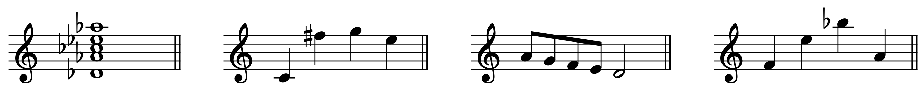
a. | [8, 11, 1, 3] | b. |  | c. |  | d.

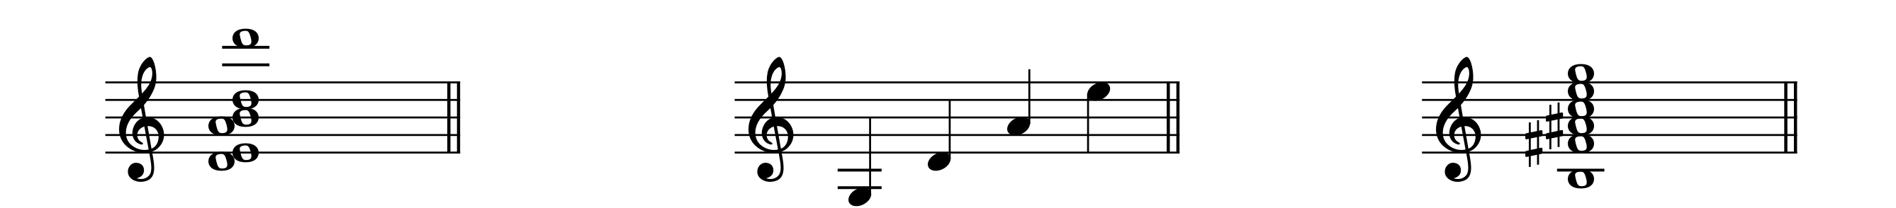
e. |  | f. |  | g.

PART 2: Calculating transformations
You are given several sets in normal order. Perform the requested operation, then write the new set in normal order. Note that when you invert a set, you may have to recalculate its normal form. The first is completed for you as an example.
 | Original | Transformation | New set in normal order
a. | [5, 9, 11, 0] | $\overset{{\text{I}}_{0}}{⟷}$ | [0, 1, 3, 7]
b. | [7, 9, 0, 1, 2] | $$\overset{{\text{T}}_{5}}{⟶}$$
c. | [0, 3, 4, 8] | $$\overset{{\text{T}}_{11}}{⟶}$$
d. | [2, 6, 9] | $$\overset{{\text{T}}_{9}}{⟶}$$
e. | [2, 5, 8, 9] | $$\overset{{\text{I}}_{9}}{⟷}$$
f. | [9, 10, 1, 3, 4, 6] | $$\overset{{\text{I}}_{2}}{⟷}$$
g. | [6, 9, 10, 11] | $$\overset{{\text{I}}_{6}}{⟷}$$

PART 3: Identifying transformations in normal form
The following pairs of sets may or may not be related by either transposition (T_{n} ) or inversion (I_{n} ). If the two are related by T_{n} or I_{n}, indicate the transformation type and index number; if they are not related, write “none.” The first is completed for you as an example.
 | Set 1 | Set 2 | Relationship
a. | [5, 9, 11, 0] | [1, 2, 4, 8] | ${\text{I}}_{1}$
b. | [7, 9, 0, 1, 2] | [2, 3, 4, 7, 9]
c. | [0, 3, 4, 8] | [10, 1, 2, 6]
d. | [2, 6, 9] | [5, 8, 0]
e. | [2, 5, 8, 9] | [7, 10, 1, 2]
f. | [9, 10, 1, 3, 4, 6] | [4, 5, 7, 10, 11, 0]
g. | [6, 9, 10, 11] | [6, 7, 8, 11]

PART 4: Identifying transformations in a score
On the following page, you are given the final page of “Nacht” from Pierrot Lunaire by Arnold Schoenberg.

- In measure 20, all the trichords formed by the eighth-note triplets in the piano can be related by transposition or inversion.
  - Calculate the T_{n} and I_{n} relationships between adjacent trichords (horizontally) as well as trichords that occur simultaneously (vertically). Hint: it may help to put sets in normal order first.
  - Draw arrows connecting the trichords and label each arrow with the T_{n} or I_{n} relationship. One has been completed for you.
- In any instrument, find four other trichords that are related by T_{n} to the trichords in m. 20. As before, draw arrows connecting each pair and label it with the T_{n} relationship.
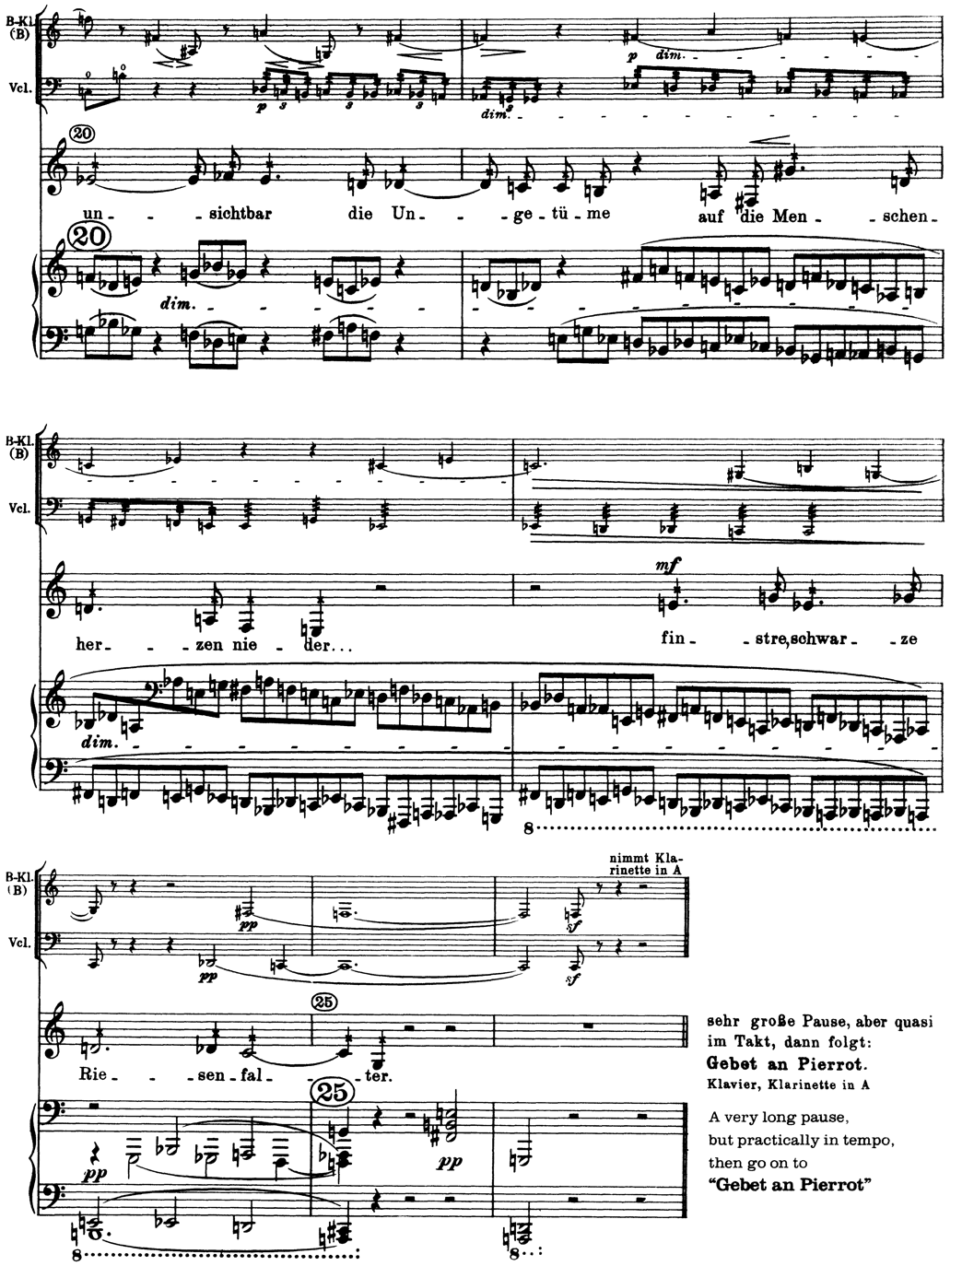
I₁₁

