Binary Form - Analysis
- Franz Schubert (1797-1828), Écossaise, D. 529, No. 3
Part 1 – Basic Questions
- This piece is in what key? __________
- What kind of cadence ends the first reprise? ______________
- Provide a Roman numeral for the key of this cadence: _____________
- Based on your answer to the previous question, is the first reprise harmonically open or closed? ____________
- Does the beginning of A return—in the home key—somewhere in the middle of the second reprise? ________
- Based on your answer to the question above, which type of binary form is this? _____________________
- Does this binary form also have a balanced aspect? __________
- If so, what measure contains the crux? __________
- Which of the following features promote a sense of instability at the start of the second reprise? (circle all that apply)
Sequence Chromaticism/Tonicization Sustained Dominant Increased rhythmic activity None
Part 2 – Additional Harmonic Questions
- Measures 5 and 13 have a C sharp and a C natural at the exact same time.
- Which one do you think is actually part of the harmony? __________
- Provide a Roman numeral for this chord: _______
- Do measures 9-12 contain a sequence? If so, what’s the name of this sequence? ____________
- The chords in m. 9 and m. 11 have an accidental in them. What Roman numeral would you give for each?
  - Measure 9: _________ (beware of the clefs)
  - Measures 11: __________(beware of the clefs)
- Which type of 64 chord does measure 2 contain? ____________
- Which type of 64 chord do measures 6 & 14 contain? ______________

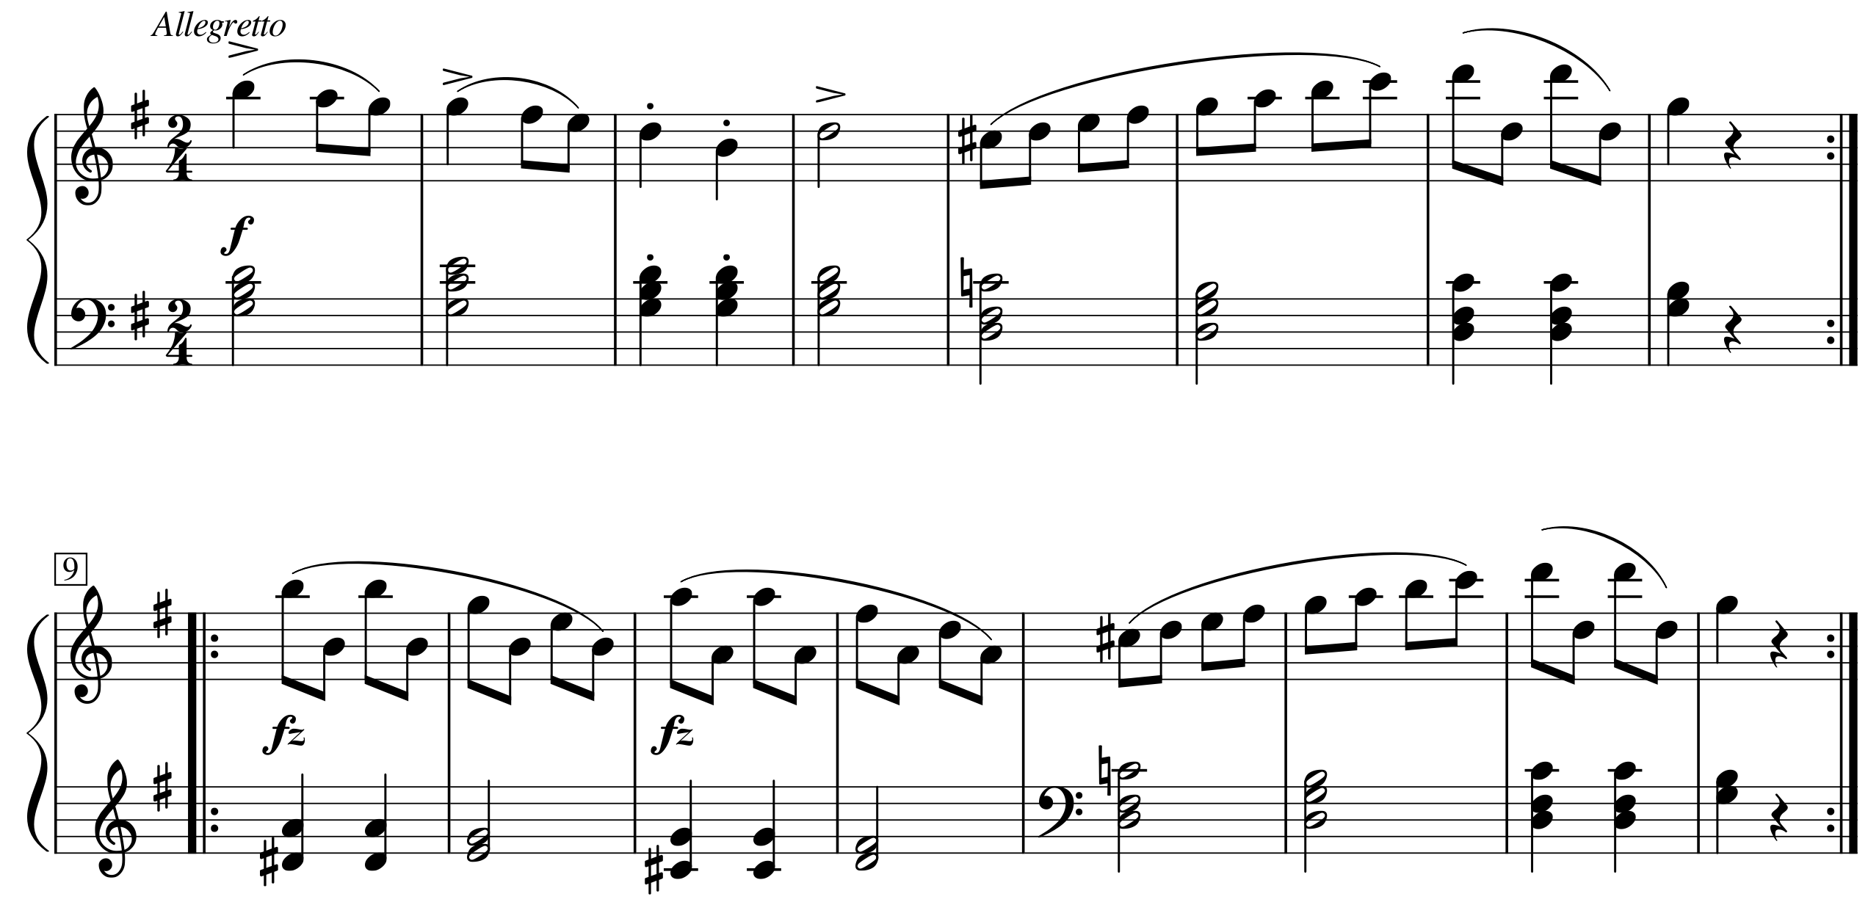

- Franz Joseph Haydn (1732-1809), Piano Sonata no. 37, III, theme

Part 1 – Basic Questions
- This piece is in what key? __________
- What kind of cadence ends the first reprise? ______________
- Provide a Roman numeral for the key of this cadence: _____________
- Based on your answer to the previous question, is the first reprise harmonically open or closed? ____________
- Does the beginning of A return—in the home key—somewhere in the middle of the second reprise? ________
- Based on your answer to the question above, which type of binary form is this? _____________________
- Does this binary form also have a balanced aspect? __________
- If so, what measure contains the crux? __________
- Which of the following features promote a sense of instability at the start of the second reprise? (circle all that apply)
Sequence Chromaticism/Tonicization Sustained Dominant Increased rhythmic activity None
Part 2 – Additional Harmonic Questions
- Measure 2 contains an embellishing tone in the melody. Play through the passage very slowly to hear it.
  - Which melody note is the embellishing tone, D, C# or E? ___________
  - What type of embellishing tone occurs? _________
- Which type of 64 chord does measure 7 contain? _______________
- The chord in measure 17 contains an accidental. What Roman numeral would you give to this chord? ____________
  - Did it resolve to the chord you expected? ____________

Part 3 – Short Answer Questions
- Do you think measures 9-12 contain a sequence? Decide and support your answer with musical details either way:

- The recurring material in this piece is not restated literally because a few changes have been made. How did these changes impact your hearing of the piece when trying to determine the form?

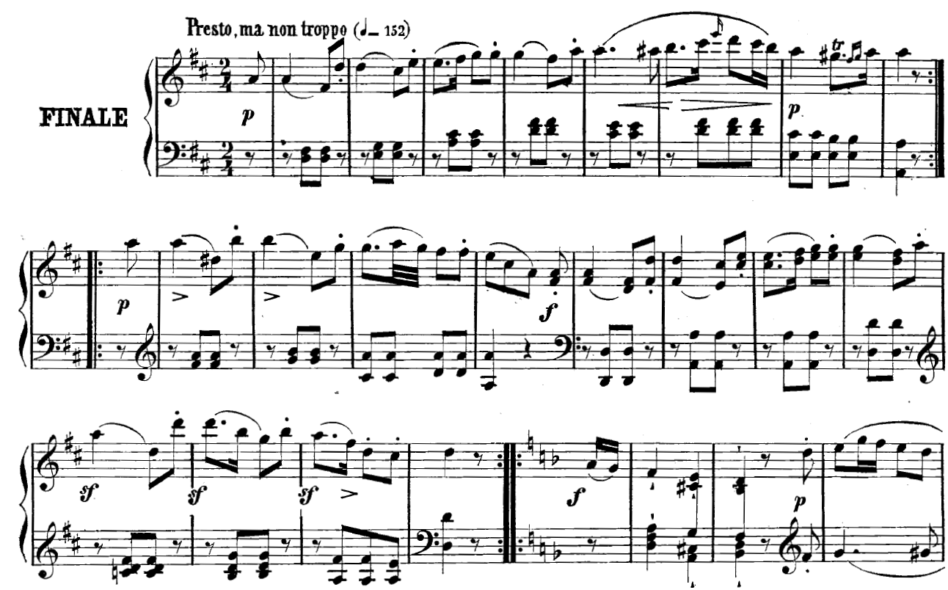

- Johann Sebastian Bach (1685-1750), Sarabande from Violin Partita no. 1, BWV 1002
Part 1 – Basic Questions
  - This piece is in what key? __________
  - What kind of cadence ends the first reprise? ______________
- Provide a Roman numeral for the key of this cadence: _____________
  - Based on your answer to the previous question, is the first reprise harmonically open or closed? ____________
  - Does the beginning of A return—in the home key—somewhere in the middle of the second reprise? ________
  - Based on your answer to the question above, which type of binary form is this? _____________________
  - Does this binary form also have a balanced aspect? __________
- If so, what measure contains the crux? __________
  - Which of the following features promote a sense of instability at the start of the second reprise? (circle all that apply)
Sequence Chromaticism/Tonicization Sustained Dominant Increased rhythmic activity None
Part 2 – Additional Harmonic Questions
- There’s something uncommon about the chords that end both the first and second reprises. What is it? (HINT: what is the chord quality?) _____________________________________________
- The middle of the second reprise features an authentic cadence in a non-tonic key.
  - Name of key of that cadence (e.g., Eb minor)__________
  - What Roman numeral is that key in terms of the whole excerpt? __________
(e.g., If the overall key were C major, then a cadence in D minor would be a cadence in the key of ii)
c. Which type of 64 chord does measure 11 contain? _______________
Part 3 – Short Answer Questions:
- The second reprise starts with an F# major chord and the second beat has an E in the bass. Do you think this E represents the seventh of that chord or do you think it is a neighbor tone? Decide and support your answer with musical details either way:

- If you had to give a single Roman numeral to represent all of measure. 13, which would you give?____________
  - How did you decide?

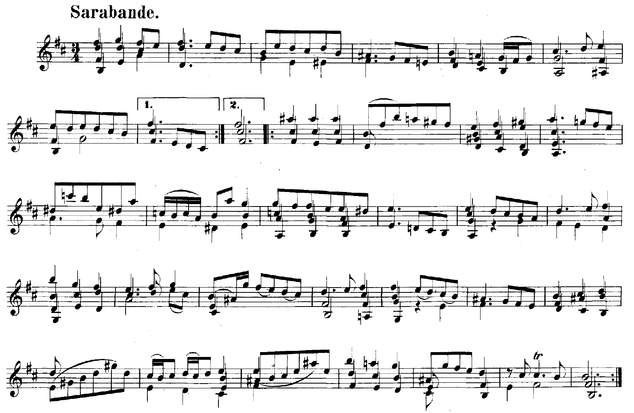

- Franz Schubert (1797-1828), Piano Sonata in E major, D. 157, II (mm. 1- 16)

Part 1 – Basic Questions
- This piece is in what key? __________
- What kind of cadence ends the first reprise? ______________
  - Provide a Roman numeral for the key of this cadence: _____________
- Based on your answer to the previous question, is the first reprise harmonically open or closed? ____________
- Does the beginning of A return—in the home key—somewhere in the middle of the second reprise? ________
- Based on your answer to the question above, which type of binary form is this? _____________________
- Does this binary form also have a balanced aspect? __________
  - If so, what measure contains the crux? __________
- Which of the following features promote a sense of instability at the start of the second reprise? (circle all that apply)
Sequence Chromaticism/Tonicization Sustained Dominant Increased rhythmic activity None
Part 2 – Additional Harmonic Questions
- Which type of 64 chord does measure 7 contain? _______________
- The resolution of the chord on beat 2 of measure 5 is elided on the downbeat of measure 6. Which Roman numeral would you have expected to occur instead on beat 1 of measure 6?
- There’s an applied chord on the 5th eighth note of measure 9. What Roman numeral would you give to this chord? ____________
  - Did it resolve to the chord you expected? ____________
- Beat 2 of measure 13 has a root-position, dominant triad but the following chord (m. 14 beat 1) is not tonic. What term describes measure 13’s dominant chord?_____________
Part 3 – Short Answer Questions
- Both reprises end with the chord root in the bass (on the downbeat of the measure) but contain many embellishing tones. How would you represent the harmony and embellishing tones in this measure?

- What terms would you use to describe the phrase structure of the entire first reprise?
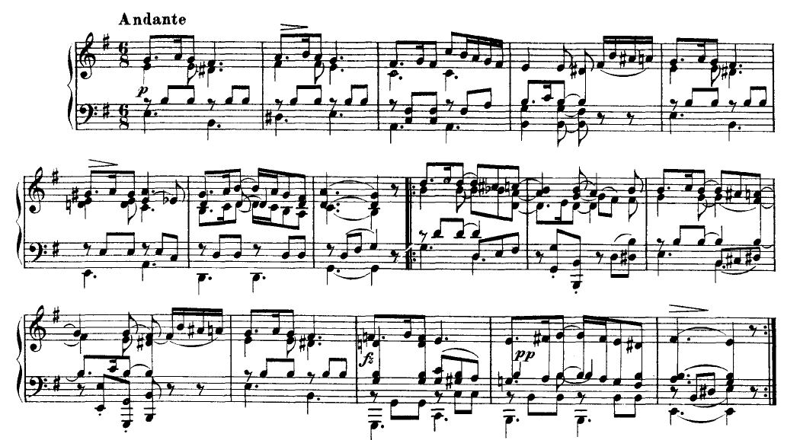

- Franz Schubert (1797-1828), Symphony no. 2 in Bb major, D. 125, II
Part 1 – Basic Questions
- This piece is in what key? __________
- What kind of cadence ends the first reprise? ______________
- Provide a Roman numeral for the key of this cadence: _____________
- Based on your answer to the previous question, is the first reprise harmonically open or closed? ____________
- Does the beginning of A return—in the home key—somewhere in the middle of the second reprise? ________
- Based on your answer to the question above, which type of binary form is this? _____________________
- Does this binary form also have a balanced aspect? __________
- If so, what measure contains the crux? __________
- Which of the following features promote a sense of instability at the start of the second reprise? (circle all that apply)
Sequence Chromaticism/Tonicization Sustained Dominant Increased rhythmic activity None

Part 2 – Additional Harmonic Questions
- Do measures 9-12 contain a sequence? If so, what’s the name of this sequence? ____________
- The resolution of the chord on beat 2 of measure 14 is elided on the downbeat of measure 15. Which Roman numeral would you have expected to occur instead on beat 1 of measure 15?
- What Roman numeral would you give to the chord on the downbeat of measure 15? ____________
  - Did it resolve to the chord you expected? ____________
Part 3 – Advanced Questions
- Measures 1-2 and measures 3-4 are similar in a number of ways but also quite different. Do you think they are two versions of the same idea or two distinct ideas? Decide and support your answer with musical details either way:
- The first reprise either ends with a half cadence in the original key, or an authentic cadence in the key of the dominant. Which do you think is the case and why?
