PART 1: Part Writing Sequences
For each excerpt below, complete the following:
- Continue the sequence pattern initiated.
- Note: The brackets indicate how many times each model should be copied.
- Analyze the progression with Roman numerals.
- Identify the sequence type.

Example #1 – Sequence Type: ____________________________________

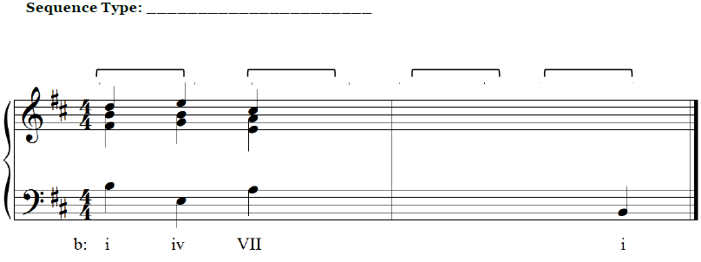

Example #2 – Sequence Type: ____________________________________

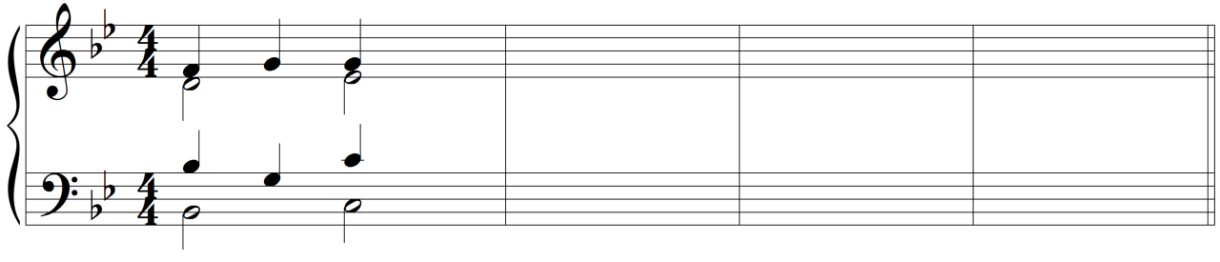
Bb: I5------6 _____ _____ _____ V I

PART 2: Analyzing Sequences

Excerpt #1: Mozart, Mass in Cm, K. 427, “Et incarnatus est,” mm. 37–41 (score on next page)

- Listen to the following excerpt several times.
  - Recording: https://youtu.be/t551jbBw-p4?feature=shared&t=2358 (excerpt at 39:18)
- A sequence appears in this excerpt. Bracket the sequence model and its copies above the staff.
- Label the sequence type.
- Provide a harmonic analysis with Roman numerals of the first four measures in the given key.
  - Note: the given key does not match the key signature.

Sequence Type: ____________________________________

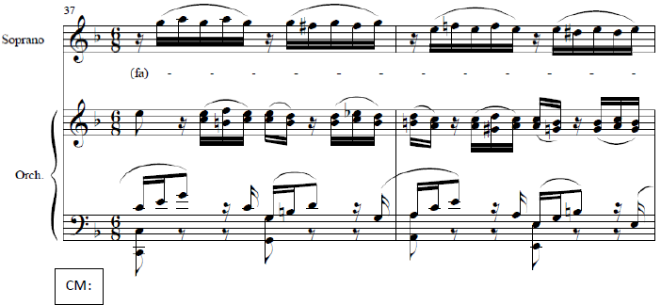
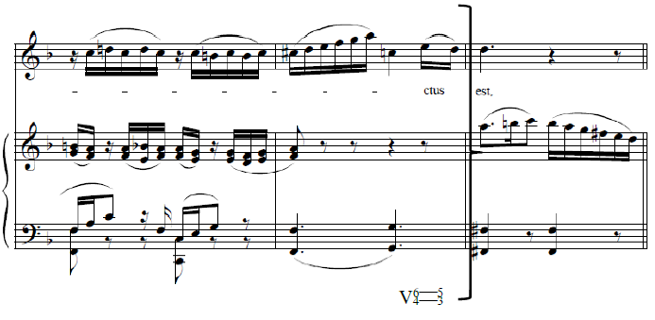

Excerpt #2: Handel, Concerto Grosso Op. 6, No. 6, III, mm. 81–95

- Listen to the following excerpt several times.
  - Recording: https://youtu.be/Qlss-UrbK8w?si=fgW-UB9QUbe_3H4i&t=572 (excerpt at 9:32)
- A sequence appears in this excerpt. Bracket the sequence model and its copies above the staff.
  - Note: some copies are slightly embellished.
- Label the sequence type.

Sequence Type: ____________________________________

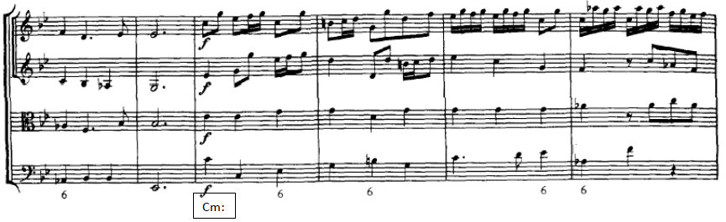
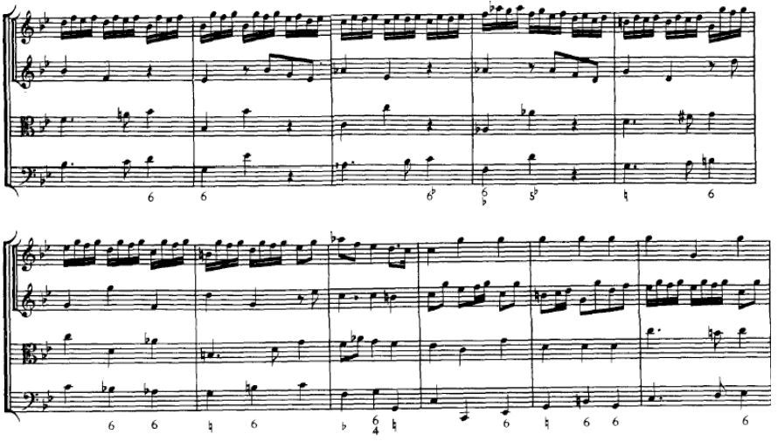
Excerpt #3: Josephine Lang, “Traumbild,” mm. 15–19

- Listen to the following excerpt several times.
  - Recording: https://youtu.be/PGCab0vlOkw?si=C18lAzMhprltVOBS&t=47 (excerpt at 0:47)
- Below is a list of features. Circle any that appear in this excerpt.

Ascending 5–6 Sequence Descending Thirds Sequence

Descending Fifths Sequence Deceptive motion

Plagal motion immediately after a cadence Phrygian HC

- Label all cadences in the excerpt. (Harmonic analysis is not required for this excerpt.)
- If a sequence appears in the excerpt, brackets its model and copies.

