Common-Tone Chords (CT°⁷ & CT⁺⁶) – Assignment 1
Part 1 – Creating common-tone chords by adding multiple neighbor tones
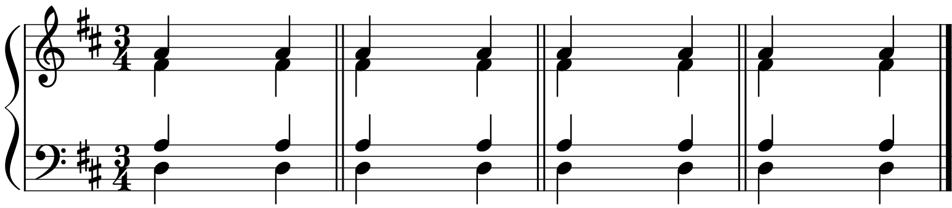
D: I% Q Q Q Q Q Q ^ Q Q Q Q Q Q Q % I% Q Q Q Q Q Q $ Q Q Q Q Q Q Q % I# Q Q Q Q Q Q @ Q Q Q Q Q Q Q # I%5£ Qqœ Qqœ Qqœ Qqœ Qqœ Qqœ ^4™ Qqœ Qqœ Qqœ Qqœ Qqœ Qqœ %5£
↑
↑
↑
↑

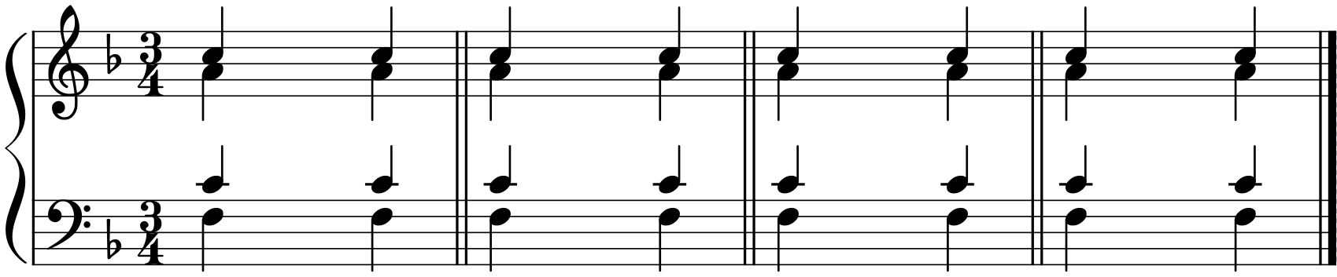
↓

F: I% Q Q Q Q Q Q ^ Q Q Q Q Q Q Q % I% Q Q Q Q Q Q $ Q Q Q Q Q Q % I# Q Q Q Q Q Q @ Q Q Q Q Q Q Q # I%5£ Qqœ Qqœ Qqœ Qqœ Qqœ Qqœ ^4™ Qqœ Qqœ Qqœ Qqœ Qqœ Qqœ %5£
↑
↑
↑
↑
↓

Part 2a
- (First two examples) Create a common-tone chord that with complete neighbors
- (Third example) Create a common-tone chord where the first chord is a triad but the third chord is a dominant seventh with the same root as the first chord.

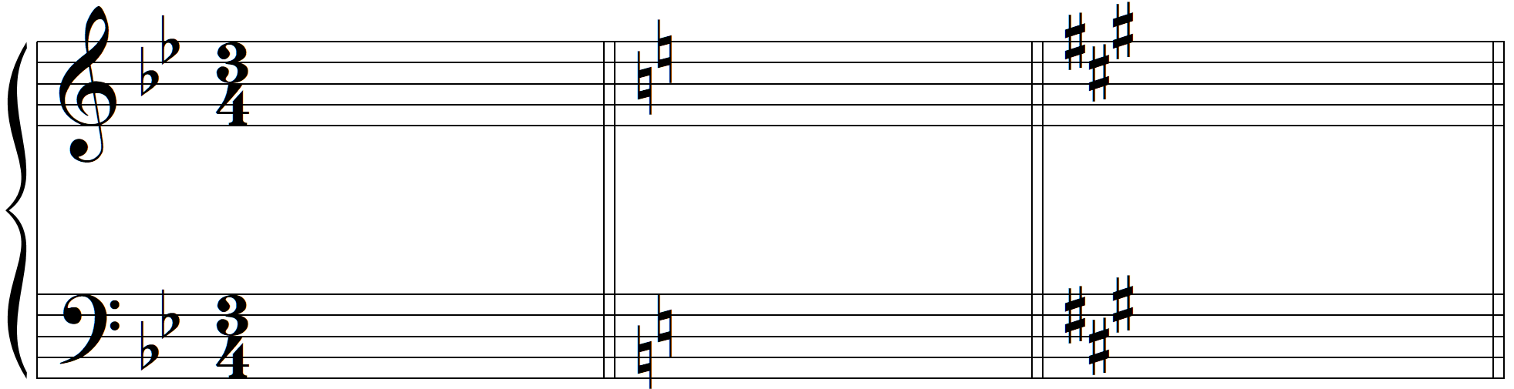
CT°⁷
CT°⁷
B<: I%5£ Qqœ Qqœ Qqœ Qqœ Qqœ Qqœ ^4™ Qqœ Qqœ Qqœ Qqœ Qqœ Qqœ %5£ C: I%5£ Qqœ Qqœ Qqœ Qqœ Qqœ Qqœ ^4™ Qqœ Qqœ Qqœ Qqœ Qqœ Qqœ %5£ A: I%5£ Qqœ Qqœ Qqœ Qqœ Qqœ Qqœ ^4™ Qqœ Qqœ Qqœ Qqœ Qqœ Qqœ &5£
↑
↑
↑
↑
↓

↑
↑

Part 2b – Create common-tone chords that are incomplete neighbors

CT°⁷
CT°⁷
E: I V$3 I^ ii^ V

Part 3 – Common-tone chords with Figured Bass
- Realize the figured bass in “keyboard style”
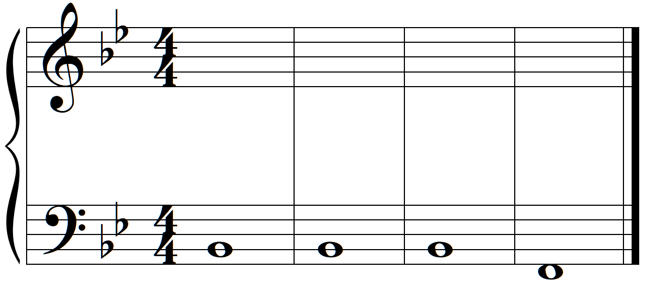
y≈ ^4™

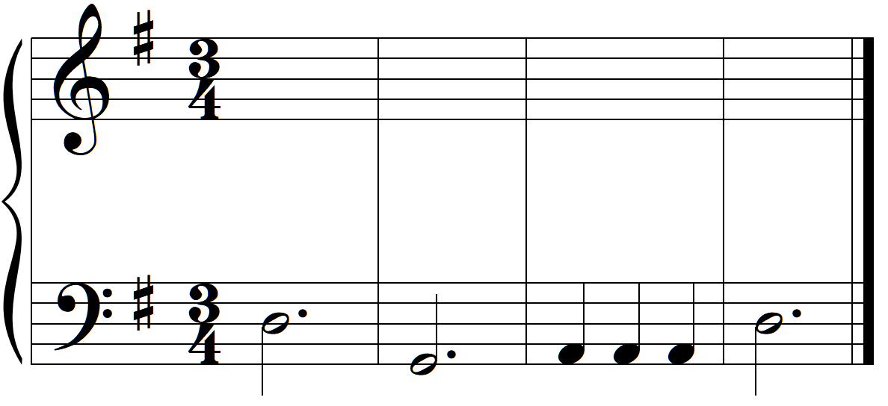
x≈ ^4™ &

Part 4 – Four-Voice Part Writing

A<: I V$2 I^ %3 V$3 CT°& I^ V^5 IV viiK & V^4 Qq Qq Qq Qq %3 I%5£ Qqœ Qqœ Qqœ Qqœ Qqœ Qqœ ^4™ Qqœ Qqœ Qqœ Qqœ Qqœ Qqœ %5%5£
CT⁺⁶
↑
↑
↓

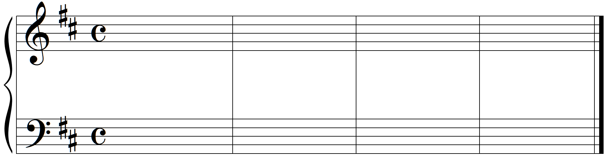
↑
↑
CT°⁷
D: I V$2 IV^ ii^5 V%5£ Qqœ Qqœ Qqœ ^4™ Qqœ Qqœ Qqœ Qqœ %5£ I

Part 5 – Analysis of Music with Common-Tone Chords
- Provide a complete harmonic analysis of the following phrase

- Schuman, Papillons, op 2, no. 10, mm. 25-40

