**Harmonic Elision – Assignment 1**

Part 1 – Creating harmonic elision

* Rewrite the progression on the left by suppressing its last chord using harmonic elision
* Then, resolve the new chord you created

Demonstration of a raised-root elision suppressing an expected I chord

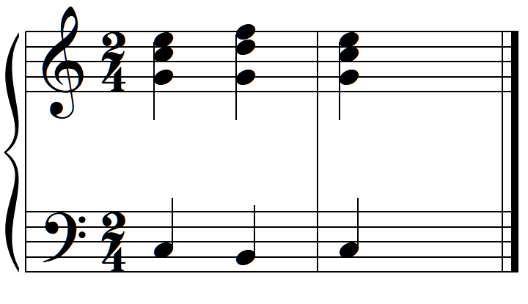 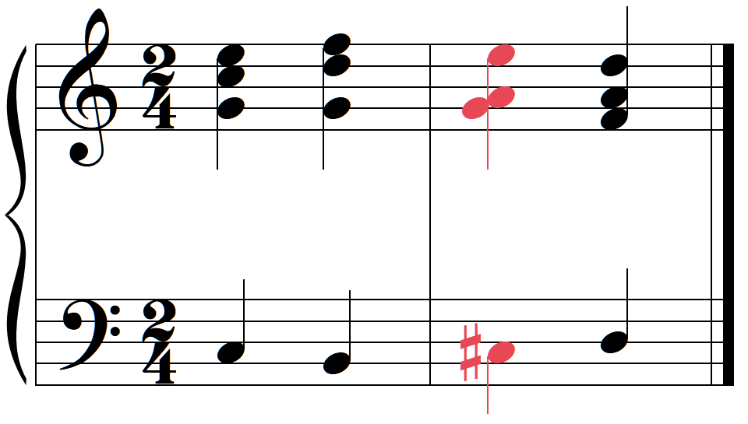

C: I V^5 I I V^5 V^5 ii

I

Use a leading-tone elision

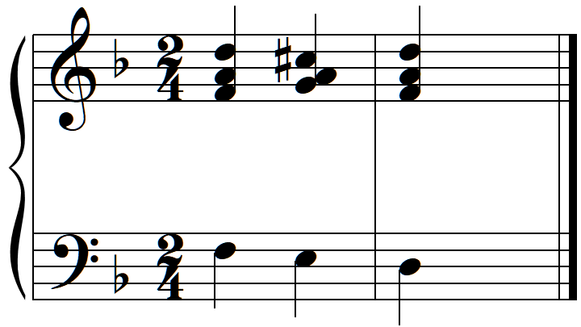 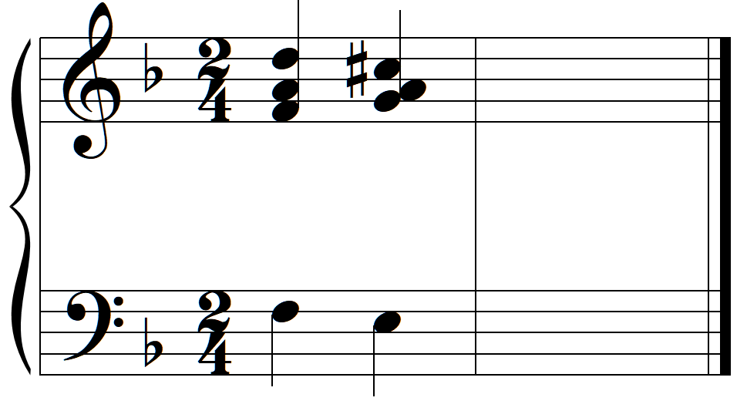

d: i V$3 i i V$3

i

Use a raised-root elision

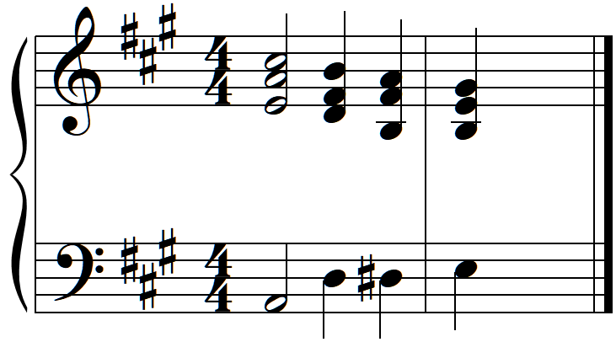 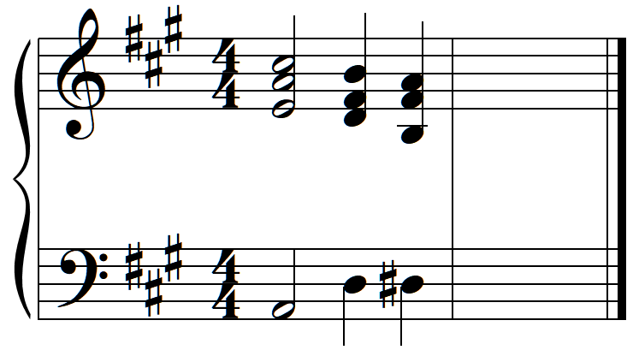

A: I ii^ V^5 V I ii^ V^5 /V

V

Part 3 – Common-tone chords with Figured Bass

* Realize the figured bass in “keyboard style”

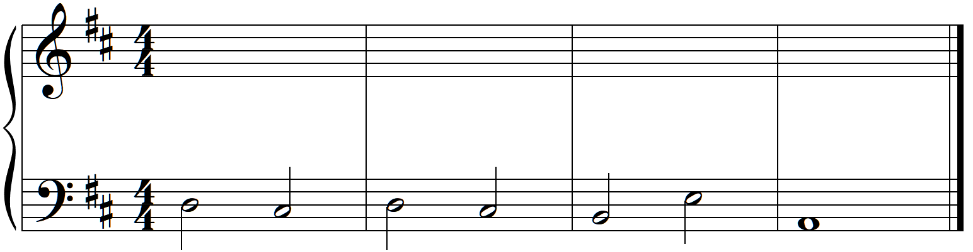

^5 X ^4£ &x

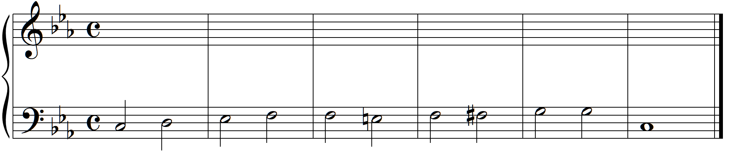

Y ^ ^ ^5 Y $2 z ^5 &y ^4 y&

Part 4 – Four-Voice Part Writing

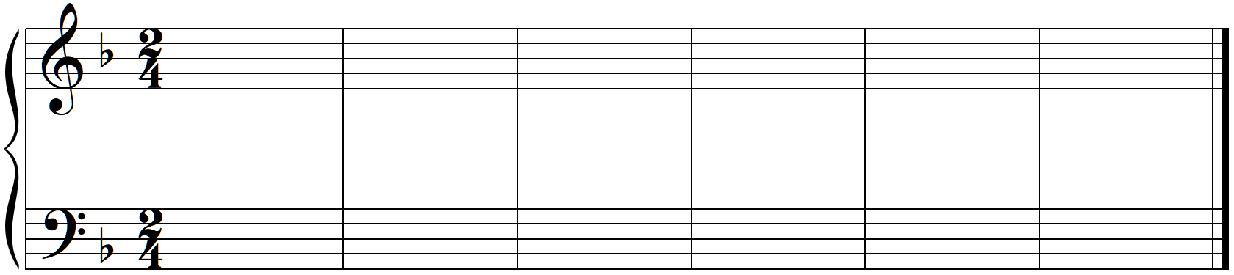

V

I

1 pedal—————————

F: I IV^ I^ V^5 V$2 I^ ii^ V& V& IV V& I

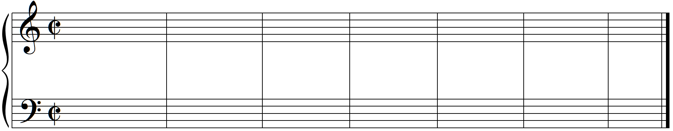

C: I V^5 viiK & ii V$3 ii^ V*6¢ Qqœ Qqœ Qqœ viiK & vi IV V^4 Qq Qq Qq Qq Qq Qq %3 I

I

qœQ Qqœ Qqœ &5£

Part 5 – Analysis of Music with Common-Tone Chords

* Provide a complete harmonic analysis of the following phrase

1. Josephine Lang, *Traumbild*, Op. 28, 1, mm. 37-47

