Modal Mixture – Assignment 1
Part 1 – Converting Existing Chords
- These notated chords do not have modal mixture. Create modal mixture by altering them so that they match the quality of the given Roman numeral.
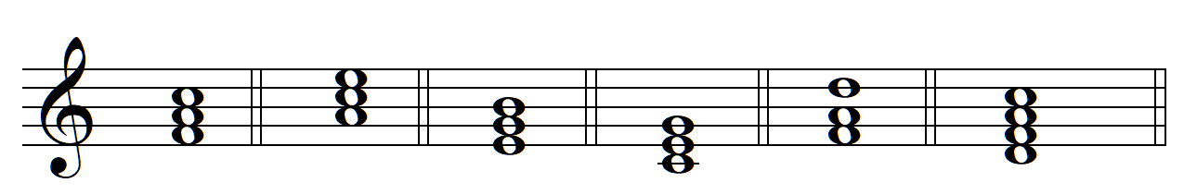
iiKJ &
iiK ^
i
<III
<VI
iv

Part 2 – Creating Modal Mixture Chords from Scratch
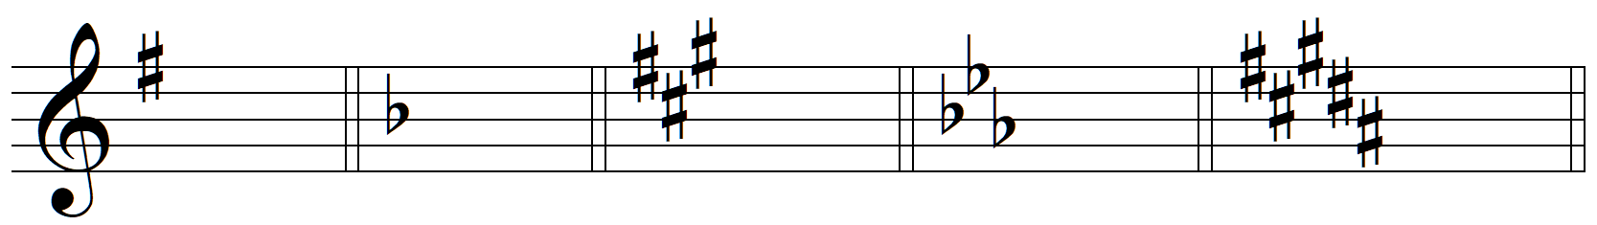
B: iv
E<: iiJ ^5
f> : I
F: iiK ^
G: <VI

A<: i
c> : I
B<: <VII
D: <III
D<: iiJ &

Part 3 – Modal Mixture with Figured Bass
- Realize the figured bass in “keyboard style”
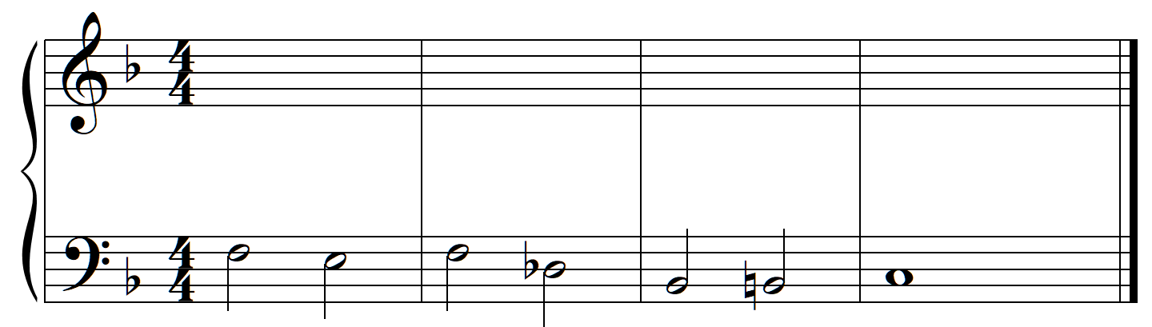
F: ^5 Z % z 3^ ¥yZ &3 ^4 Qq Qq Qq Qq Qq Qq Qq Qq %3
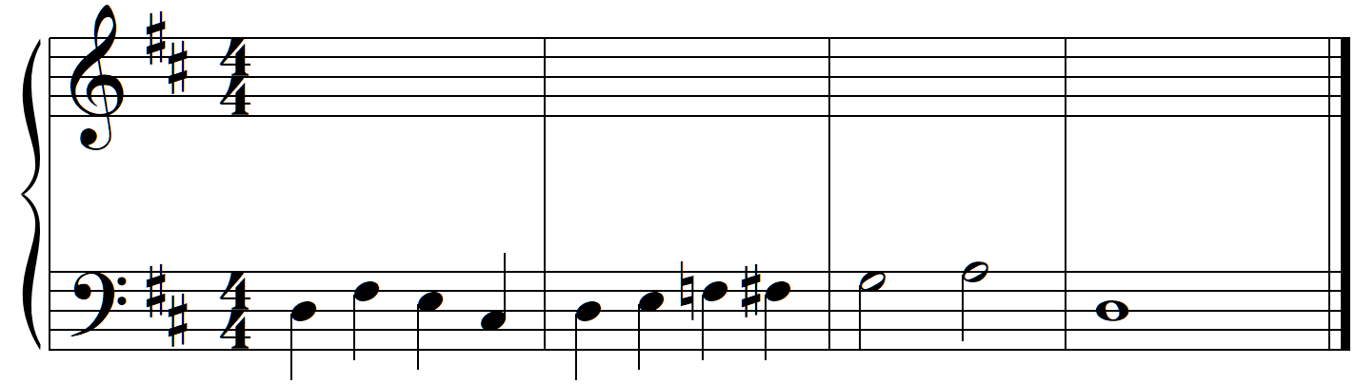
D: ^ $3 ^5 Yz ^5 Y % y ^5 % Q Q Q Q ^ *6¢ Qqœ Qqœ Qqœ Qqœ &5£

Part 4 – Four-Voice Part Writing
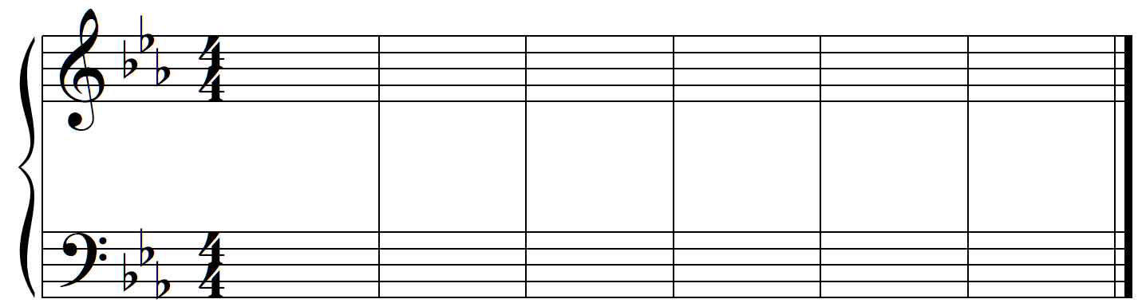
E,<: I V$2 iv^ iiK ^ V* Q Q Q Q & <VI iv V* Q Q Q Q & I$ Q Q Q Q #
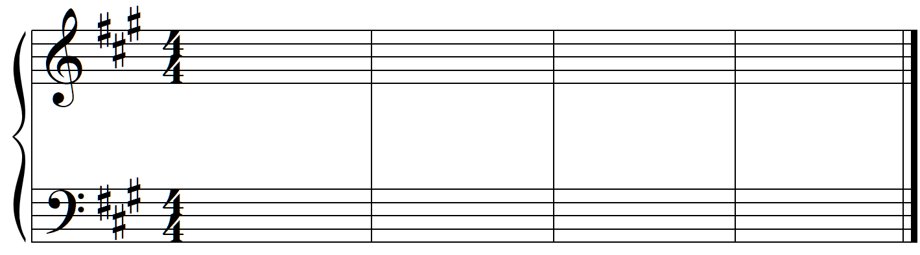
A: I V$2 I^ V$3 I V$3 <VI iiK ^ viiK & V^4 Qq Qq Qq %3 I

Part 5 – Analysis of Music with Modal Mixture
