Neapolitan 6th ( <II^ ) – Assignment 1
Part 1 – Converting Existing Chords
These chords are either ii°⁶ or ii⁶. Convert them into <II^ chords.
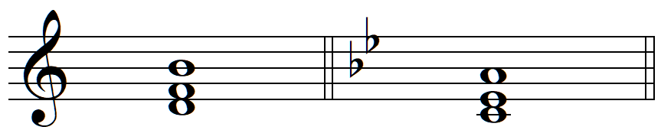
G minor
A minor

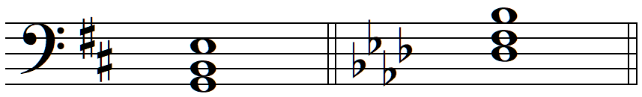
Ab major
D major

Part 2 – Creating Neapolitan 6th Chords from Scratch
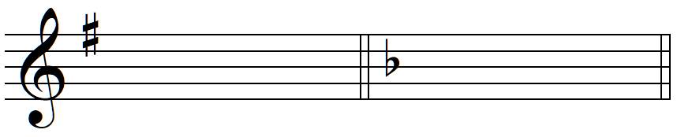
e: <II^
d: <II^

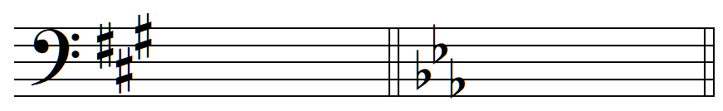
E<: <II^
A: <II^

Part 3 – The Neapolitan 6th with Figured Bass
- Realize the figured bass in “keyboard style”
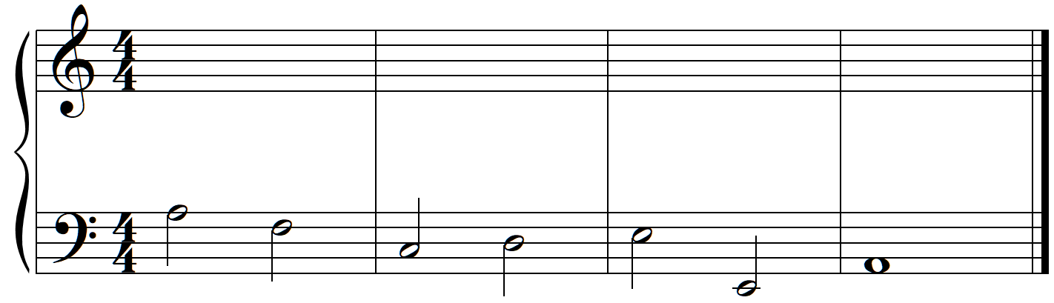
a: ^ ^ Z ^ ^4 &5≈ $ Q Q Q Q Q Q Q Q #

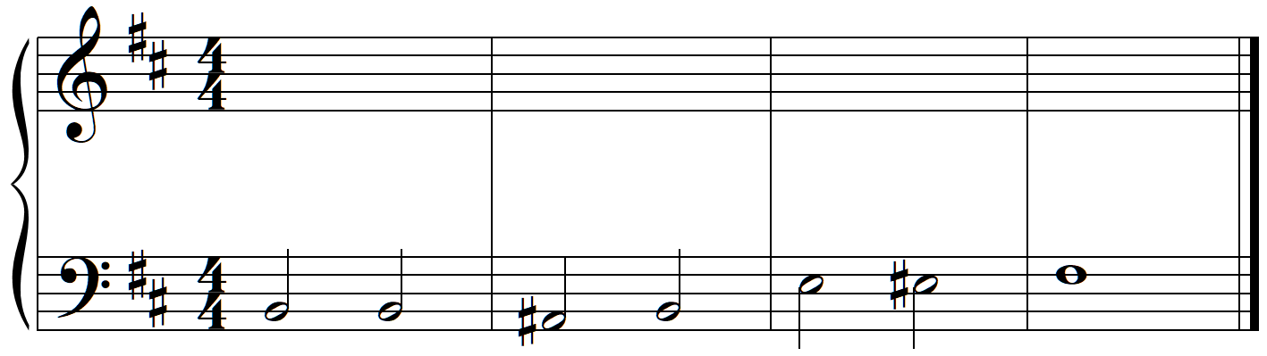
b: $2 ^5 Y ^ x &3 X #

Part 4 – Four-Voice Part Writing
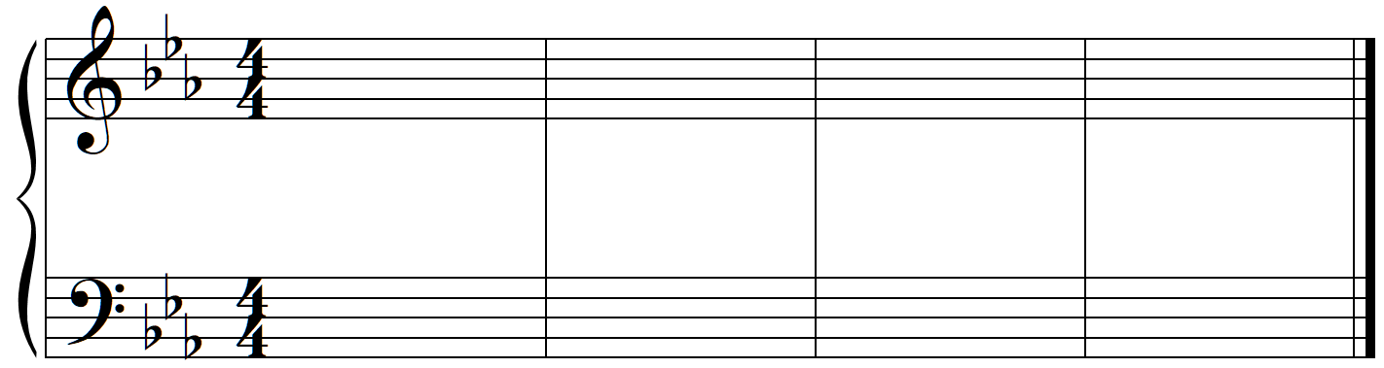
c: i V^5 i viiK ^ i^ <II^ V^4 Qq Qq Qq Qq %3
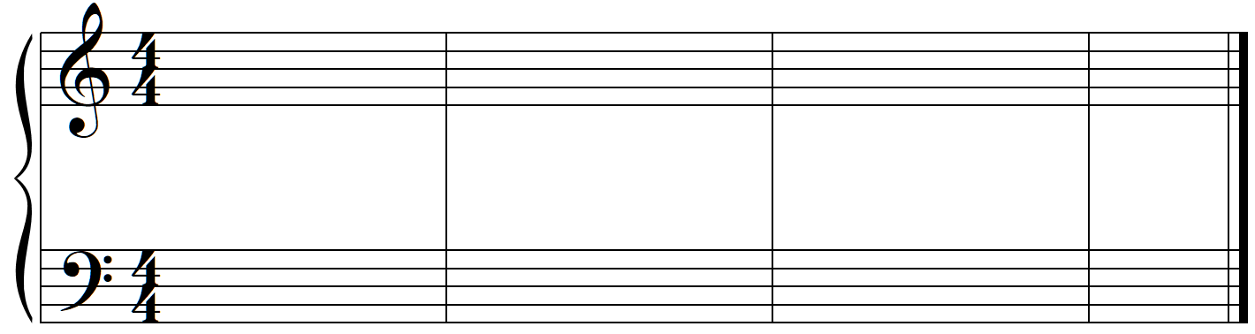
(passing)
C: I V$2 IV^ ^4 ii^5 V$2 I^ %3 <II^ viiK & V^4 Qq Qq %3 I

Part 5 – Analysis of Music with the Neapolitan 6th
- Provide a complete harmonic analysis of the following phrase
- Moritz Moszkowski – Spanish Dance, Op. 12, no. 1 (originally for piano four hands), mm. 51-58
