Chords as Forms of Prolongation (and Review!)

Part I. Review: writing tonic expansions from figures.
- Provide a harmonic analysis of the given figures.
- Realize each progression in four parts.

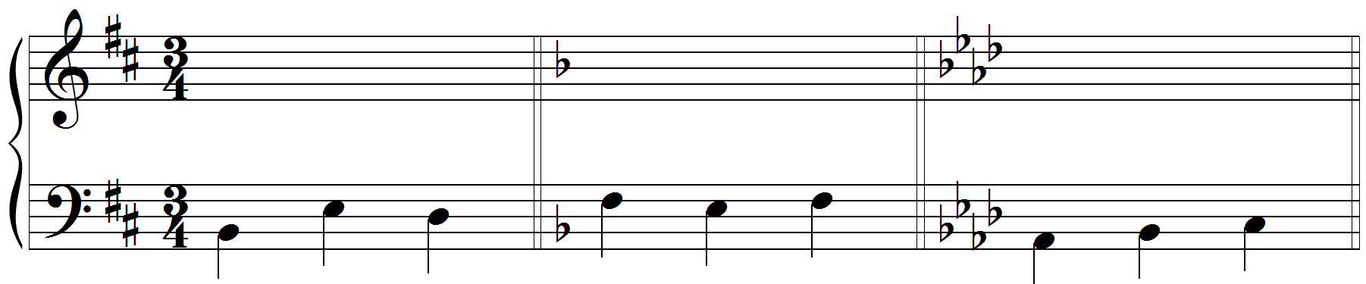
6 6
b: F: A:

Part II. Review: strong predominants and the cadential .
- For each of the two progressions below, add a different strong predominant in the blank, then
- Realize each progression in four parts

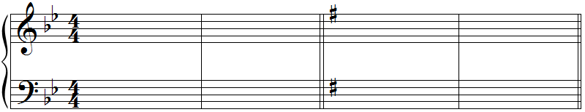

g: i _____ V i e: i _____ V i

Part III. Writing chords from figures.
- Provide a harmonic analysis of the figures
- Realize each progression in four parts

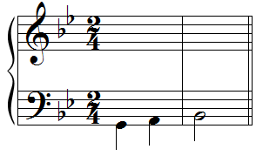  6  g: | 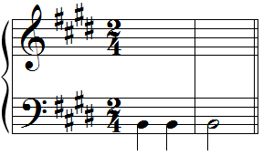  E:
Part IV. Putting it all together.
- Identify how the phrase model operates using the labels Tb-PD-D-Te
- Realize the progression in four parts
- Label the cadence with which the excerpt ends

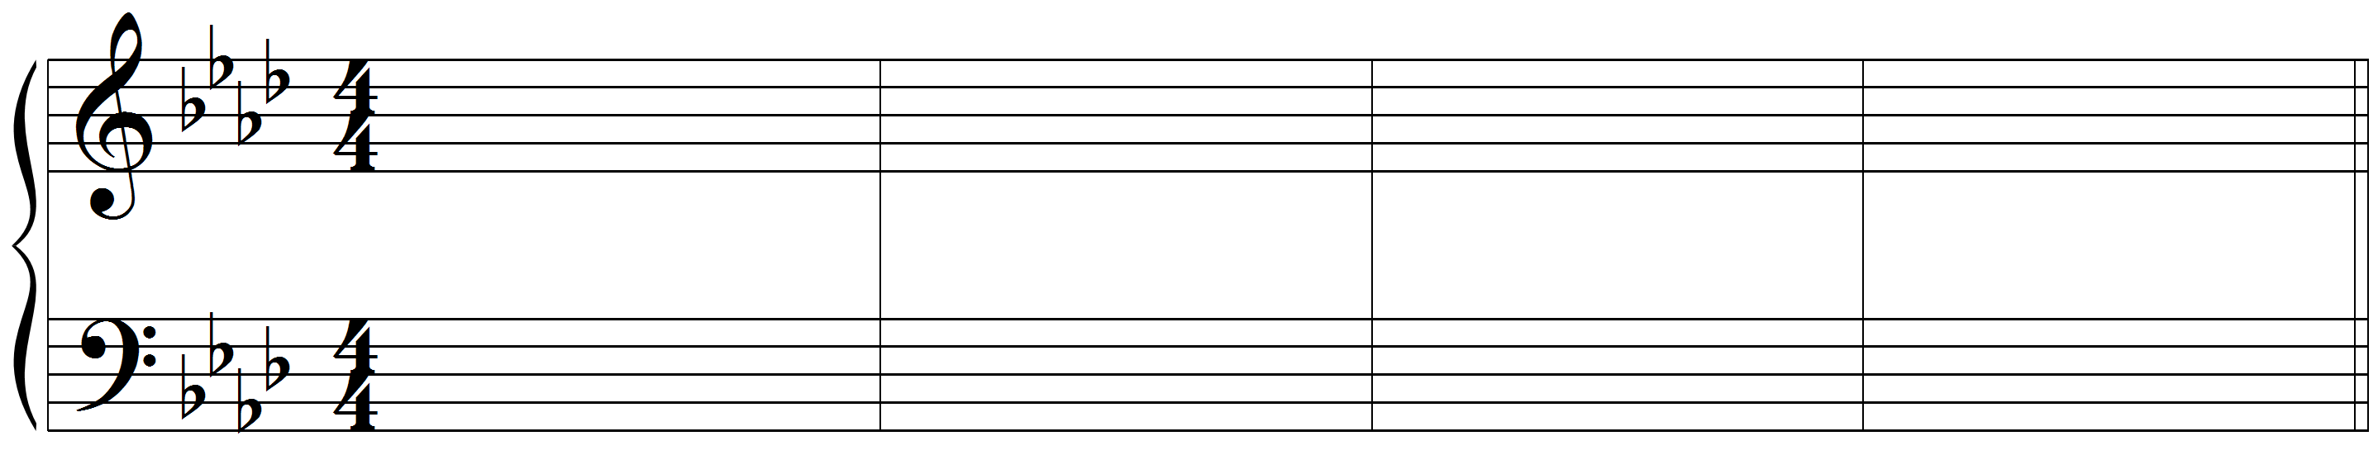

A: I viiº I⁶ P I ii⁶ V I

Part V. Analysis: Mozart, 6 Variations K. 398 (Theme)
- Listen to the passage several times: https://open.spotify.com/track/3QtPJYQ0T3UQVhYcUQUIDZ?si=86da13b2291b4b26Label the key.
- Label any cadences in the passage.
- Provide a harmonic numeral analysis of the passage. Ignore the circled notes, which are embellishing tones.
- Identify how the phrase model operates using the labels Tb-PD-D-Te

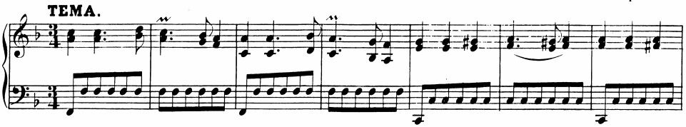

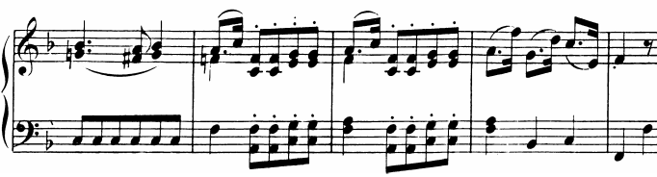
.

Part VI. Analysis: Mozart, Violin Concerto No. 3, K. 216, III, mm. 1–16
- Listen to the following passage several times: https://open.spotify.com/track/3WYlr5cBiumjseqYlWTG2d?si=f6aecf13c3e14630
- Label the key
- Label any cadences directly above the final chord of the cadence.
- Provide a harmonic analysis. Although there are embellishing tones in the passage, they have not been circled for you.
- Identify how the phrase model operates using the labels Tb-PD-D-Te

