Prolonging Tonic at Phrase Beginnings with V⁶ and Inverted V⁷
Part I. Short resolutions
- For each excerpt below:
  - Fill in the blank with an appropriate inversion of tonic
  - Realize the progression in four parts

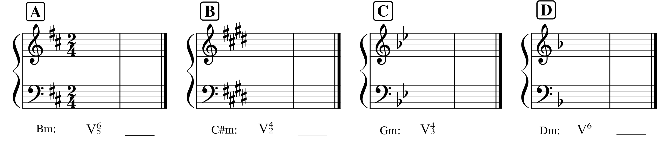

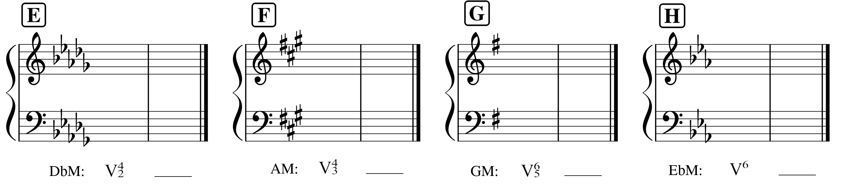

Part II. Figured bass.
- Label the key
- Provide a harmonic analysis of the given figures
- Realize the progression in four-part keyboard style, demonstrating typical common-practice voice leading based on the patterns we’ve been discussing in class.

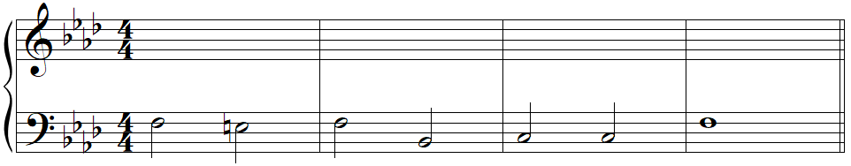
6

_____:
(key)

Part III. Guided Analysis: Schubert, Three Piano Pieces, d. 946
- Listen to a recording of the opening of this piece: https://open.spotify.com/track/7xuOO8nByJUQ0NkkouldST?si=af7f360f7c3d48a6
- Label the key
- Label any cadences in the excerpt below by type
- Provide a harmonic analysis of the excerpt below
  - Measure 3 contains an incomplete chord, but I’m confident you can figure out what note is missing, and identify it appropriately by looking at what chords happen in m. 2 and m. 4 to help you decide which Roman numeral makes sense in m. 3
- There are two embellishing tones in the melody in this passage. Circle and label them appropriately.
- At the beginning, a repeated note is introduced and it continues to play a prominent role in the piece, but that role shifts as the piece progresses. How does it shift? Work through the questions below to find out!! A score for the entire work appears in the same place you found this assignment, and you’ll need to refer to that score.
  - Where does the repeated note receive emphasis in the bass? ______
    - Given how long the note lasts in the bass, what kind of embellishing tone has it become?

  - There’s a key change at the top of page 3. What is the new key?_______
  - If you enharmonically respell the repeated note from the opening, what scale degree does it become in the new key? ______
    - Look at the last measure on page 2 (just before the key change). In what voice does the repeated note appear? _______
    - What is the root and quality of the chord in which it appears (i.e. the chord in the last measure on page 2)? _______
    - What is the purpose of this chord (hint: it will become clearer to you if you enharmonically respell the whole chord and think about what the upcoming key change!)

  - With what note does the second movement begin (page 6)? _______(!)
