Embellishing Tones

Part I. Writing embellishing tones in a two-voice texture.
- Several bass lines are given below.
- Add three notes on the treble staff to create at least one example of each of the following embellishing tones:
- Passing tone  - Neighbor tone  - Appoggiatura | - Escape tone  - Suspension  - Retardation
- Remember: your embellishing tone should be the middle note of the three notes, and the outer two notes must be consonant with the base.
- Circle the embellishing tone and label it appropriately (please circle only the embellishing tone, not all three notes).

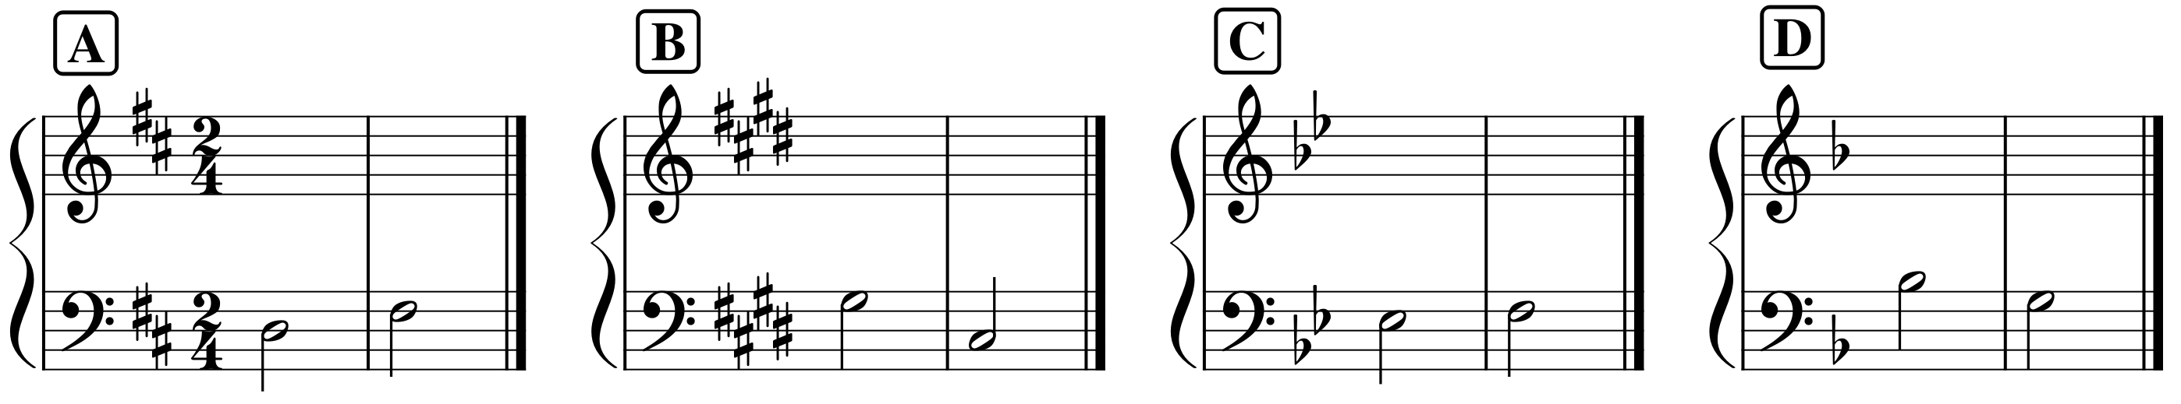

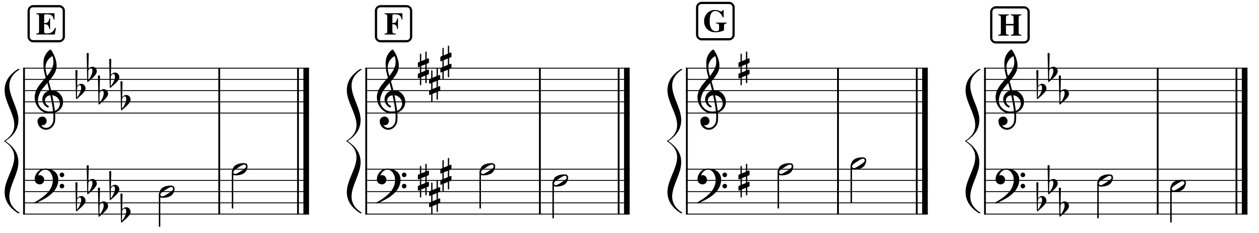

Part II. Analysis: Francis Johnson, “William,” No. 5 from A New Collection of Cotillions, mm. 1–16
- Several embellishing tones have been circled in the passage below. Label them by type.
- https://youtu.be/p4xipbOihI0?t=312

