Extended Tonicization and Modulation to Closely-Related Keys

Part I. Additional practice writing and resolving secondary chords
- Add the key signature for each excerpt below (the first one is done for you), then
- Fill in the blank with an appropriate Roman numeral, then
- Part-write the progression

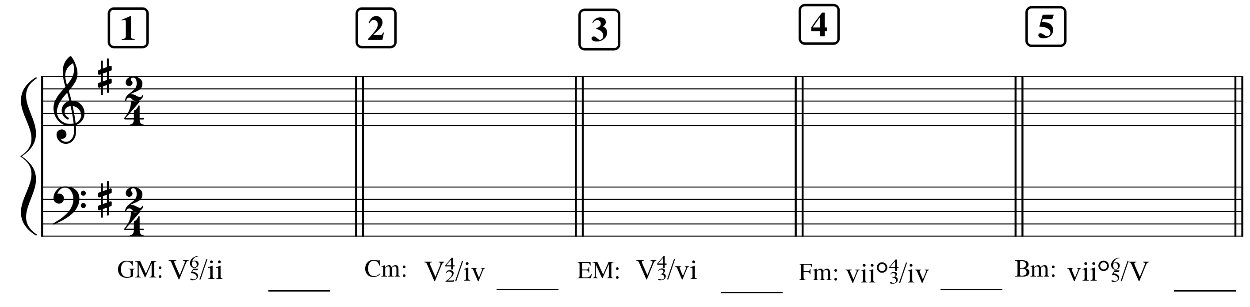

Part II. Closely-related keys

A. List all the keys that are closely-related to D major.  D major (I) | B. List all the keys that are closely-related to F minor.  F minor (i)

Part III. Analysis of a modulating excerpt: Schubert, String Quartet No. 9, II (score below)
- A score appears on the next page. Listen to the excerpt: https://open.spotify.com/track/0cLADQIYaPTzrwLdJYrwQi?si=88242baf1daf4e82
- Label the home key at the beginning of the score
- Label all cadences in the excerpt by key and cadence type (e.g.: V:PAC means “a PAC in the dominant”)
- Provide a harmonic analysis of the entire excerpt. The excerpt modulates: please be sure to identify cadences first so you know which phrase contains the modulation. As you analyze, please keep in mind the next bullet point.
- Some unusual harmonic motion occurs in m. 1 to the downbeat of m. 2, and that motion is repeated several times in the excerpt. “Unusual” means that your Roman numeral won’t make much sense here. On the staff below, provide a reduction of these three beats in which you show only one soprano and bass note for each beat (no inner voices). Measure 1 beat 2 contains several soprano options: the best one is going to be the one that gives you a smooth soprano; the others can be considered embellishing. Your reduction should include very smooth motion.
  - In the space beside the reduction, discuss how your reduction shows what makes the passage coherent better than your harmonic analysis does (hint: think intervals!)

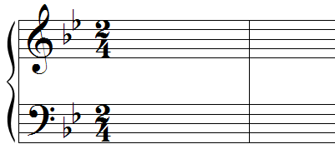

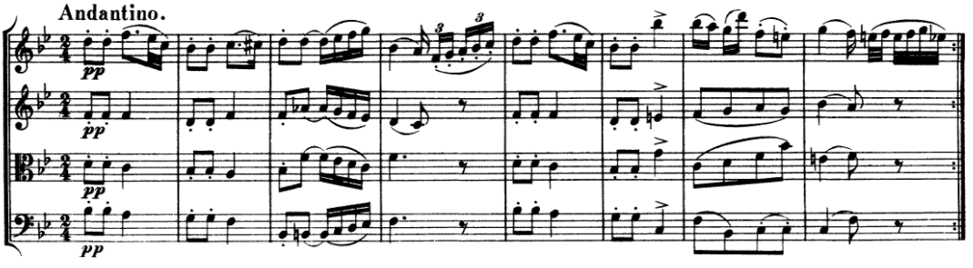

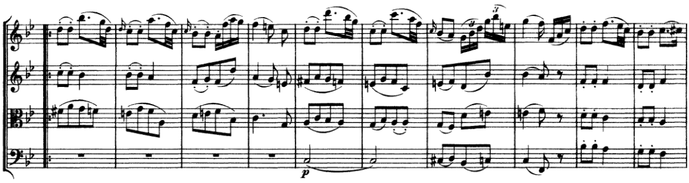

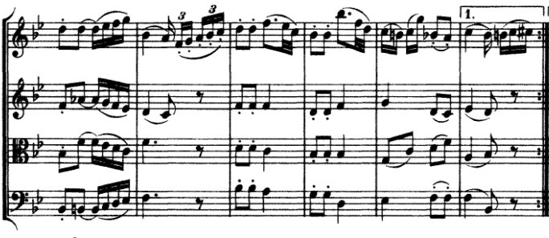

Part IV. Writing a modulation
- On the blank staff below, write a four-measure harmonic progression that:
  - Is in B minor and
  - Begins by establishing the home key using a common tonic expansion paradigm
  - Modulates to a closely-related key using an appropriate pivot chord
  - Ends with an authentic cadence in the new key
  - Uses at least one cadential
- Provide a harmonic analysis of your progression
- Realize your progression in four voices.

