Introduction to harmony, cadences, and phrase endings

Part I. Cadences in major
- For each excerpt below:
  - Identify the major key below the key signature
  - Write the requested cadence in four voices using only I and V chords

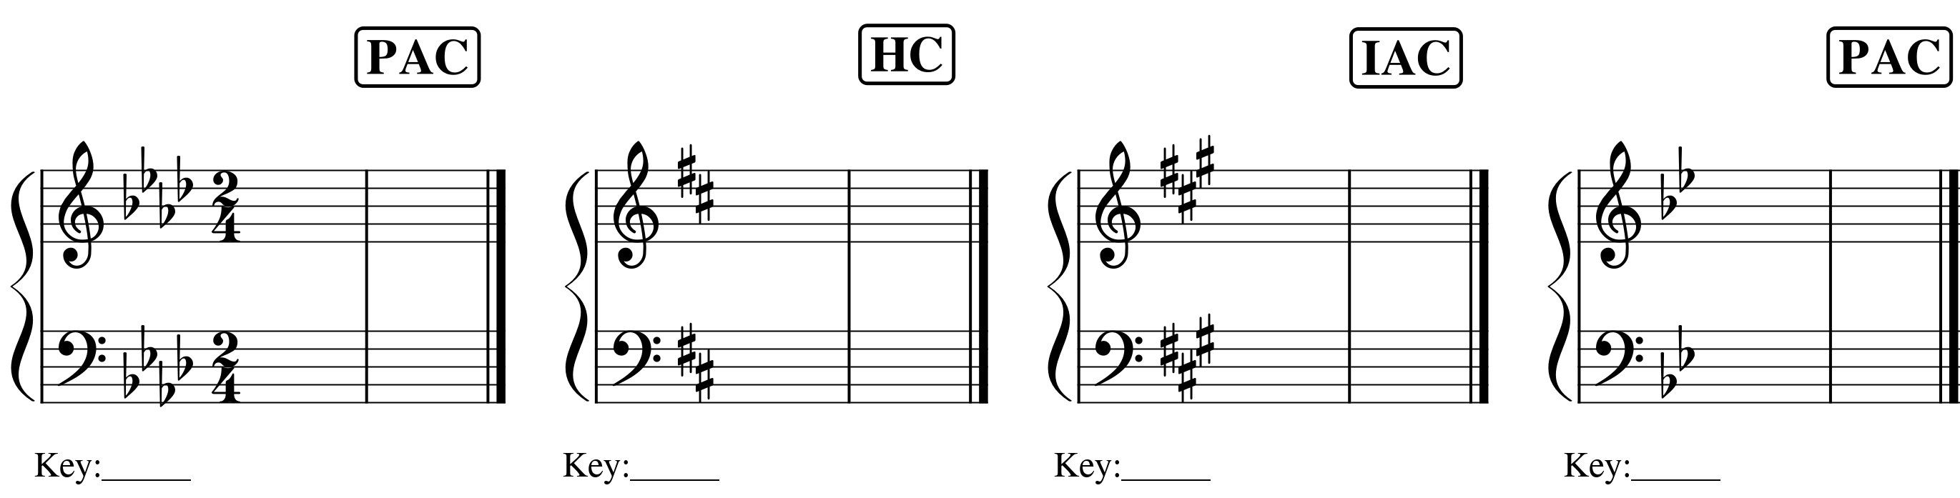

Part II. Cadences in minor.
- For each excerpt below:
  - Identify the minor key below the key signature
  - Write the requested cadence in four voices using only i and V chords

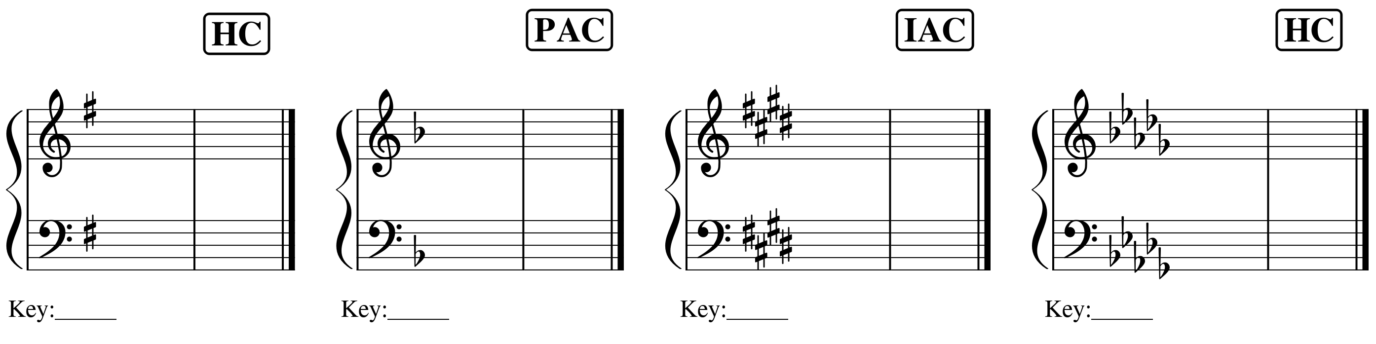

Part III. Analyzing cadences.
- Identify all cadences in each excerpt below by labeling the cadence directly above the final chord of the cadence.

- Francis Johnson, “Ford,” No. 7 from A New Collection of Cotillions, mm. 1–8.
  - https://youtu.be/p4xipbOihI0?t=484

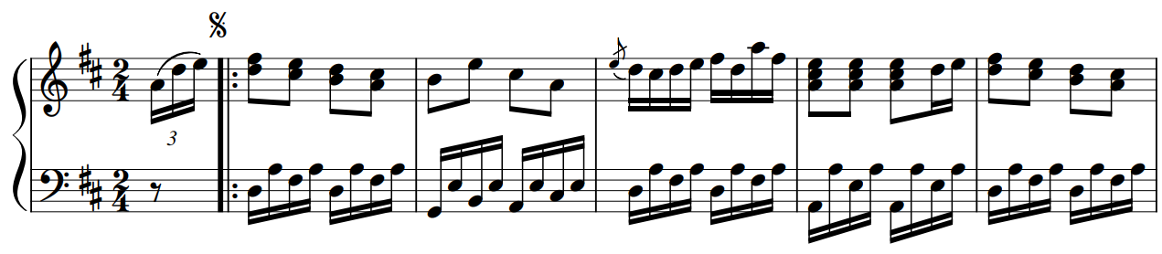

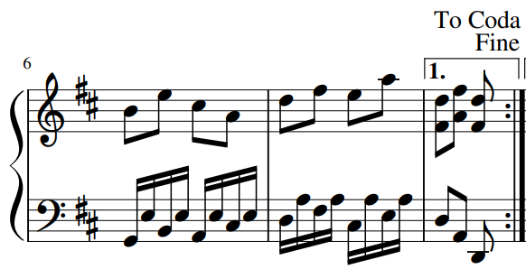

- Francis Johnson, “Ford,” No. 7 from A New Collection of Cotillions, mm. 18–26.
  - https://youtu.be/p4xipbOihI0?t=541

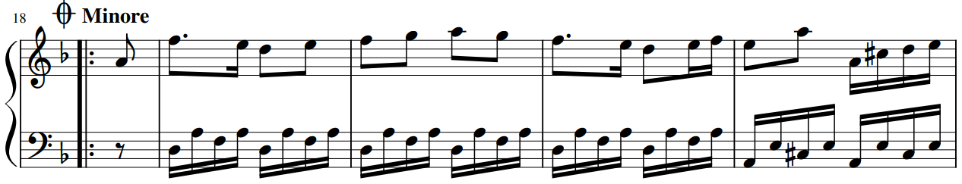

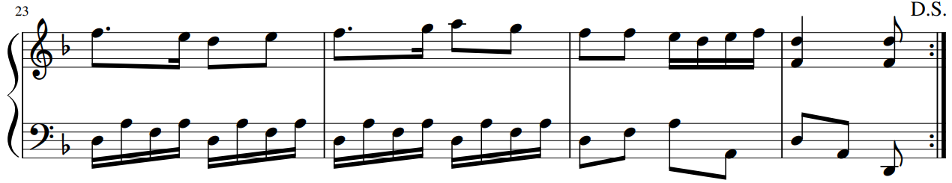
- Francis Johnson, “Augustus,” No. 3 from A New Collection of Cotillions
  - https://youtu.be/p4xipbOihI0?t=180

