La (Þ6) in the Bass at Beginnings, Middles, and Endings
Part I. Bass Lines.
- Below are several bass lines.
  - Label the key you’re thinking in, then
  - using Roman numerals, indicate a common harmonization of the given bass line according to where it occurs in a phrase (beginning, middle, end).
- You do not need to part write the progression.

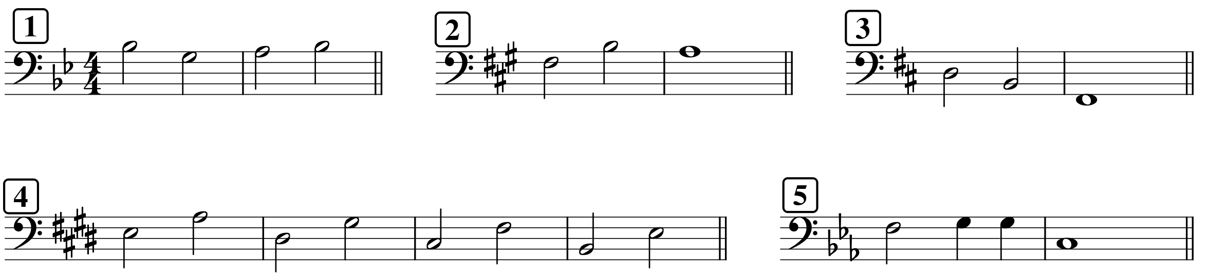

Part II. Short progressions from figures and Roman numerals
- Two excerpts below use figures, while the other two use Roman numerals.
- Provide a harmonic analysis of the two excerpts with figures, then
- Realize the Roman numerals for all excerpts in four parts.

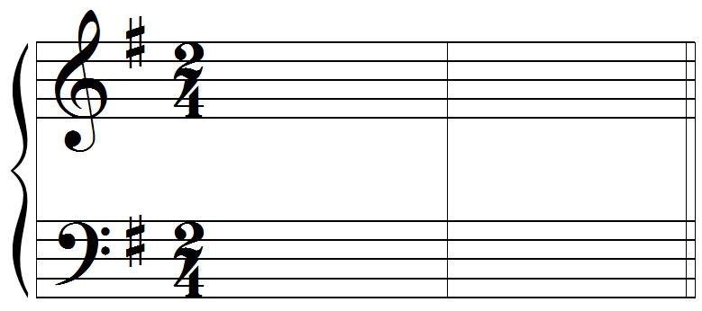  G: I (IV⁶) I⁶ | 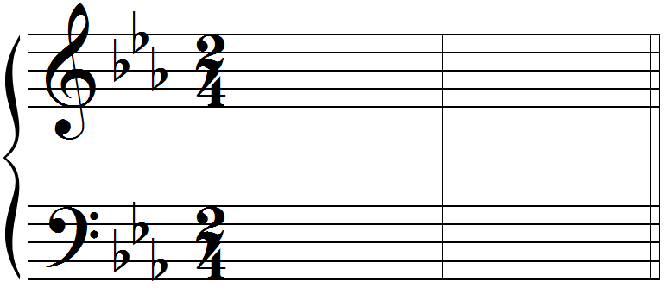  c: i iv⁶ V
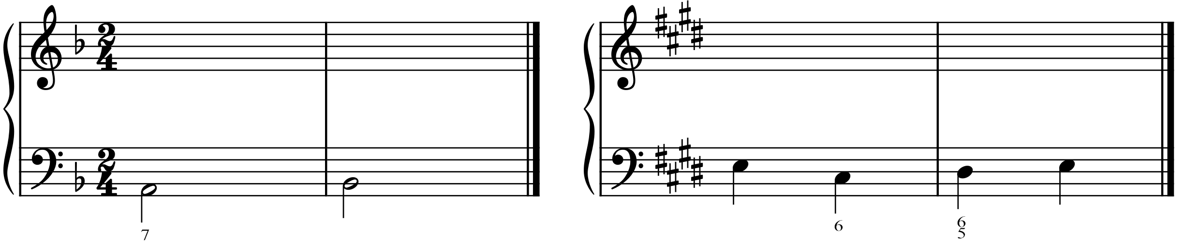

Part III. Unfigured bass
- Provide a Roman numeral analysis that appropriately harmonizes the given bass line
- Add a contextual analysis below your Roman numerals
- Realize your analysis in either keyboard or vocal style (your choice)
- Label the type of cadence you wrote appropriately

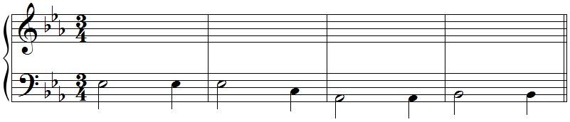
E:

Part IV. Analysis: Joseph Bologne, Six Concertante Quartets No. 5, I, mm. 14–21 (see attached score packet)
- Listen to the excerpt: https://youtu.be/6ASJMvFLYYI?t=30 (starts at about 0:30)
- Although the key signature suggests GM/Em, this passage is in DM.
- Identify all cadences (in DM!)
- Provide a harmonic analysis of the entire passage (in DM!)
  - Note 1: the bass has the melody here, so there are some embellishing tones in the bass. You don’t need to label them.
  - Note 2: mm. 18–20 are a little tricky because of embellishing tones in the cello. You should find a progression that relates to the chapter here.
- On the blank staff below, provide a reduction of the progression you discovered in Bologne’s quartet. Be sure you begin with the soprano and bass notes from the quartet itself, then continue on with part-writing as we have been in class.
  - As you work with mm. 14–17, consider that 16–17 are a repetition of 14–15. If you choose to reflect that repetition in your reduction, it might mean that an active note in m. 15 doesn’t resolve as expected, and that’s okay!
  - For m. 21, you can just use a whole note to represent a single I chord in that measure.

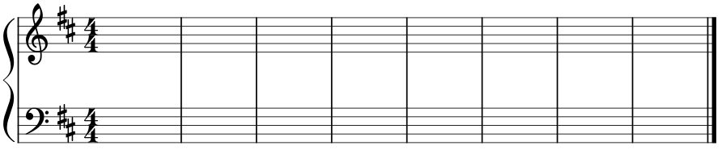

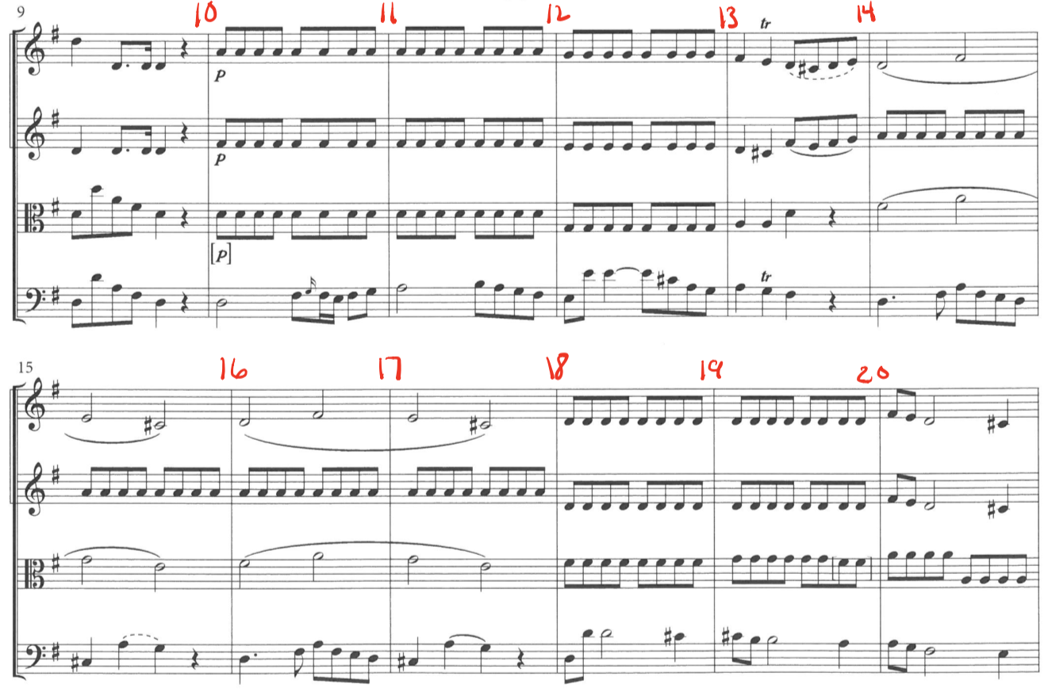

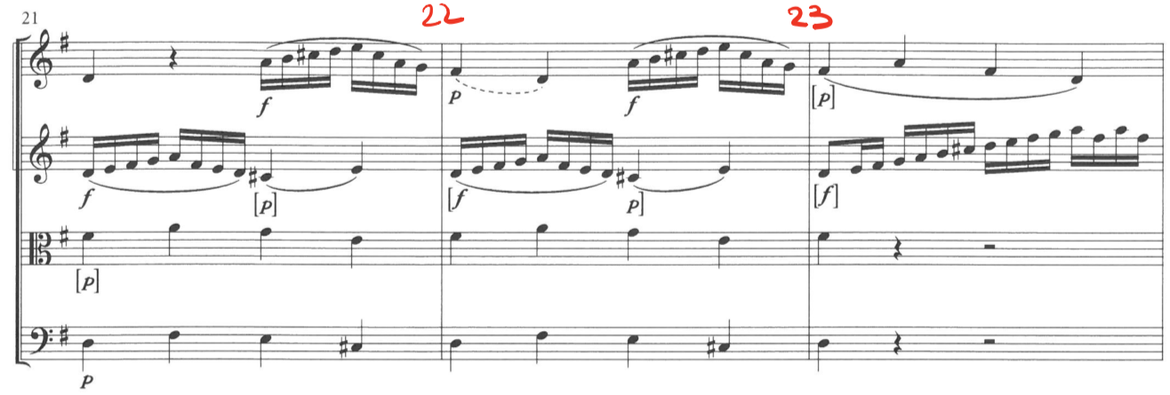

Part V. Analysis 2: Emilie Mayer, String Quartet in E minor, mm. 9–20 (score on next page).
- Recording: https://youtu.be/h8uMhXLJcYE (@ 0:17)
- Below is a list of features. Circle any that appear in this excerpt.

Deceptive motion | Plagal motion immediately after a cadence | Phrygian HC
- Label all cadences in the excerpt.
- Harmonic analysis is not required for this excerpt.

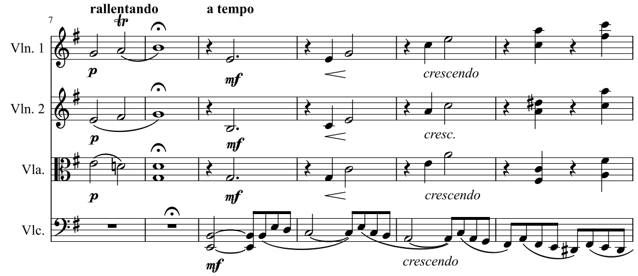

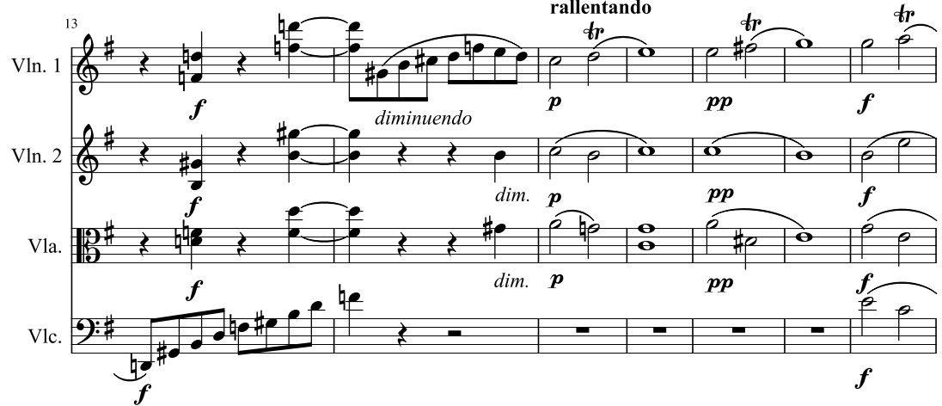

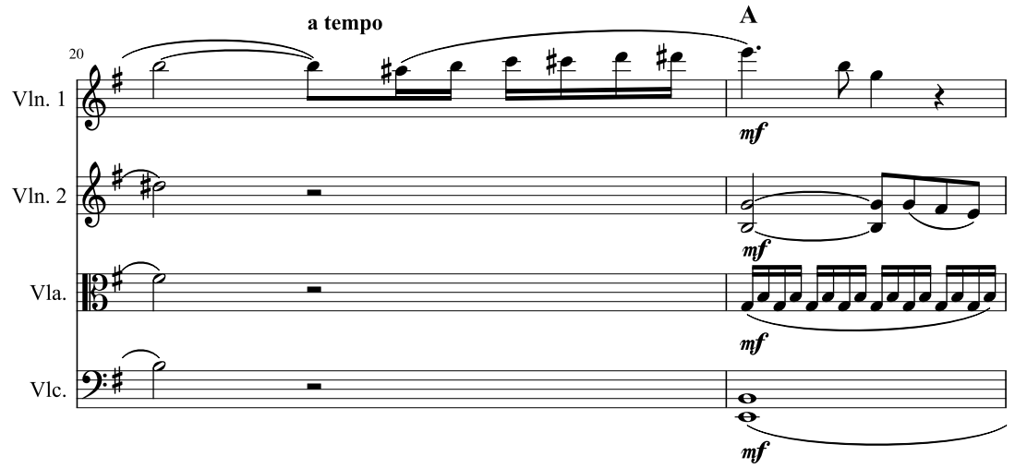
Part VI. Analysis 3: Emilie Mayer, Impromptu Op. 44, mm. 33–40.
- Recording: https://youtu.be/QhTTZjxWlO0 (@ 0:57)
- Below is a list of features. Circle any that appear in this excerpt.

Deceptive motion | Plagal motion immediately after a cadence | Phrygian HC
- Label all cadences in the excerpt.
- Provide a harmonic analysis in D major. The excerpt has changed keys.
  - The harmony in the box is one we haven't learned yet. You can ignore it for now.
- Part write the progression from the excerpt on the blank staff below the excerpt.
  - Begin on a I chord with a D in the soprano. This will connect to the excerpt better than starting on an A.
  - For m. 37, you can just show the chord on the downbeat as if it lasts a whole measure (so with a dotted half note).

