Performing harmonic analysis using the phrase model
- For each excerpt below:
  - Label the key
  - Label all cadences
  - Provide a harmonic analysis of the entire excerpt
  - Circle and label embellishing tones in the melody line
  - Identify how the phrase model operates in each excerpt using the labels Tb-PD-D-Te as discussed in the chapter

Excerpt 1: Francis Johnson, “Francis,” No. 9 from A New Collection of Cotillions, mm. 1-8
https://youtu.be/p4xipbOihI0?t=671

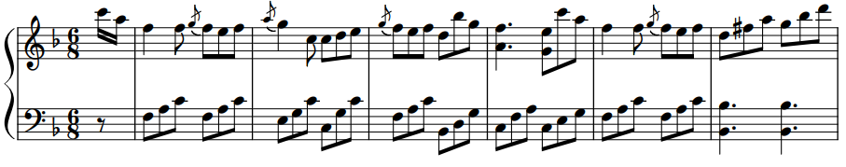

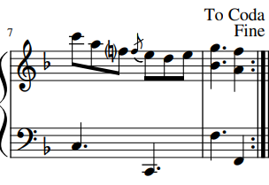

Excerpt 2: Maria Hester Park, A Waltz, mm. 9–17
https://open.spotify.com/track/2cDHzxtjU9wqDcJbIqOibN?si=2989fa69f403435c (begins @ 1:12)
Begin analyzing here

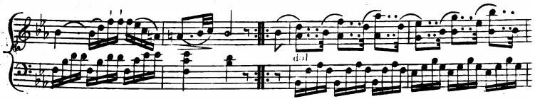

(continues on next page)
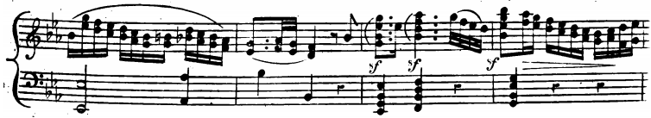

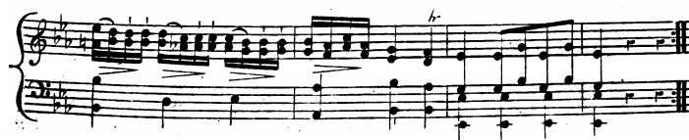

Excerpt 3: Wolfgang Amadeus Mozart, Das Kinderspeil¸K. 598, mm. 1–8
https://open.spotify.com/track/0dFkWS1SP4Rcdf8FQVp1xk?si=f1ef1341cb98493f

