Name: __________________________________

Half- and Whole-Steps on the Piano

- “Identifying Half- and Whole-Steps” Directions: The brackets indicate two different notes, which form either a half-step or a whole-step. Write “H” for half-step or “W” for whole-step in the blanks below the piano keyboards.

- __________
- __________

- __________

- __________

- __________

- __________

- __________

- __________

- __________

- __________

1 .__________
2. __________

3. __________

4. __________

5. __________

6. __________

7. __________

8. __________

9. __________

10. __________

2. “Writing Half- and Whole-steps on the Piano Keyboard” Directions: Write the numbers of the indicated notes on the piano keyboard. Number one has been done in each example.

- Write the numbers of the notes onto the piano keys which are a half-step up from the given note on the staff. Some keys may have more than one number.

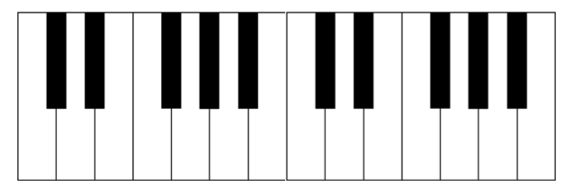

1

1. 2. 3. 4. 5. 6. 7. 8. 9. 10.

- Write the numbers of the notes onto the piano keys which are a half-step down from the
given note on the staff. Some keys may have more than one number.

1

1. 2. 3. 4. 5. 6. 7. 8. 9. 10.
- Write the numbers of the notes onto the white piano keys which are a whole-step up
from the given note on the staff. If the note falls on a black key, write the number on the
blank above that key. Some black keys will have more than one number and not every
blank will be used.

____ ____ ____ ____ ____ ____ ____ ____ ____ ____

____ ____ ____ ____ _1__ ____ ____ ____ ____ ____

1. 2. 3. 4. 5. 6. 7. 8. 9. 10.

- Write the numbers of the notes onto the white piano keys which are a whole-step down
from the given note on the staff. If the note falls on a black key, write the number on the
blank above that key. Some black keys will have more than one number and not every
blank will be used.

____ ____ ____ ____ ____ ____ ____ ____ ____

____ ____ _1__ ____ ____ ____ ____ ____ ____

1. 2. 3. 4. 5. 6. 7. 8. 9. 10.

