Name: __________________________________
Musical Texture
- Matching Definitions
Directions: Match each term to a definition.
- Multiple voices with separate melodic lines and rhythms

- A single, unaccompanied melodic line

- All voices moving together rhythmically

- Multiple voices harmonically moving together at the same pace

- Multiple simultaneous variations of a single melodic line

- Texture where the melodic and supporting voices are clearly distinguishable from each other, usually with different rhythms

1. Monophony: _______
2. Heterophony: _______
3. Homophony: _______
4. Homorhythm: _______
5. Melody and Accompaniment: _______
6. Polyphony: _______

- Score Examples

Directions: Listen, view, and match each score example to a texture provided. Each term will be used twice. Spotify playlist can be found in the “Assignments” section of the “Texture” chapter in Open Music Theory.

Word Bank: Monophony, Heterophony, Homophony, Polyphony
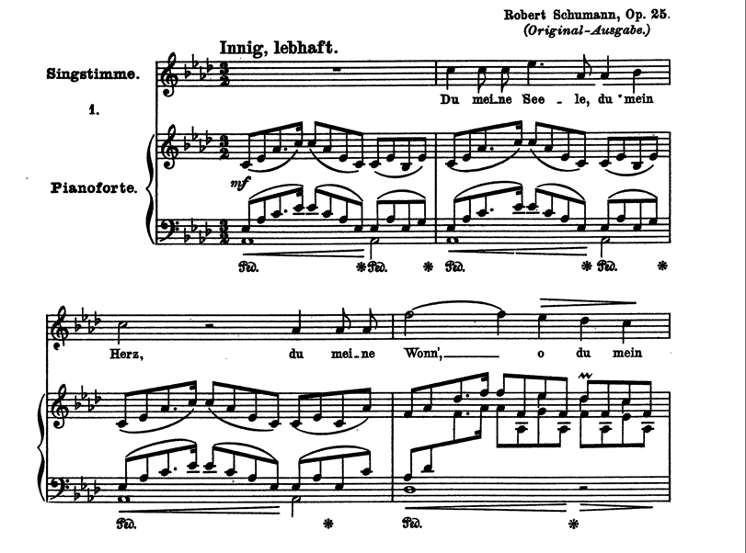
- The first 4 measures of Robert Schumann’s “Widmung” (1840). (OMT - WK Texture #1; 0:00–0:12)

_________________________________________
- Measures 211-214 of “Piano Concerto in C minor” (1786) K. 491, written by Wolfgang Amadeus Mozart. (OMT - WK Texture #2; 4:54–5:00)
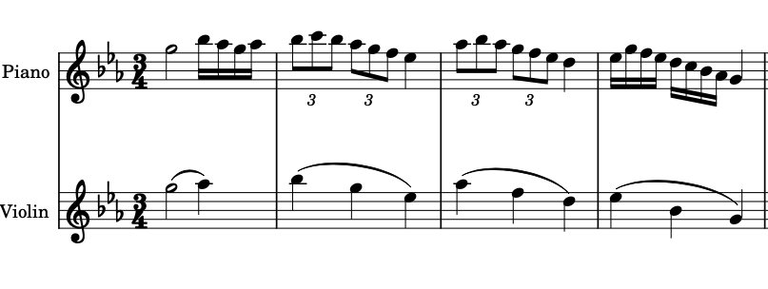
_________________________________________

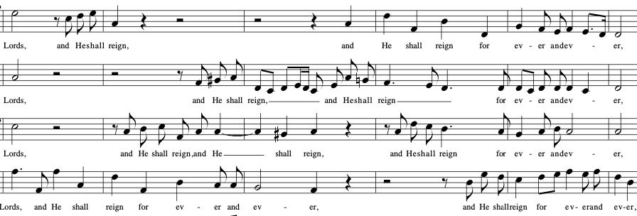
- Measures 69-74 of “Hallelujah Chorus” from George Frideric Handel’s Messiah (1741). (OMT - WK #3; 2:29–2:35)

_________________________________________
- Measures 116-122 of “Overture” to The Marriage of Figaro (1786), written by Wolfgang Amadeus Mozart. (OMT - WK #4; 1:38–1:45)
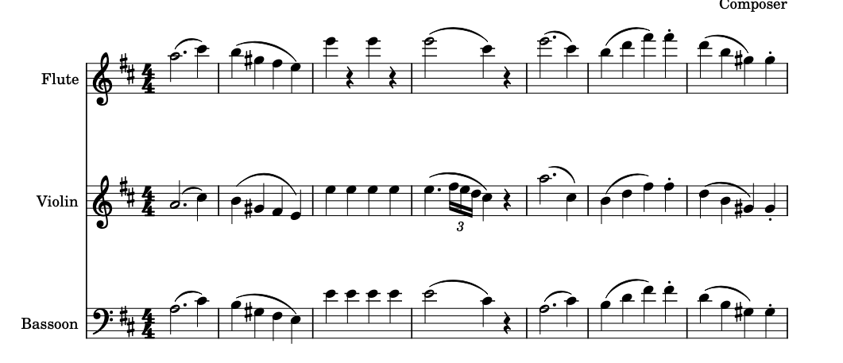

_________________________________________

- The first 12 measures of “3 Pieces for Solo Clarinet; Movement I” (1919), written by Igor Stravinsky. (OMT – WK #5; 0:00–0:32)
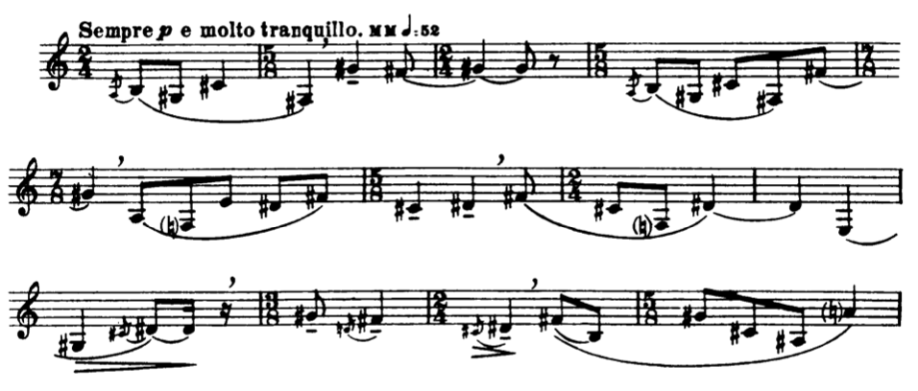

_________________________________________
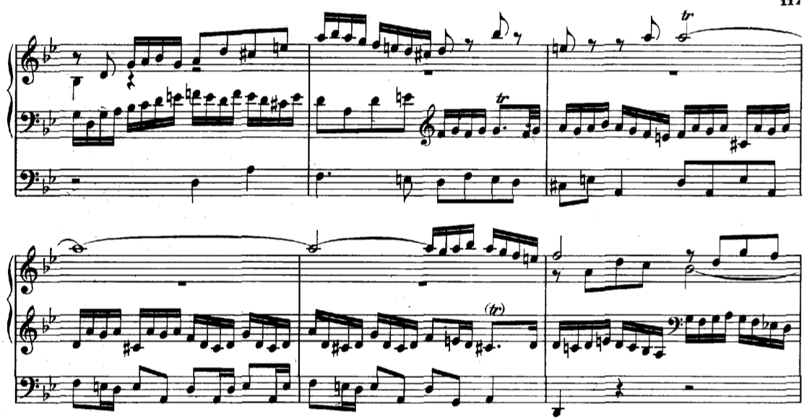
- Measures 17-23 of “Prelude and Fugue No. 1 in G Minor; Fugue” (1722) from The Well-Tempered Clavier, written by Johann Sebastian Bach. (OMT - WK #6; 0:51–1:06)
_________________________________________

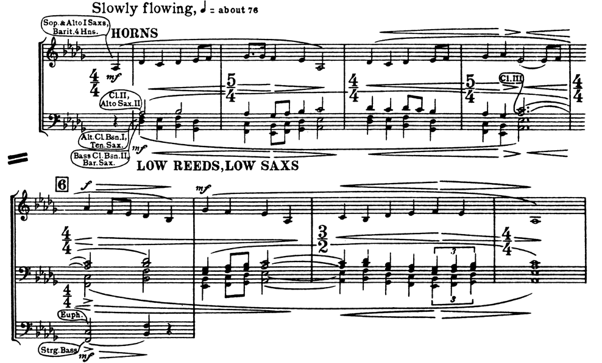
- Measures 1-9 of “Horkstow Grange” from Percy Grainger’s Lincolnshire Posy ( c. 1937). (OMT - WK #7; 0:00–0:45)
_________________________________________
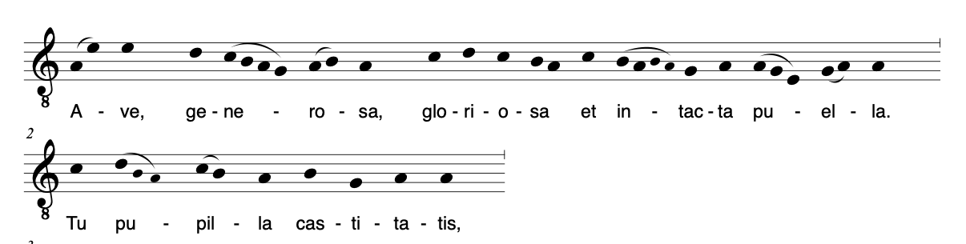
- The first two lines of “Ave Generosa” (c. 1150) written by Hildegard von Bingen. (OMT - WK # 8; 0:00–0:34)

_________________________________________

- Audio Examples

Directions: Listen to each example and label the type of texture. Each term will be used twice:

Word Bank: Monophony, Heterophony, Homophony, Polyphony

- _______________________________ (OMT - WK #9; 0:00–0:35)
- _______________________________ (OMT - WK #10; 1:28–1:53)
- _______________________________ (OMT - WK #11; 0:00–0:25)
- _______________________________ (OMT - WK #12; 0:07–0:35)
- _______________________________ (OMT - WK #13; 0:45–1:26)
- _______________________________ (OMT - WK #14; 0:00–0:35)
- _______________________________ (OMT - WK #15; 0:00–0:15)
- _______________________________ (OMT - WK #16; 0:00–0:45)

