The Phrase, Archetypes, and Unique Forms – Analyzing Sentences

Name: _______________________________________________

Part 1: Writing embellishing tones in a two-voice texture
- Several bass lines are given below.
- Add three notes on the treble staff to create at least one example of each of the following embellishing tones:
- Passing tone  - Neighbor tone  - Appoggiatura | - Escape tone  - Suspension  - Retardation
- Remember: your embellishing tone should be the middle note of the three notes, and the outer two notes must be consonant with the base.
- Circle the embellishing tone and label it appropriately (please circle only the embellishing tone, not all three notes).

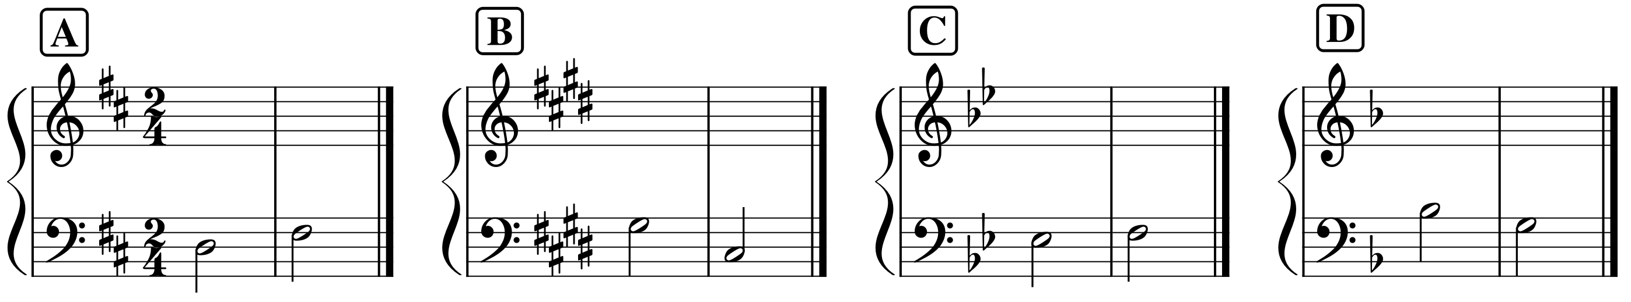

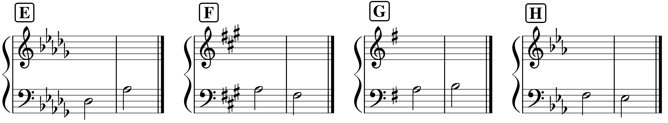

Embellishing Tones

Name: _______________________________________________

Part 2: Analysis: Francis Johnson, “William,” No. 5 from A New Collection of Cotillions, mm. 1–16
- Listen to the excerpt several times: https://youtu.be/p4xipbOihI0?t=312
- Several embellishing tones have been circled in the passage below. Label them by type.

