Introduction to Harmony, Cadences, and Phrase Endings

Name: _______________________________________________

Part 1: Cadences in major
- For each excerpt below:
  - Identify the major key below the key signature
  - Write the requested cadence in four voices using only I and V chords

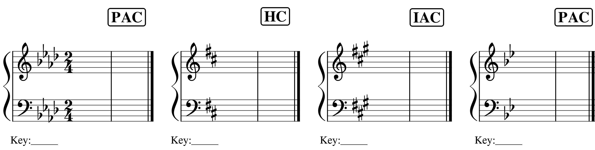

Part 2: Cadences in minor.
- For each excerpt below:
  - Identify the minor key below the key signature
  - Write the requested cadence in four voices using only i and V chords

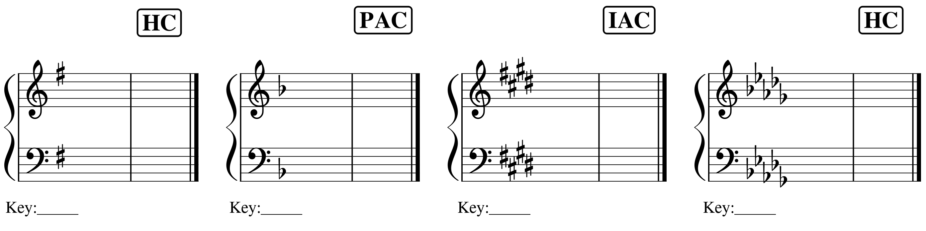

Introduction to Harmony, Cadences, and Phrase Endings

Name: _______________________________________________

Part 3: Analyzing cadences.
- Identify all cadences in each excerpt below by labeling the cadence directly above the final chord of the cadence.

Excerpt #1: Francis Johnson, “Ford,” No. 7 from A New Collection of Cotillions, mm. 1–8.
  - https://youtu.be/p4xipbOihI0?t=484

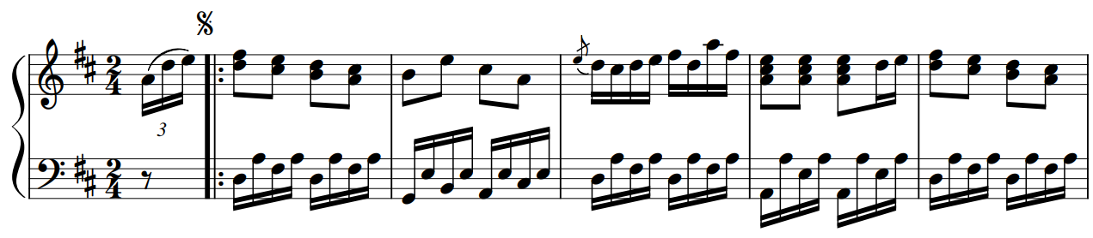

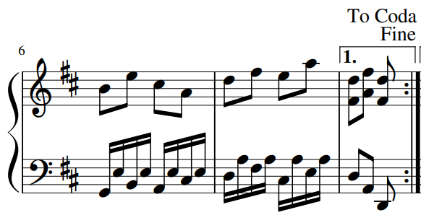

Introduction to Harmony, Cadences, and Phrase Endings

Name: _______________________________________________

Excerpt #2: Francis Johnson, “Ford,” No. 7 from A New Collection of Cotillions, mm. 18–26.
  - https://youtu.be/p4xipbOihI0?t=541

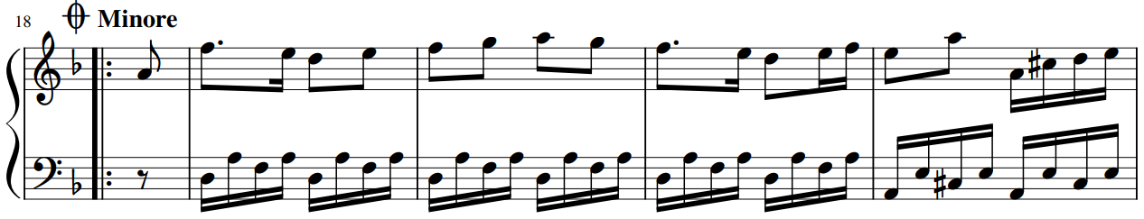

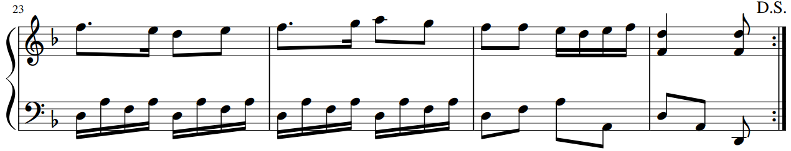

Introduction to Harmony, Cadences, and Phrase Endings

Name: _______________________________________________

Excerpt #3: Francis Johnson, “Augustus,” No. 3 from A New Collection of Cotillions
  - https://youtu.be/p4xipbOihI0?t=180
