Predominant Sevenths

Name: _______________________________________________

Part 1: Unfigured bass
- Provide a Roman numeral analysis that appropriately harmonizes the given bass line
- Add a contextual analysis below your Roman numerals
- Realize your analysis in either keyboard or vocal style (your choice)
- Label the type of cadence you wrote appropriately

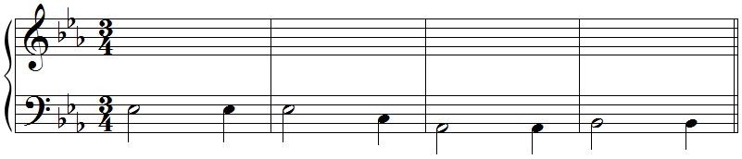
E:

Part 2: Figured bass
- Label the key
- Analyze the given figures appropriately
- Add a contextual analysis below your Roman numerals
- Realize your analysis in four-part keyboard style

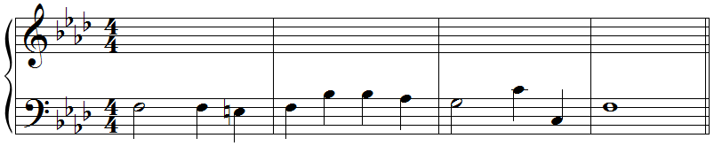
6 7

Predominant Sevenths

Name: _______________________________________________

Part 3: Analysis: Chopin, Waltz Op. 69, No. 2 (mm. 9–16) (on next page)
- Listen to the following excerpt several times
  - Recording available on Canvas in the same place you found the link to this assignment.
- Label the key
- Label any cadences
- Provide a Roman numeral analysis of mm. 9–16 only
- Add a contextual analysis below your Roman numerals
- Diagram the form of the excerpt in the blank space underneath the first system

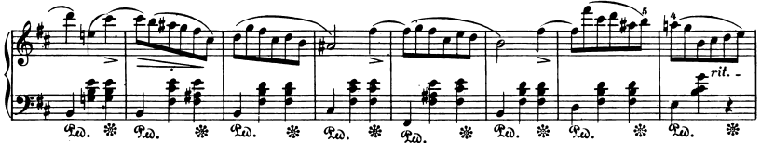
9 10 11 12 13

15 16
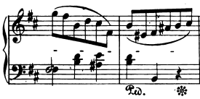

Part 4: Analysis: Farrenc, Cello Sonata, II, mm. 1–8. (on next page)
- Listen to the following excerpt several times: https://www.youtube.com/watch?v=lOqdl1sdE0k
- Label the key
- Label any cadences
- Provide a Roman numeral analysis of the excerpt
- Add a contextual analysis below your Roman numerals
- Diagram the form of the excerpt in the blank space below.

Predominant Sevenths

Name: _______________________________________________

