Strengthening Endings with Cadential

Name: _______________________________________________

Part 1: Writing
- Several bass lines appear below. For any bass line that represents an ending pattern: (1) label the key, (2) provide a harmonic analysis, and (3) realize your progression in four parts.
- For any bass line that isn’t an ending pattern, leave the score blank.
- You must use IV, ii⁶, cadential , and V⁷ at least once below.
- Label the type of cadence you've written appropriately.

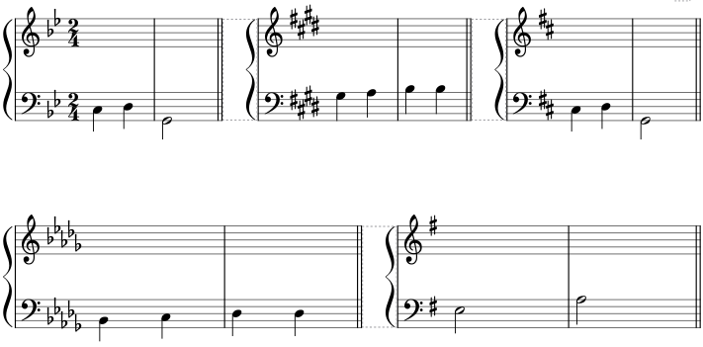

Part 2: Analysis: Emilie Mayer, “Abendglocken,” No. 1 from 2 Gesange, mm. 13–21. (see below for recording)
- Label the key
- Identify all cadences
- Provide a harmonic analysis of the ending pattern
- Circle and label any embellishing tones in the vocal part that occur over the ending pattern you’ve analyzed.
- On the blank staff below, part-write the ending pattern you identified in four parts to show the idealized underlying voice-leading. Make sure you begin with the same bass and soprano notes as in the excerpt.

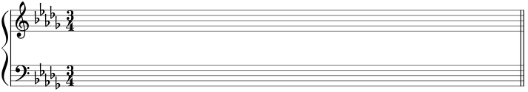

- This work has not been recorded, so we’ll have to make due with a midi version. That can be found in the MuseScore file in the same place you found this assignment.

