Strengthening Endings with Strong Predominants

Name: _______________________________________________

Part 1: Writing from Roman numerals
- Given a key and Roman numerals, realize the following progressions in four parts.
  - Don’t forget to raise the leading tone in minor!
- Identify the type of cadence you have written in each excerpt.

Excerpt 1:  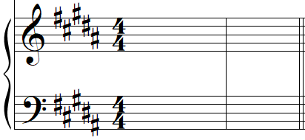  B: ii⁶ V I | Excerpt 2:  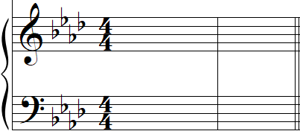  f: iv V i
Excerpt 3:

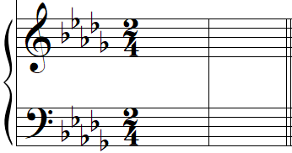

Db: IV V

Strengthening Endings with Strong Predominants

Name: _______________________________________________
Part 2: Writing from figures.
- For each of the following ending patterns, please do the following:
  - Identify the key
  - Analyze the given figures with Roman numerals
  - Realize the progression in four parts
  - Label the type of cadence you wrote appropriately

Excerpt 1:  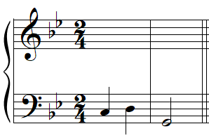  ⁶  _____:  (key) | Excerpt 2:  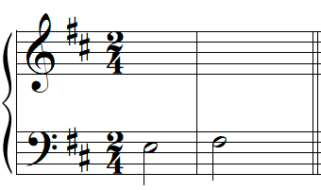  #  _____:  (key)
Excerpt 3:
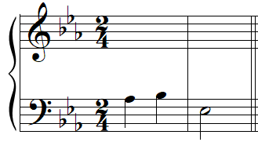
7

_____:
(key)

Strengthening Endings with Strong Predominants

Name: _______________________________________________

Part 3: Analysis
- For each excerpt below:
  - Label the key below the key signature
  - Identify all cadences in the excerpt
  - Provide a harmonic analysis of the cadential ending by:
    - Looking to see if the bass line follows the pattern F-S-D (--) as discussed in the chapter, then
    - Analyzing those bass notes with Roman numerals appropriately

Excerpt 1: Francis Johnson, “Maria Caroline,” No. 2 from A Collection of New Cotillions, mm. 1–8
https://youtu.be/p4xipbOihI0?t=121

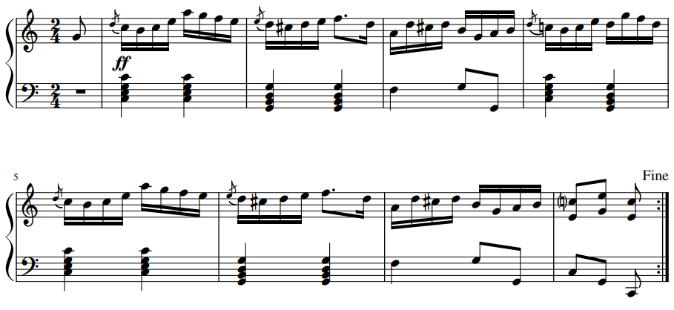

Strengthening Endings with Strong Predominants

Name: _______________________________________________

Excerpt 2: Francis Johnson, “William,” No. 5 from A Collection of New Cotillions, mm. 17–24
https://youtu.be/p4xipbOihI0?t=368

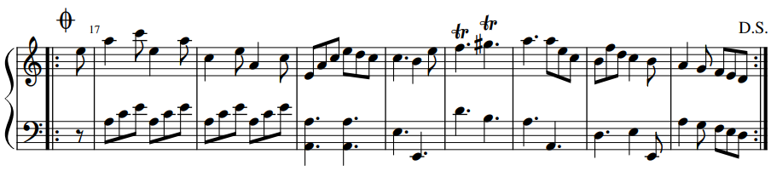

Excerpt 3: Miranda, “You’ll Be Back” from Hamilton (on next page)
- Note: this excerpt is more advanced
- Listen to this excerpt several times: https://open.spotify.com/track/6OG1S805gIrH5nAQbEOPY3?si=398be69f734f48f7
- In a written response or a recorded video response, please answer the following:
  - You’ll surely notice a repeated accompanimental pattern in this excerpt (e.g. mm. 1–4 are repeated in 5–8). This repetition may obscure the sense of ending: is there a cadence on beat 3 of m. 4, or is the cadence on beat 1 of m. 5? Or do you hear something different entirely?
  - The bass line’s ending pattern is slightly different than what we’ve seen, and yet the pattern is clearly related to the F-S(-D) we expect. Explain what pitch replaces FA in the bass during the ending pattern, and explain how that replacement pitch makes sense given the chord(s) we might have expected to harmonize FA if it were there.
  - If you aren’t familiar with the plot of Hamilton, you can find a reliably quick synopsis on Wikipedia. “You’ll Be Back” is sung by the character King George III, and the style of the song is remarkably different from the numbers sung by all the other cast members. Why did Lin-Manuel Miranda (the composer) choose such a different style for King George’s character? How might the choice of style reflect the character, the plot, or other elements of the musical?

