Spotify playlist
(link on textbook
website)

The Phrase, Archetypes, and Unique Forms – Analyzing Sentences

Name: _______________________________________________

Note: All score excerpts are found in an Excerpt Bank at the end of this worksheet.

PART 1: Sentences on a Continuum
- First, review the traits of the archetypal sentence, part way down on this page: https://viva.pressbooks.pub/openmusictheory/chapter/phrase-archetypes-unique-forms/
- Listen to each of the excerpts, while following along with the scores in the Excerpt Bank.
- Fill out the chart below by rating each excerpt on a scale from 1–3:
- 1 = the excerpt is identical or nearly identical to the archetypal sentence
- 2 = the excerpt is a sentence, but it’s not an archetypal sentence
- 3 = the excerpt is not a sentence

# | Excerpt | Rating
1 | Joseph Bologne, String Quartet No. 4, II, mm. 1–8
2 | Joseph Haydn, Horn Concerto in DM, I, mm. 16–26 (0:28–0:46)
3 | Marianna Martines, Piano Sonata in A, III, mm. 1–9
4 | Giacomo Puccini, “O mio babbino caro,” mm. 1–8 (begins at 0:22)
5 | Wolfgang Amadeus Mozart, “Dies irae” from Requiem, mm. 1–8
6 | Maria Szymanowska, Polonaise in Fm, mm. 1–6

The Phrase, Archetypes, and Unique Forms – Analyzing Sentences

Name: _______________________________________________

PART 2: Explanation
- Select one of the excerpts you rated as a “1” above. In the space below, describe how this excerpt is like the archetypal sentence by listing all of the features of a sentence that are present. Be sure to use all appropriate terminology in your description.

____________________________________________________________________________________

____________________________________________________________________________________

____________________________________________________________________________________

____________________________________________________________________________________

- Select one of the excerpts you rated as a “2” above. In the space below, describe the features that are like the archetypal sentence, as well as those that make it not an archetype.

____________________________________________________________________________________

____________________________________________________________________________________

____________________________________________________________________________________

____________________________________________________________________________________

- Select one of the excerpts you rated as a “3” above. In the space below, describe the features that convince you it’s not a sentence.

____________________________________________________________________________________

____________________________________________________________________________________

____________________________________________________________________________________

____________________________________________________________________________________

The Phrase, Archetypes, and Unique Forms - Analyzing Sentences

Name: _______________________________________________

PART 3: Formal Analysis
In the spaces below, draw form diagrams for each of the requested excerpts.
- Model your diagram on those found in the textbook.
- Be sure to show the idea level and above.
- For any excerpt you rated as “1” or “2” above, be sure to label all segments appropriately.
- For any excerpt you rated as “3” above, you do not need to label the segments of your diagram.

Diagram Excerpt 1: Joseph Bologne, String Quartet No. 4, II, mm. 1–8

Diagram Excerpt 3: Marianna Martines, Piano Sonata in A, III, mm. 1–9

Diagram Excerpt 6: Maria Szymanowska, Polonaise in Fm, mm. 1–6

The Phrase, Archetypes, and Unique Forms - Analyzing Sentences

Name: _______________________________________________

PART 4: Harmonic Analysis
Directly on the score(s) in the Excerpt Bank below, provide a harmonic analysis for one excerpt of your choosing, or for any excerpt(s) your teacher requests.

Excerpt Bank

Excerpt #1: Joseph Bologne (Chevalier de Saint-Georges), String Quartet No. 4, II (Quatuor No. 4 do mineur: Rondeau), mm. 1–8

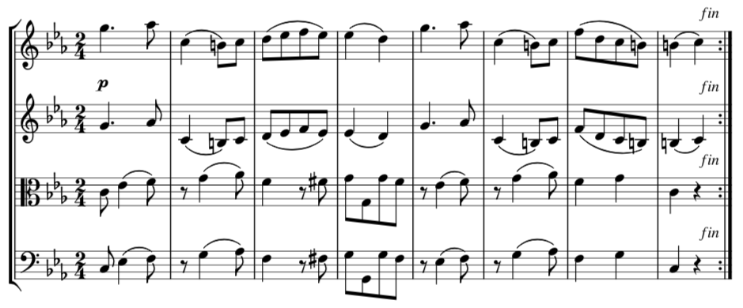

The Phrase, Archetypes, and Unique Forms - Analyzing Sentences

Name: _______________________________________________

Excerpt #2: Joseph Haydn, Horn Concerto in DM, I, mm. 16–26 (0:28–0:46)

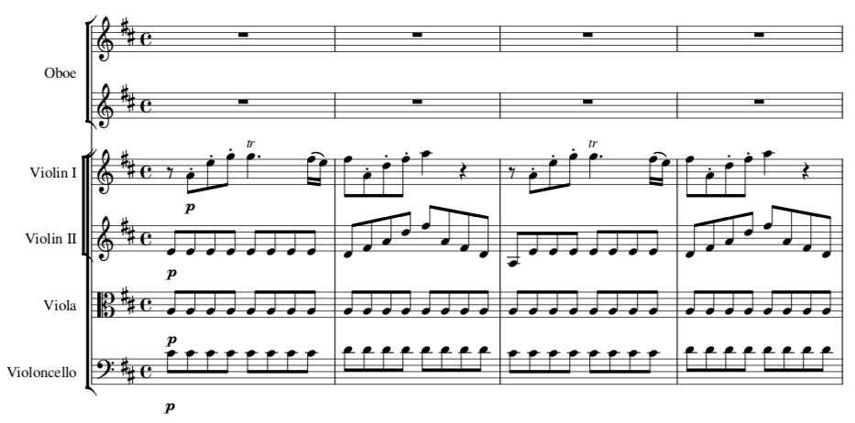

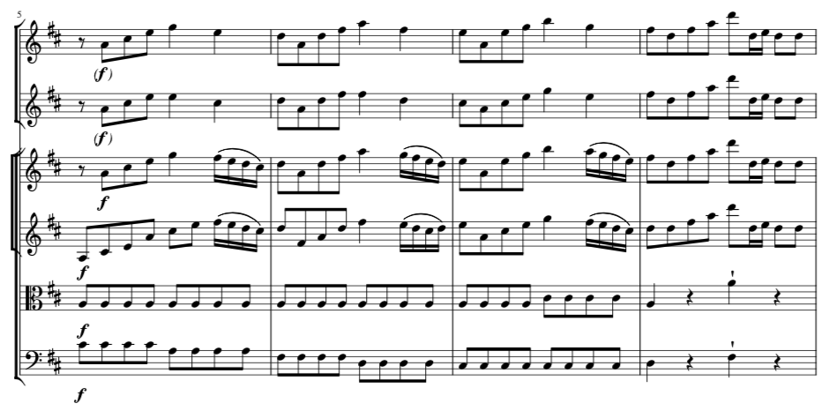

The Phrase, Archetypes, and Unique Forms - Analyzing Sentences

Name: _______________________________________________

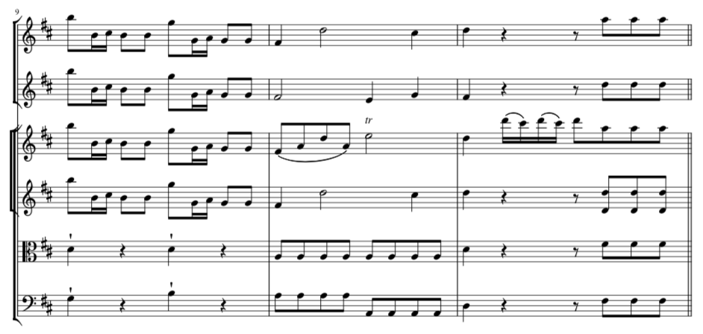

Excerpt #3: Marianna Martines, Piano Sonata in A, III, mm. 1–9

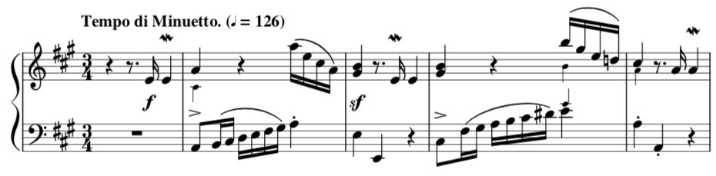

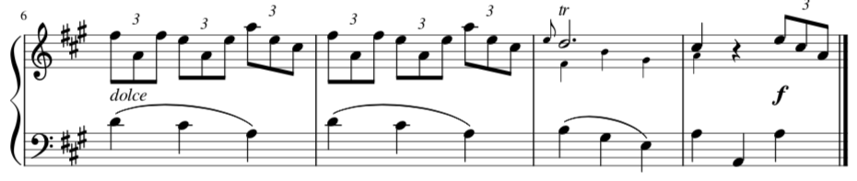

The Phrase, Archetypes, and Unique Forms - Analyzing Sentences

Name: _______________________________________________

Excerpt #4: Giacomo Puccini, “O mio babbino caro,” mm. 1–8 (excerpt begins at 0:22, after an instrumental introduction)

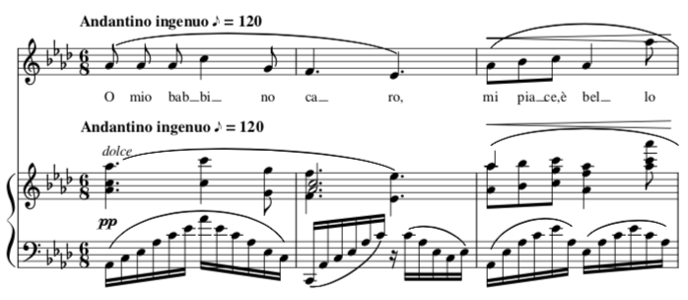

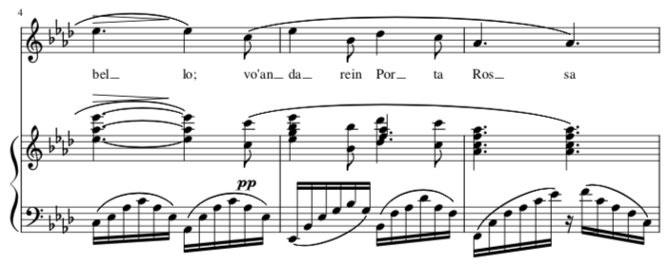

The Phrase, Archetypes, and Unique Forms - Analyzing Sentences

Name: _______________________________________________

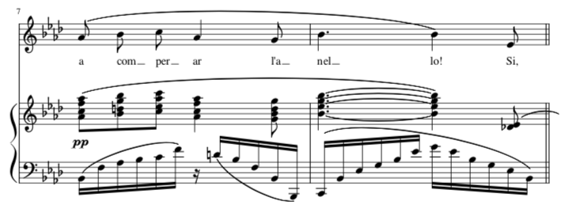

Excerpt #5: Wolfgang Amadeus Mozart, “Dies irae” from Requiem, mm. 1–8

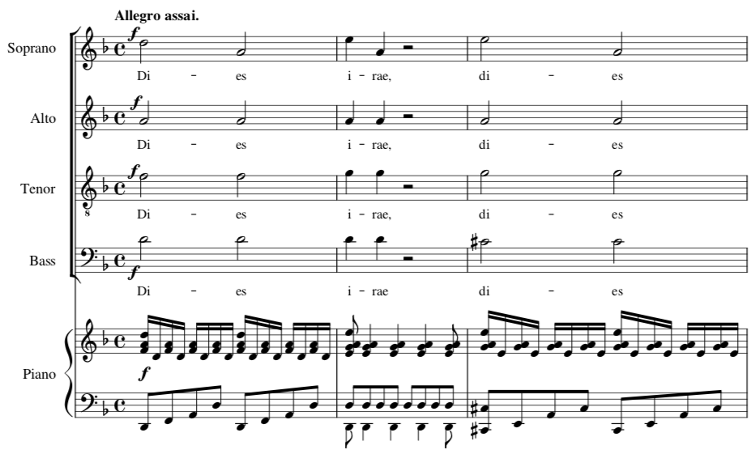

The Phrase, Archetypes, and Unique Forms - Analyzing Sentences

Name: _______________________________________________

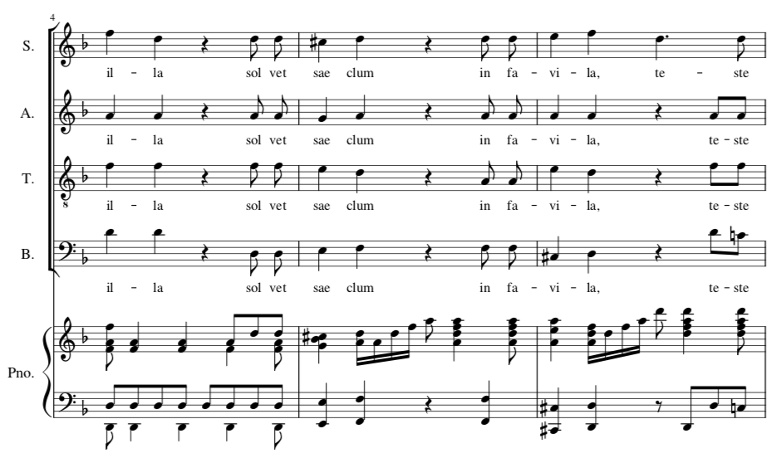

The Phrase, Archetypes, and Unique Forms - Analyzing Sentences

Name: _______________________________________________

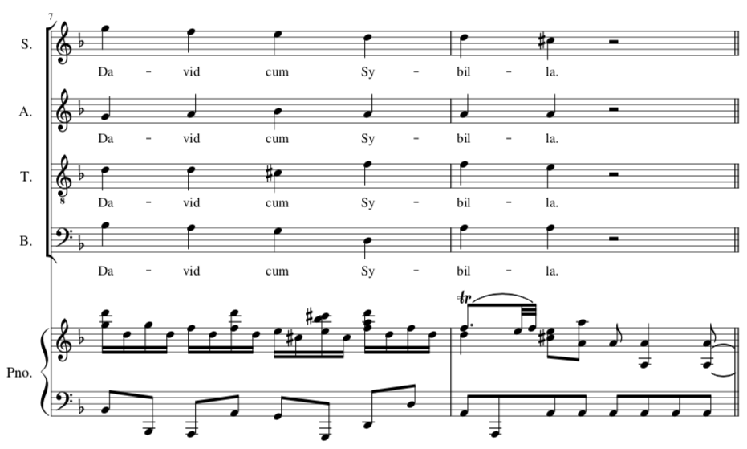

The Phrase, Archetypes, and Unique Forms - Analyzing Sentences

Name: _______________________________________________

Excerpt #6: Maria Szymanowska, Polonaise in Fm, mm. 1–6

