Name: _________________________________________________________

PART 1: Calculating IC Vectors for Pitch Class Sets
- For each pitch class set given in normal order below, provide the interval class vector.

 | Pitch class set (normal order) | Interval Class Vector
1. | [3, 4, 7, 9]
2. | [0, 2, 6, 8]
3. | [4, 5, 7, 8, 10]
4. | [6, 8, 9, 10, 0, 1]

PART 2: Calculating IC Vectors for Unordered PC Sets
Each collection below is an unordered pitch class set.
- First, put each set in normal order.
- Then, provide the interval class vector for each.

Unordered Set |  | Normal order | Interval Class Vector
1. | 5 1 6 8
2. | e 0 5 4 2
3. | t 6 7 5
4. | 0 6 5 7 4 8

Continued on next page

PART 3: Providing IC Vectors for Notated Unordered PC Sets
Each notated collection below is an unordered pitch class set.
- First, give the normal order of each set.
- Then, provide the interval class vector for each set.

Unordered Set |  | Normal order | Interval Class Vector
1. | 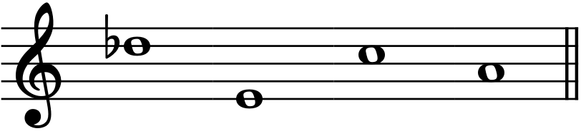
2. | 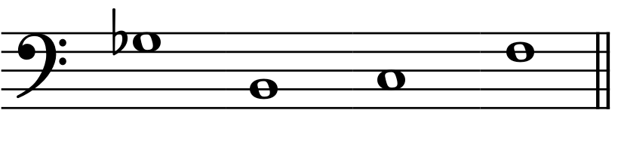
3. | 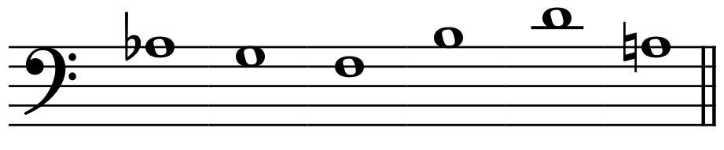
4. | 