PART 1: Identifying Black Keys on the Piano Keyboard
Directions: Write letter names in the blanks above the black keys of the pianos. Notice that the pattern of black keys changes between examples.

- Use sharps:

____ ____ ____ ____ ____ ____ ____ ____ ____ ____
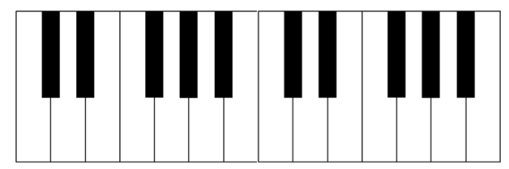

- Use flats:

____ ____ ____ ____ ____ ____ ____ ____ ____ ____ ____ ____ ____

- Use sharps and flats:

____ ____ ____ ____ ____ ____ ____ ____ ____ ____ ____ ____

____ ____ ____ ____ ____ ____ ____ ____ ____ ____ ____ ____

PART 2: The Grand Staff and the Black Keys on the Piano Keyboard
Directions: Write the number of the notes found on the grand staves onto the blanks above the black keys of the piano keyboards. Some keys will have more than one number and not every blank will be used. Number one has been done in each example.

- Treble Clef

____ ____ ____ ____ ____ ____ ____ ____ ____ ____

____ ____ ____ _1__ ____ ____ ____ ____ ____ ____

1. 2. 3. 4. 5. 6. 7. 8. 9. 10.

- Bass Clef

____ ____ ____ ____ ____ ____ ____ ____

____ ____ _1__ ____ ____ ____ ____ ____

1. 2. 3. 4. 5. 6. 7. 8. 9. 10.

- With Ledger Lines

____ ____ ____ ____ ____ ____ ____ ____

____ ____ ____ ____ ____ ____ ____ ____

____ ____ _1__ ____ ____ ____ ____ ____

1. 2. 3. 4. 5. 6. 7. 8. 9. 10.

