PART 1: White Keys on the Piano Keyboard
Directions: Write letter names on the white keys of the piano keyboards. Notice that the pattern of black keys changes between examples.

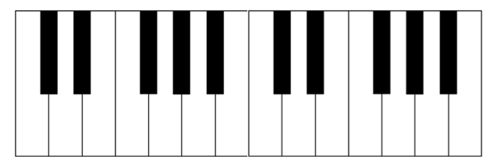

PART 2: The Grand Staff and the Piano Keyboard
Directions: Write the numbers of the notes found on the grand staves onto the white keys of the piano keyboards. Number one has been done in each example.

A.

1

- 2. 3. 4. 5. 6. 7. 8. 9. 10.

B.

1

1. 2. 3. 4. 5. 6. 7. 8. 9. 10.

