# PART 1: Drawing Noteheads

Writing Noteheads, Clefs, and Ledger Lines

Treble and Bass Clef Only

**Name: _______________________________________________**

1. Draw five open (white) note heads, one on each line.  
     
   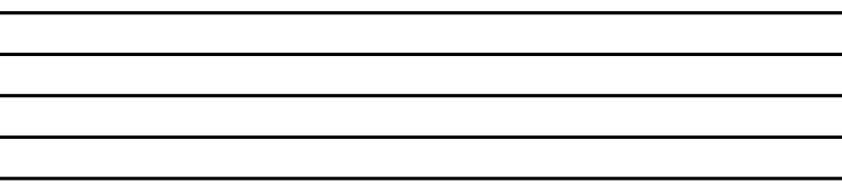
2. Draw four open (white) note heads, one on each space.  
     
   
3. Draw five filled in (black) note heads, one on each line.  
     
   
4. Draw four filled in (black) note heads, one on each space.  
     
   

# PART 2: Drawing Clefs

1. Draw six treble clefs.   
     
   
2. Draw six bass clefs.   
     
   

# PART 3: Drawing Stacked Ledger Lines

Draw stacks of ledger lines above/below the staff, as indicated.

1. **Above** the staff, draw stacksof ledger lines:

|  |  |  |  |
| --- | --- | --- | --- |
| one ledger line | two ledger lines | three ledger lines | four ledger lines |
|  |  |  |  |

1. **Below** the staff, draw stacksof ledger lines:

|  |  |  |  |
| --- | --- | --- | --- |
| one ledger line | two ledger lines | three ledger lines | four ledger lines |
|  |  |  |  |

# PART 4: Drawing Ledger Lines with Noteheads

Draw the indicated number of stacked ledger lines above and below the staves. This time, include filled in noteheads on the highest and lowest ledger line.

1. **Above** the staff, draw stacksof ledger lines with a **filled notehead on** the highest line:

|  |  |  |  |
| --- | --- | --- | --- |
| one ledger line | two ledger lines | three ledger lines | four ledger lines |
|  |  |  |  |

1. **Below** the staff, draw stacksof ledger lines with a **filled notehead on** the lowest line:

|  |  |  |  |
| --- | --- | --- | --- |
| one ledger line | two ledger lines | three ledger lines | four ledger lines |
|  |  |  |  |

1. **Above** the staff, draw stacksof ledger lines with a **filled notehead above** the highest line:

|  |  |  |  |
| --- | --- | --- | --- |
| one ledger line | two ledger lines | three ledger lines | four ledger lines |
|  |  |  |  |

1. **Below** the staff, draw stacksof ledger lines with a **filled notehead below** the lowest line:

|  |  |  |  |
| --- | --- | --- | --- |
| one ledger line | two ledger lines | three ledger lines | four ledger lines |
|  |  |  |  |