Write a composition in a bebop style. Comparable tunes are “Salt Peanuts” (Gillespie/Clark) and “Passport” (Parker). Record yourself performing your blues melody (sung or on an

Bebop Composition  
Audio option

**Name: _______________________________________________**

instrument), and include a harmonic accompaniment (e.g., piano or guitar).

### Audio

1. **Form:** Your piece will be in 32-bar AABA form: an A section of 8 bars (repeated), an 8-bar B section, followed by a repeat of the initial A section.
2. **Motive and rhythm**
   * **Option a:** Choose one of the four rhythmic motives (see Page 2) to develop in your melody. Almost all of your melody should be variations on this rhythm, though you may compose a new rhythm at the cadence.
   * **Option b:** If you choose not to use one of these motives, take care that your tune is still motive-driven and uses characteristic [swing rhythms](https://viva.pressbooks.pub/openmusictheory/chapter/swing-rhythms/).
3. **Harmony**
   1. The initial A sections follow the template given in the [Composing with ii–V–I worksheet](http://www.apple.com).
   2. For the B section, use a cycle of [secondary dominants](https://viva.pressbooks.pub/openmusictheory/chapter/tonicization/): $V^{7}/vi-V^{7}/ii-V^{7}/V-V^{7}$. (This is called a “Sears Roebuck bridge.”) That’s four harmonies, so each chord will last two measures.
   3. After you’ve composed your basic harmonies, incorporate the following embellishments and substitutions:
      1. one [CTo7](https://viva.pressbooks.pub/openmusictheory/chapter/jazz-embellishing-chords/%23common-tone) in the A section, embellishing a tonic chord
      2. one [mixture chord](https://viva.pressbooks.pub/openmusictheory/chapter/substitutions/%23mode-mixture) in the A section, replacing a ii chord
      3. two [tritone substitutions](https://viva.pressbooks.pub/openmusictheory/chapter/substitutions/%23tritone-substitutions) in the B section, replacing every other chord in the B section
4. **Accompaniment:** To demonstrate fluency in chord symbols and [voicings](https://viva.pressbooks.pub/openmusictheory/chapter/jazz-voicings/), provide a basic harmonic accompaniment. **Follow the [three upper voices paradigm](https://viva.pressbooks.pub/openmusictheory/chapter/jazz-voicings/#three-upper-voices) given in the Jazz Voicings chapter** to create smooth voice leading with appropriate chord extensions.

### Chord sheet

To evaluate your understanding of chord symbols, accompany your audio file with a chord sheet that maps out harmonies in chord symbols. Show the placement of the chords using bar lines.

**Rhythmic motives**

Choose one of the four two-bar rhythmic motives below to use as the basis for your composition. If you choose not to use one of these motives, you must still ensure that your piece is rhythmically unified!

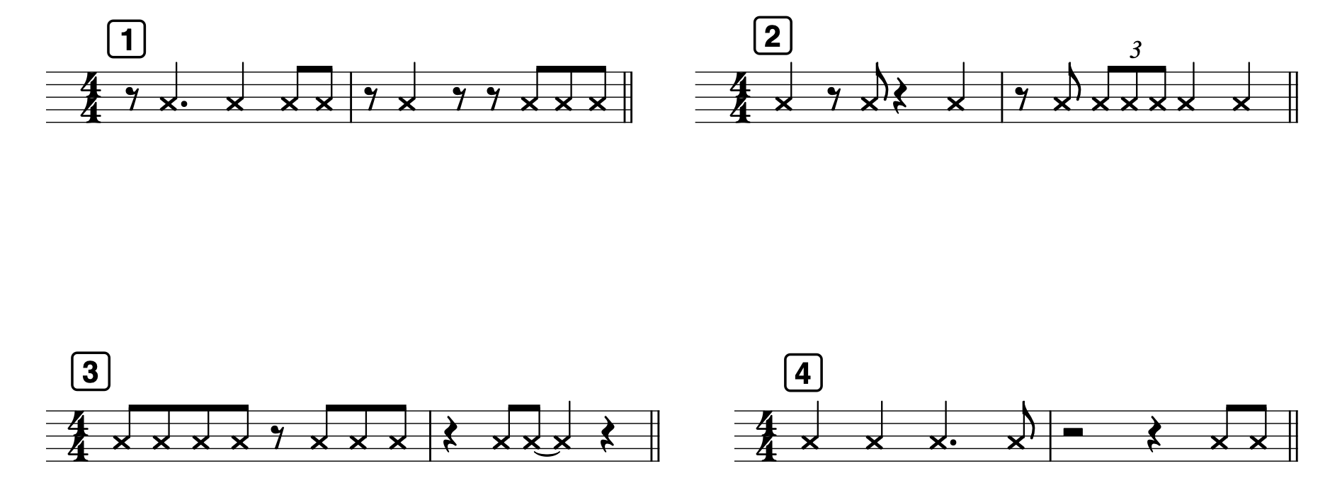

# Submission

Your complete submission will include two files:

* An .mp3 or .wav file
* A .pdf of your chord sheet

# Grading

You will be evaluated on:

* Motive and rhythm
* Harmonic progressions
* Chord embellishments and substitutions
* Voicing
* Chord symbols