PART 1: Graphic Score
Examine the score of “Museik No. 2” by Henrik Colding-Jørgensen, below. This score has no instructions. Next, answer the questions in part 2.

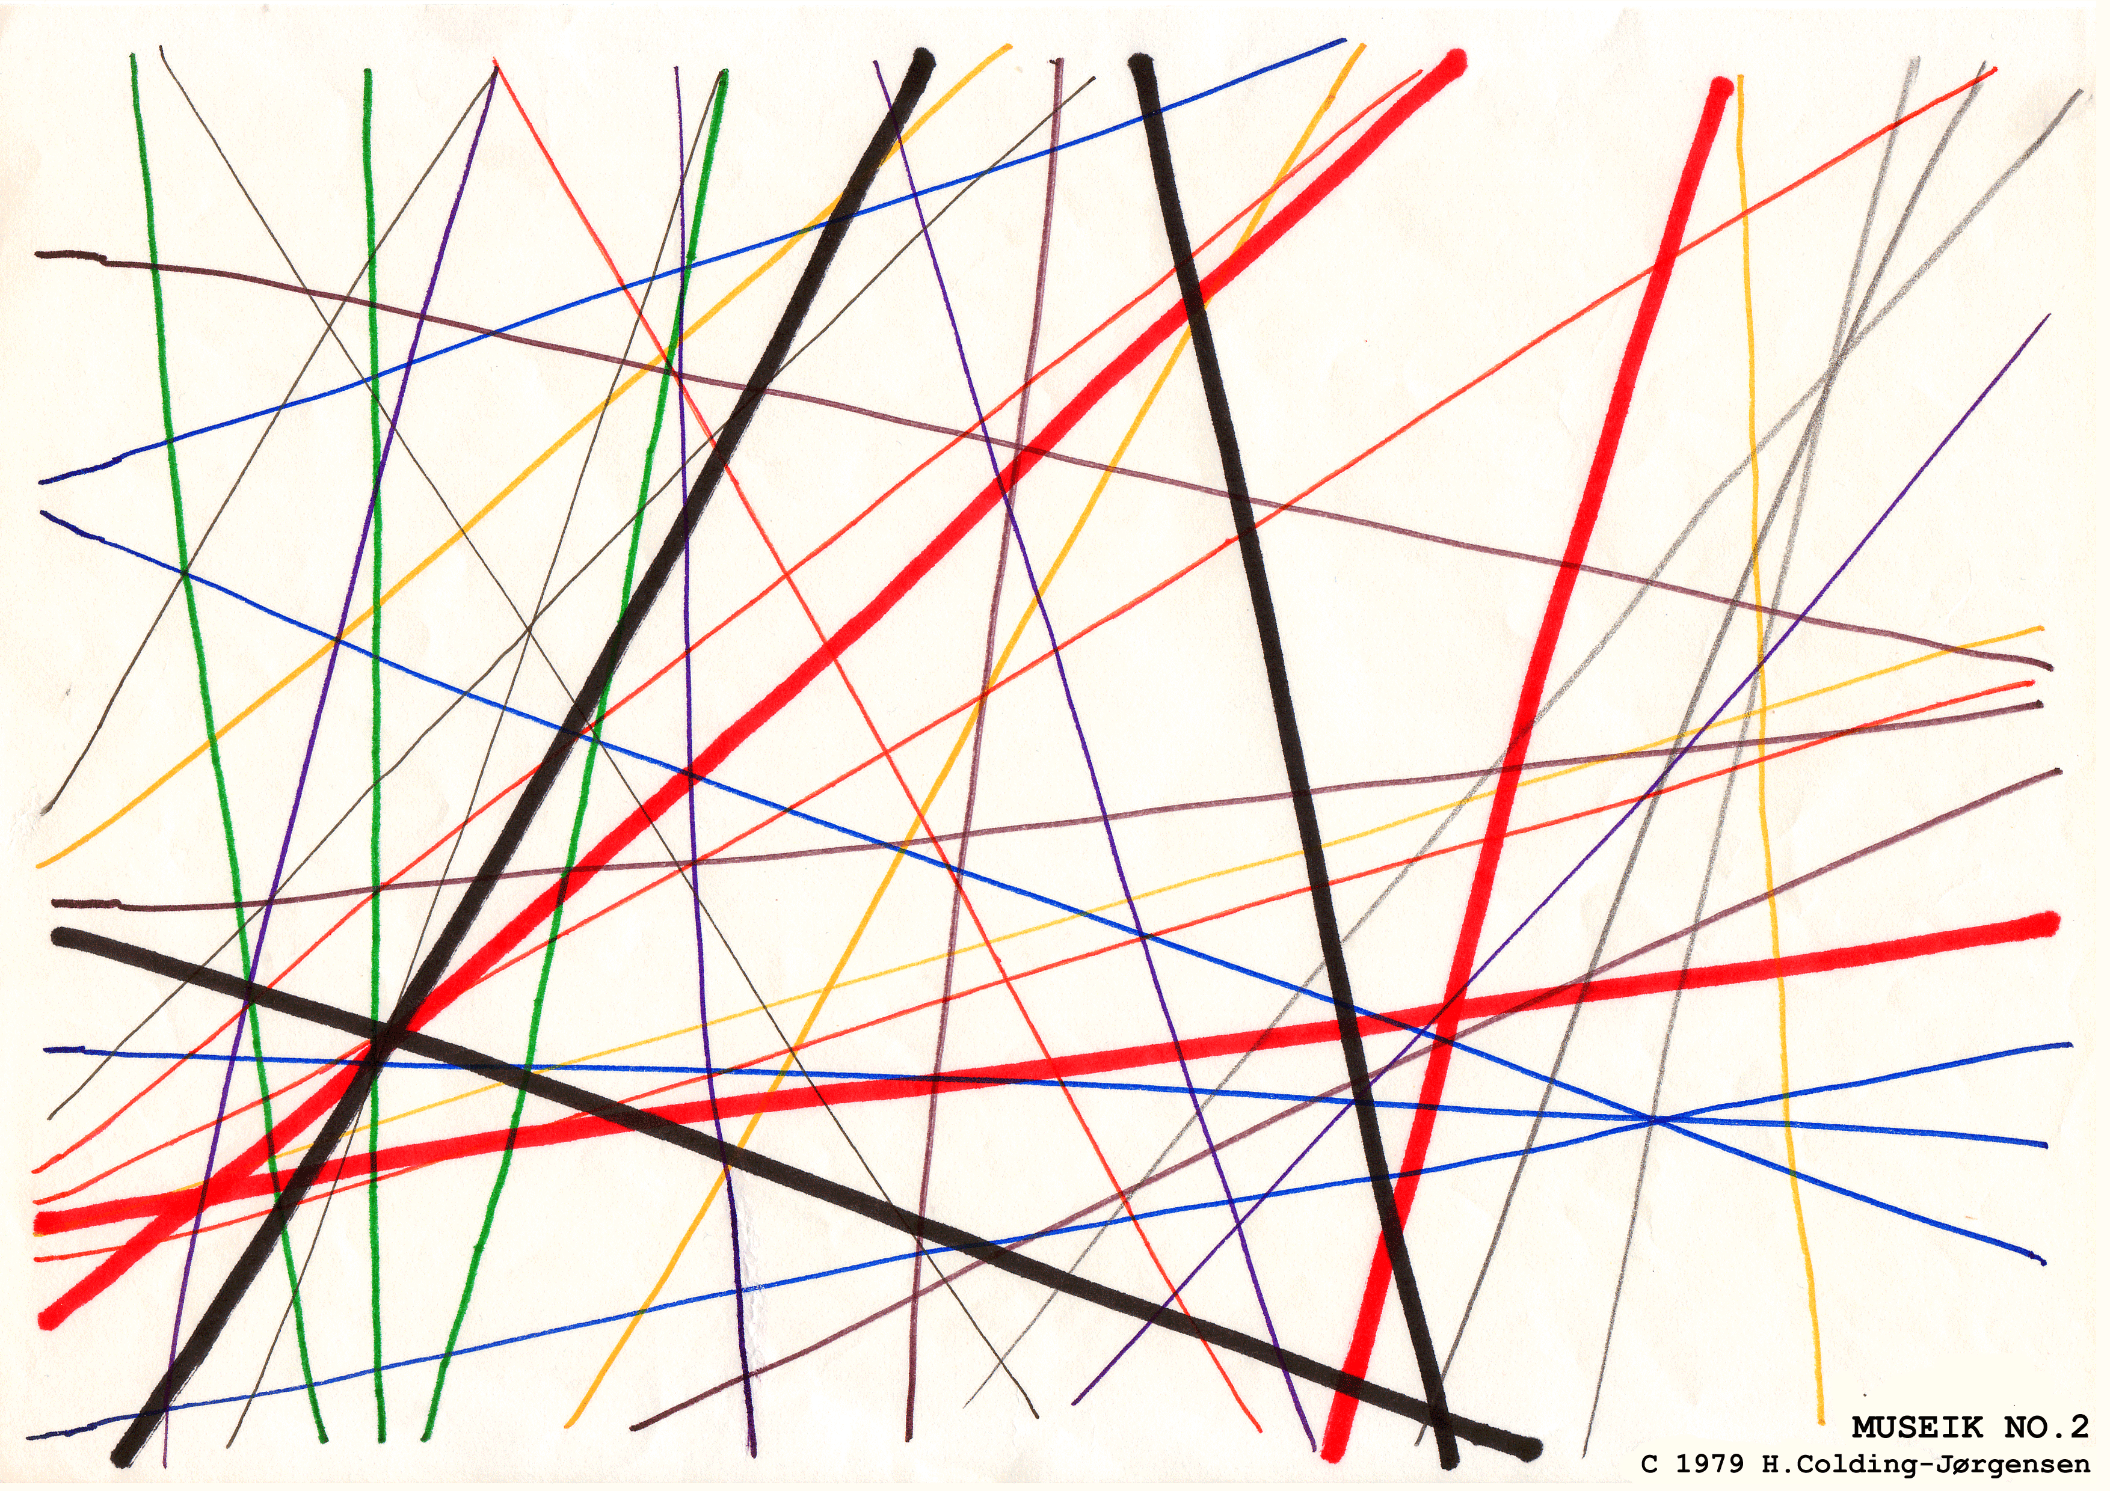

PART 2: Graphic Score Analysis
Answer the following questions. Continue onto another page if there isn’t enough room.
- Would you consider this score to be determinate or indeterminate? Why?

____________________________________________________________________________________

____________________________________________________________________________________

____________________________________________________________________________________

____________________________________________________________________________________

____________________________________________________________________________________

____________________________________________________________________________________

____________________________________________________________________________________

- How would you go about performing this work? What performance decisions would you have to make? Be as specific as possible.

____________________________________________________________________________________

____________________________________________________________________________________

____________________________________________________________________________________

____________________________________________________________________________________

____________________________________________________________________________________

____________________________________________________________________________________

____________________________________________________________________________________

____________________________________________________________________________________

____________________________________________________________________________________

____________________________________________________________________________________

