## PART 1: Notating rhythmic values

On the **middle line** of the following staves:

|  |  |
| --- | --- |
| 1. Draw four whole notes. | 2. Draw four half notes: two with upstems, two with downstems. |
|  |  |

1. Draw four quarter notes on the middle line: two with upstems and two with downstems.

Note and Rest Values

Name: _______________________________________________

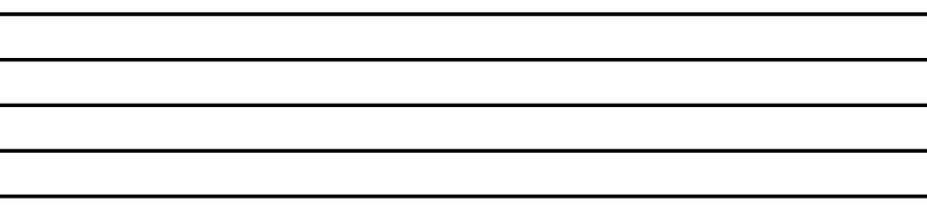

|  |  |
| --- | --- |
| 4. Draw four flagged eighth notes: two with upstems and two with downstems. | 5. Draw a pair of eighth notes, beamed together, with downstems. |
|  |  |

|  |  |
| --- | --- |
| 6. Draw four flagged sixteenth notes: two with upstems and two with downstems. | 7. Draw a set of four sixteenth notes, beamed together, with upstems. |
|  |  |

|  |  |
| --- | --- |
| 8. Draw four flagged sixteenth notes: two with upstems and two with downstems. | 9. Draw a set of four sixteenth notes, beamed together, with upstems. |
|  |  |

|  |  |
| --- | --- |
| 10. Draw four flagged thirty-second notes: two with upstems and two with downstems. | 11. Draw a set of eight thirty-second notes, beamed together, with upstems. |
|  |  |

## PART 2: Notating rests

Draw four of each of the requested rest values on the staves below.

|  |  |
| --- | --- |
| 12. Whole rests | 13. Half rests |
|  |  |

|  |  |
| --- | --- |
| 14. Quarter rests | 15. Eighth rests |
|  |  |

|  |  |
| --- | --- |
| 16. Sixteenth rests | 17. Thirty-second rests |
|  |  |

## PART 3: Rhythm Math

Solve the following rhythmic equations.

* A quarter note = 1.
* Your answers may not always be whole numbers.

|  |  |  |  |
| --- | --- | --- | --- |
| 18. | 𝅝 + 𝅗𝅥 + 𝅘𝅥 + 𝅘𝅥𝅮 | = |  |
| 19. | 𝅘𝅥𝅯 + 𝅘𝅥𝅯 + 𝅘𝅥𝅮 + 𝅗𝅥 | = |  |
| 20. | 𝅘𝅥𝅮 + 𝅘𝅥 + 𝅘𝅥 + 𝅗𝅥 | = |  |
| 21. | 𝅘𝅥𝅮 + 𝅗𝅥 + 𝅝 + 𝅘𝅥𝅯 + 𝅘𝅥 + 𝅘𝅥𝅯 | = |  |
| 22. | 𝅘𝅥 + 𝅘𝅥𝅯 + 𝅘𝅥𝅮 + 𝅘𝅥𝅯 + 𝅗𝅥 | = |  |
| 23. | 𝅗𝅥 + 𝅘𝅥𝅯 + 𝅘𝅥𝅯 + 𝅘𝅥 + 𝅘𝅥𝅮 | = |  |
| 24. | 𝄼 + 𝄾 + 𝄽 + 𝄽 + 𝄿 + 𝄿 | = |  |
| 25. | 𝄽 + 𝄿 + 𝄻 + 𝄼 + 𝄿 | = |  |
| 26. | 𝄾 + 𝄼 + 𝄿 + 𝄽 | = |  |
| 27. | 𝄼 + 𝄿 + 𝄾 + 𝄽 + 𝄿 | = |  |
| 28. | 𝄾 + 𝄻 + 𝄽 + 𝄽 + 𝄻 | = |  |
| 29. | 𝄽 + 𝄼 + 𝄻 + 𝄻 + 𝄽 | = |  |