Name: __________________________________
Identifying Scale Degrees and Solfège in a Melodic Context

Directions: Identify each note below the excerpt with both a solfège and scale degree in the key provided. Note the changes in key, clef, and mode.

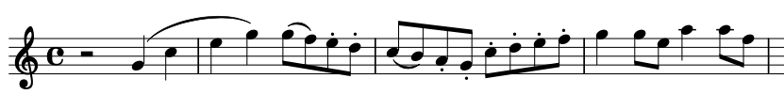
A. Measures 151–154 of the Horn I part in Mozart’s Serenade in E-flat Major (K. 375) (1781); Spotify Playlist #1 (4:53–5:00). The key is C major:
Scale
Degree: __ __ __ __ __ __ __ __ __ __ __ __ __ __ __ __ __ __ __ __ __ __

Solfège: __ __ __ __ __ __ __ __ __ __ __ __ __ __ __ __ __ __ __ __ __ __
B. Measures 5–9 of the clarinet part in the final movement of Samuel Coleridge-Taylor’s Clarinet Quintet in A (1895); Spotify Playlist #2 (0:04–0:10). The key is A minor:

Scale
Degree: __ __ __ __ __ __ __ __ __ __ __ __ __ __ __ __

Solfège: __ __ __ __ __ __ __ __ __ __ __ __ __ __ __ __

C.

C. Measures 28–31 of Nadia Boulanger’s Three Pieces for Violioncello and Piano No. 2, Movement 2 (1914); Spotify Playlist #3 (1:25–1:43). The key is A minor:
Scale
Degree: __ __ __ __ __ __ __ __ __ __ __ __ __ __ __ __ __ __ __ __ __

Solfège: __ __ __ __ __ __ __ __ __ __ __ __ __ __ __ __ __ __ __ __ __

D. Measures 9–12 of the bass part in Isaac Albéniz’s Suite Espangnole, No. 1 Granada (c. 1886); Spotify Playlist #4 (0:19–0:25). Only identify the highest line of notes. The key is F major:
Scale
Degree: __ __ __ __ __ __ __ __ __ __ __ __ __ __

Solfège: __ __ __ __ __ __ __ __ __ __ __ __ __ __

