ESL95 Understanding the Relationship between the Assignment and the Rubric

Resource for the instructor:
- Understand the relationship between the assignment and the rubric
  - RUBRIC Teaching Students to Use Grading Rubrics
The article provides detailed information about why rubrics are important, how to create them (with links to sites), and how to introduce the concept of rubrics to students.

Activity: Select a rubric for one of your upcoming assignments and lead students through a class or small group discussion using Table 2 from the article and the R.U.B.R.I.C. method outlined below.
.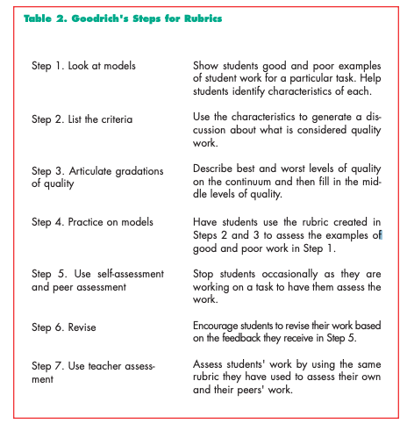

R.U.B.R.I.C. guide for small group rubric analysis
