Spotify playlist
(link on textbook
website)

Strengthening Endings with V⁷

Name: _______________________________________________

Part 1: Resolving V⁷
- Add the correct key signature to each excerpt, then
- Part-write each resolution of V⁷ in four-part vocal style following the directions above each excerpt.
- Draw lines to show the correct resolution of the leading tone and chordal 7th
Key!

Incomplete V⁷ Default resolution Leading-tone drop
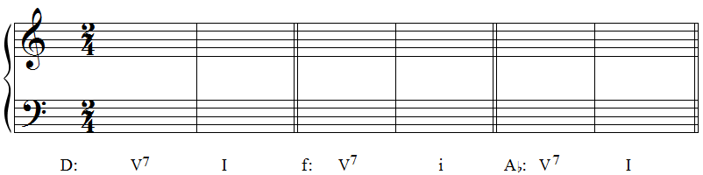

Leading-tone drop Incomplete V⁷ Default resolution
b: V⁷ i d: V⁷ i G: V⁷ I

Strengthening Endings with V⁷

Name: _______________________________________________

Part 2: Analysis
- Two excerpts appear on the following pages. For each:
  - Label the key of the excerpt underneath the key signature at the beginning of the staff
  - Label all cadences in the excerpt.
    - Note: the ends of the excerpts here do not end with cadences; it’s important to listen to excerpt and mark where you hear endings occurring
  - Provide a Roman numeral analysis of any cadence point that ends V⁷-I in major or V⁷-i in minor.

Excerpt 1: Mozart, “S’altro che lacrime” from La clemenza di Tito, mm. 3–10

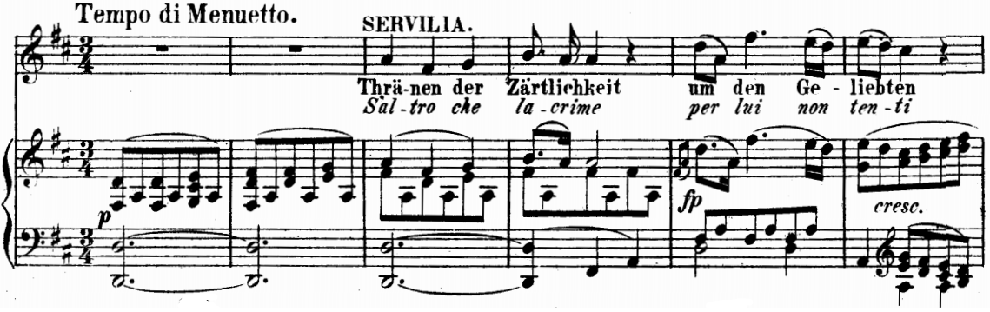

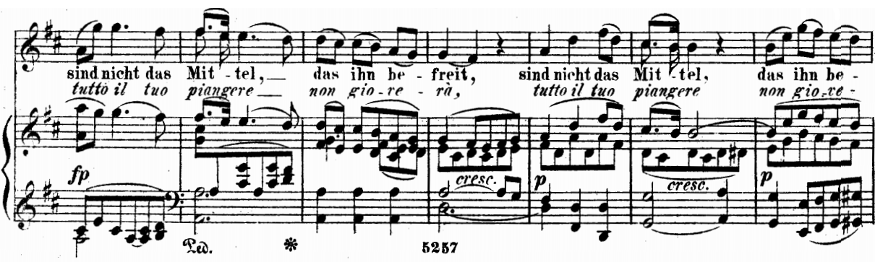

Strengthening Endings with V⁷

Name: _______________________________________________

Excerpt 2: Clara Schumann, Piano Trio Op. 17, I

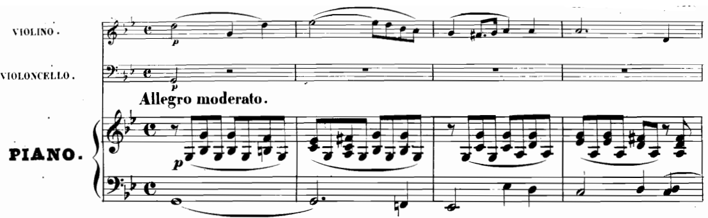

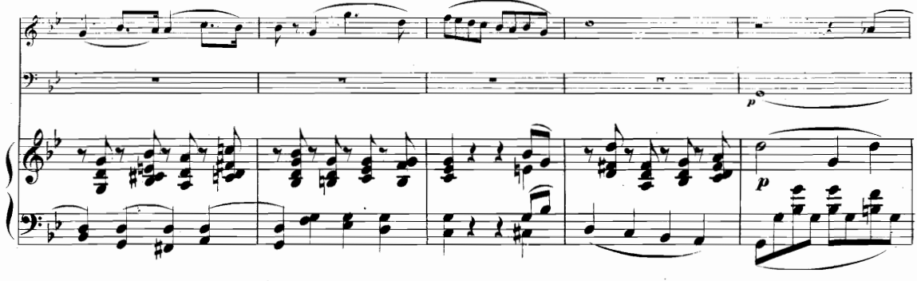

(excerpt continues on next page)

Strengthening Endings with V⁷

Name: _______________________________________________

