Mi (Þ3) in the Bass at Beginnings

Name: _______________________________________________

Part 1: Unfigured bass
- Play or sing through the given bass line.
- Label the key.
- Label every bass pitch with solfège.
- Provide a harmonic analysis that uses progressions we have read about in the textbook according to the bass line patterns you’ve identified by labeling the pitches with solfège
- Identify how the phrase model operates in the excerpt using the labels Tb-PD-D-Te
- Realize the progression in four parts
- Label the cadence you wrote.

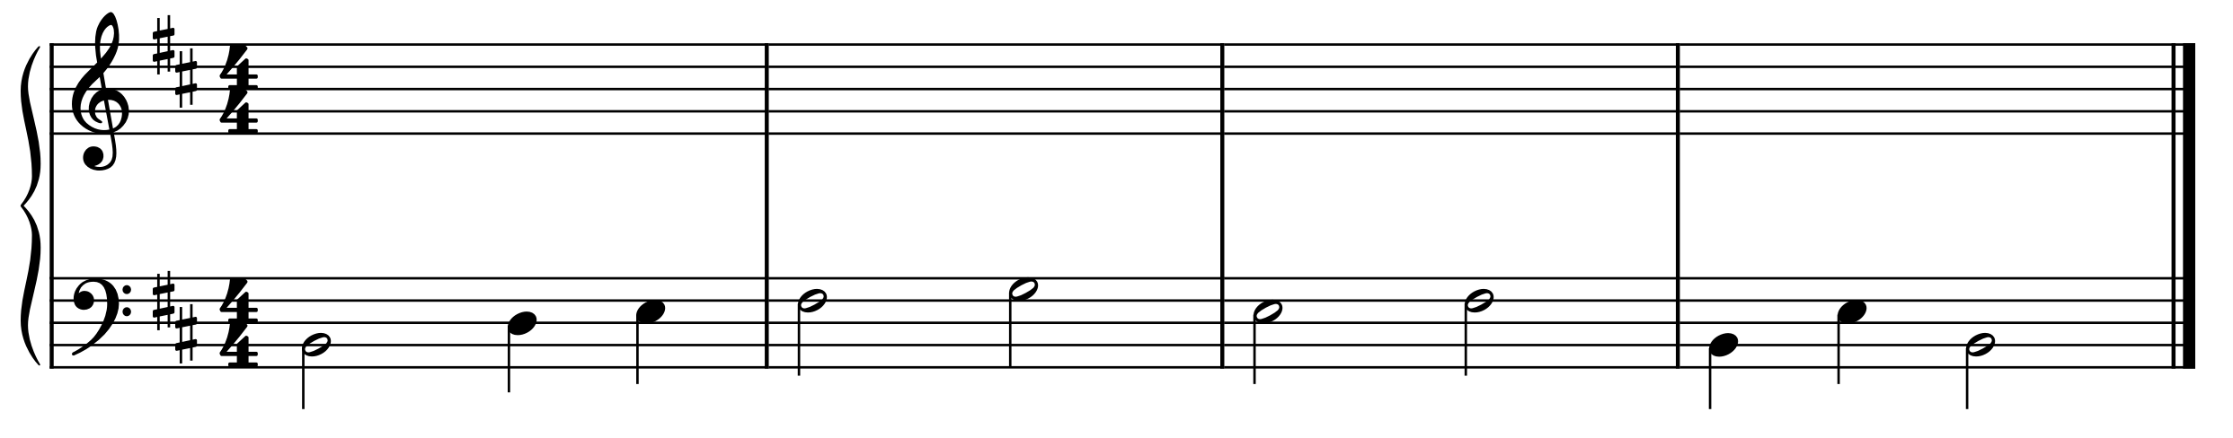
_____:
(key)

Part 2: Analysis: Beethoven, “Urians Reise um die Welt” Op. 52, No. 1.
- Listen to Urian’s first stanza here: https://open.spotify.com/track/2EGJPeOaqdhgZFiaACMeYE?si=5118c04e62ff4e0b
- Label the key (score on next page)
- Labels for all cadences in the excerpt
- Provide a harmonic analysis
- Identify how the phrase model operates in the excerpt using the labels Tb-PD-D-Te

Mi (Þ3) in the Bass at Beginnings

Name: _______________________________________________

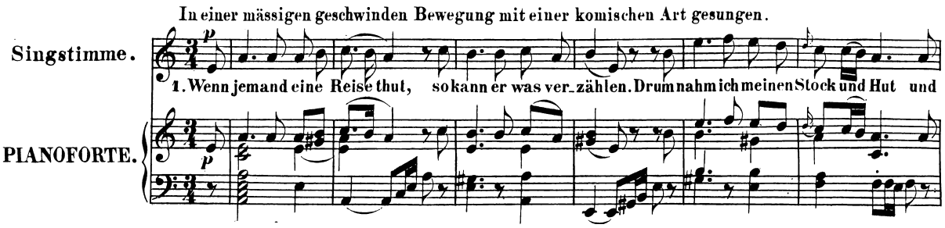

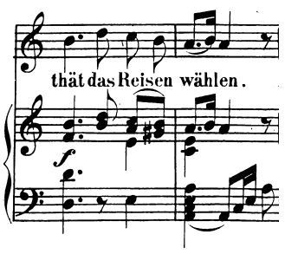

Part 3: Transcription and analysis: Weezer, “Dreamin”
- The score on the next page shows the vocal line and the harmonic rhythm (speed at which chords change) for the first chorus of Weezer’s “Dreamin”: https://open.spotify.com/track/76fPCApSm83NPiLDC4o07u?si=4ebd6a486d2343eb (@ 0:15)
- Notate the bass. You should have one bass note per chord change, and your bass line should be very repetitive.
- It’s common for pop songs to use mostly root position chords, and this song is no exception. Using your notated bass line as a guide, provide a Roman numeral analysis of the chord changes in this song (one numeral per bass note).
  - Hint: you should find that it follows a chord progression we studied in class!
- Do you think the repetitiveness of the chord progression means that the verse ends without a cadence/closure? Briefly discuss in the blank space below.

Mi (Þ3) in the Bass at Beginnings

Name: _______________________________________________

