Prolonging Tonic at Phrase Beginnings Using the Leading-Tone Chord

Name: _______________________________________________

Part 1: Short resolutions
- For each excerpt below:
  - Fill in the blank with an appropriate inversion of tonic
  - Realize the progression in four parts

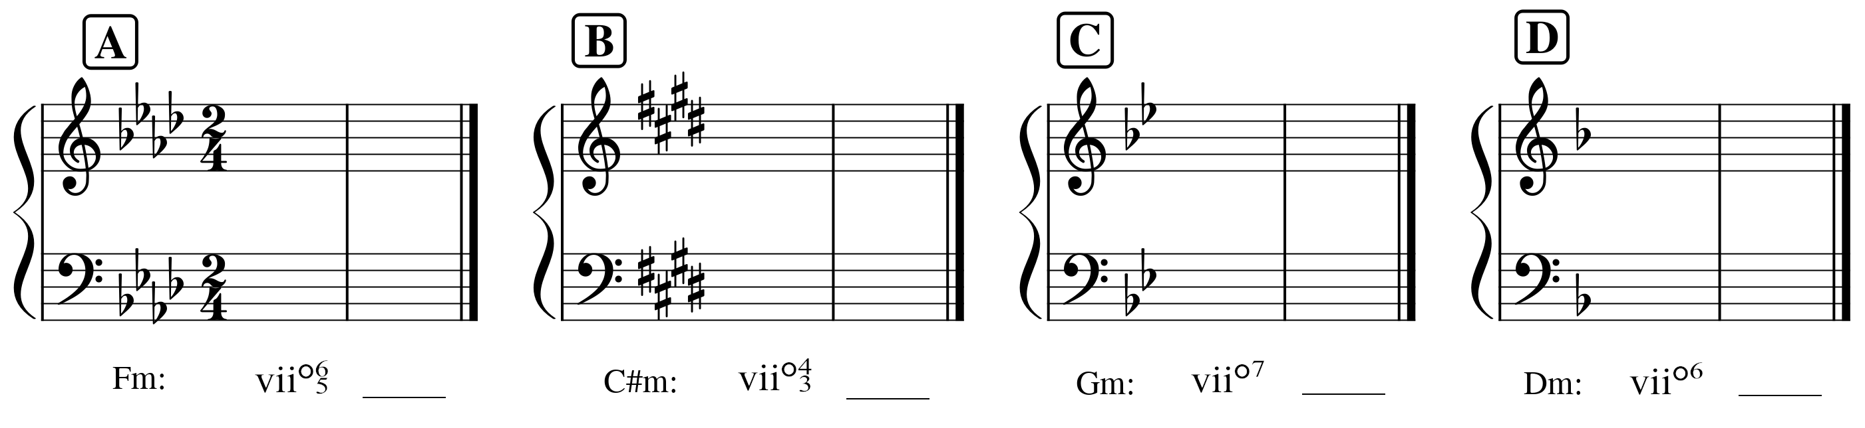

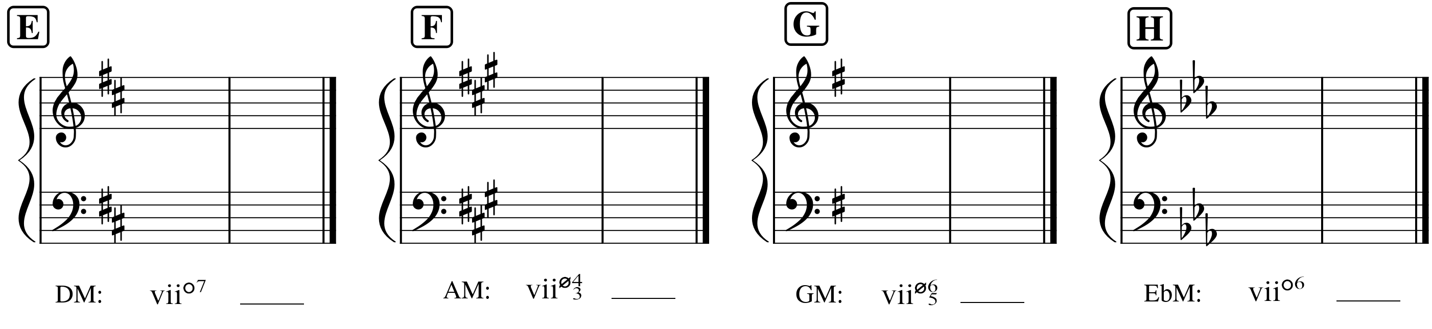

Part 2: Analysis: Farrenc, Cello Sonata Op. 46, I
- Listen to the excerpt several times: (score on next page) https://open.spotify.com/track/5SzVEIZZNbYW97G7UFM4UN?si=8833971423e04ba0
- Label the key
- Label any cadences in the excerpt
- Provide a harmonic analysis (i.e. Roman numerals)
- Identify how the phrase model operates using the labels Tb-PD-D-Te

Prolonging Tonic at Phrase Beginnings Using the Leading-Tone Chord

Name: _______________________________________________

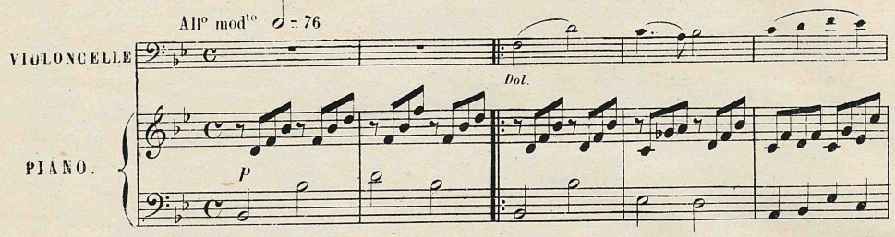

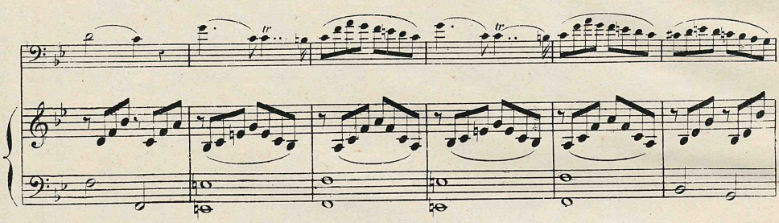

Part 3: Analysis: Beethoven, Piano Sonata Op. 2, No. 3, II
- Listen to the excerpt several times (score on next page): https://open.spotify.com/track/3PT3O4HhQ29yRcQ8vkbIpw?si=afef71aa4bb444b8
- Label the key
- Label any cadences in the excerpt
- Provide a harmonic analysis (i.e. Roman numerals)
- Identify how the phrase model operates using the labels Tb-PD-D-Te

Prolonging Tonic at Phrase Beginnings Using the Leading-Tone Chord

Name: _______________________________________________

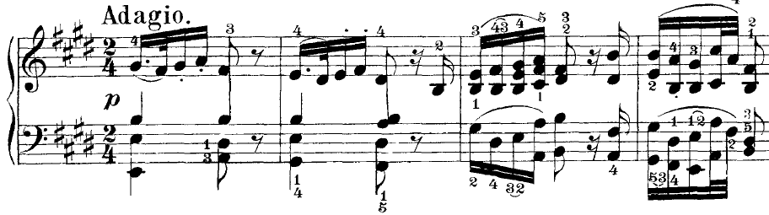

Part 4: Writing from figures
- Label the key
- Provide a harmonic analysis of the figures
- Realize the progression in four parts
- Label the type of cadence you wrote at the end of the excerpt

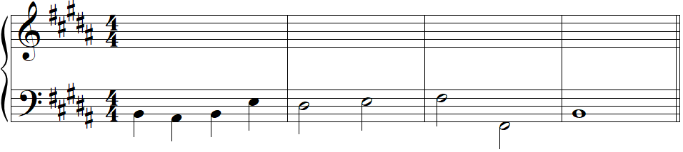
6 6
_____:
(key)

