PART 1: The Grand Staff and the Piano Keyboard with Ledger Lines
Directions: Write the numbers of the notes found on the grand staves onto the white keys of the piano keyboard. Some keys may have more than one number. Number one has been done in each example.

A.

1

- 2. 3. 4. 5. 6. 7. 8. 9. 10.

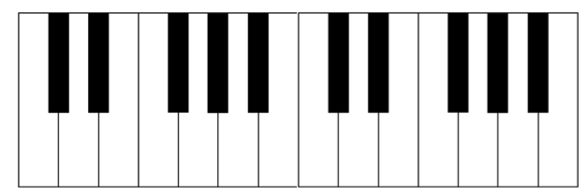
B.

1
1. 2. 3. 4. 5. 6. 7. 8. 9. 10.

C.

1

1. 2. 3. 4. 5. 6. 7. 8. 9. 10.

D.

1

1. 2. 3. 4. 5. 6. 7. 8. 9. 10.

E.

1

1. 2. 3. 4. 5. 6. 7. 8. 9. 10.

