Tonicization

Name: _______________________________________________

Part 1: Spelling and resolving
- For each of the following excerpts:
  - Under m. 2 write the Roman numeral of the expected chord to which each secondary chord in m. 1 will resolve
  - Part write the progression in four parts
- Double check your accidentals!

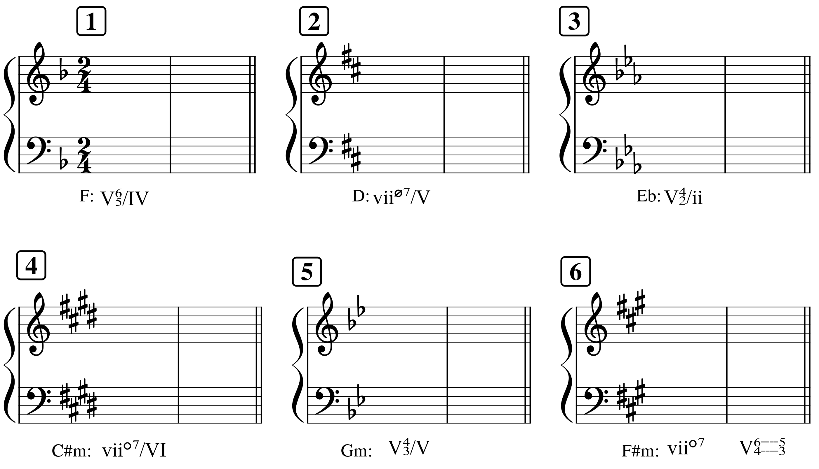

Tonicization

Name: _______________________________________________

Part 2: Short figured bass
- Label the key for each segment
- Analyze the figures in each segment
- Realize each two-chord progression in four parts

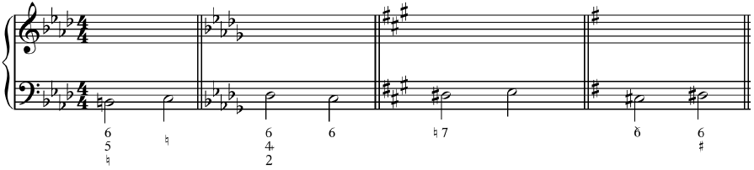

Part 3: Longer figured bass
- Label the key
- Analyze the figures
- Realize the progression in four parts
- Label any cadences
- Identify how the phrase model operates using the labels Tb-PD-D-Te

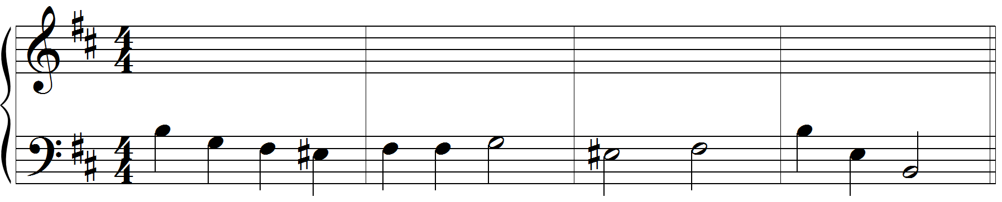
6

Tonicization

Name: _______________________________________________

Part 4: Analysis: Schubert, “An die Musik” (score at end of assignment)
- Listen to the excerpt: https://open.spotify.com/track/4GGLg6HeStoXAv2SBqRli0?si=08ccbbfe28b44763
- Label the key
- Label all cadences (but see the short answer question below for some more context first)
- Provide a harmonic analysis (but again see the short answer question below for some more context first)
- A chart appears on page 2. Identify which of features in the chart appear in this excerpt by indicating the measure in which the feature appears. If one doesn’t appear, write “N/A”
  - Note 1: I’ve just listed nearly all features we’ve studied. Several do not appear.
  - Note 2: If a feature appears more than once, you can just select one measure where it appears

Neighbor |  | Plagal use of (IV)
Passing |  | Tonicized deceptive motion
Cadential |  | Phrygian HC

Part 5: Short answer questions
- Schubert chooses to make the bass more melodic than the right hand piano part at the beginning of the excerpt, and he also chooses not to have the left hand play anything on beat one of m. 1.
  - What note would occur there if we were to insert one (consider where we're at in the piece as well as other measures in the piece that are similar for clues)?

  - What effect does Schubert create by omitting this note and starting on Sol in the bass harmonized by a tonic chord in the right hand?

Tonicization

Name: _______________________________________________

- There are several possible ways to interpret phrase and cadence with respect to this excerpt. Remember that cadences are goals toward which a phrase moves, and that the clearest phrase endings are marked by a cadence then followed by a sense of beginning. Remember also that it's possible for a cadence to be proposed and then subsequently undermined by what happens next. We've seen this symbol to represent that: 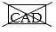With all this in mind, discuss your interpretation of phrase and cadence in this piece. What locations did you consider? What factors led to your decision to accept or reject a particular location as a phrase ending/cadence point?

- Finally, taking into consideration all your thoughts so far, consider the text (below). Do you think there is a reason that Schubert has chosen not to make phrase endings particularly clear in this song?

Du holde Kunst, in wieviel grauen Stunden,  Wo mich des Lebens wilder Kreis umstrickt,  Hast du mein Herz zu warmer Lieb entzunden,  Hast mich in eine bessre Welt entrückt!  Oft hat ein Seufzer, deiner Harf entflossen,  Ein süsser, heiliger Akkord von dir  Den Himmel bessrer Zeiten mir erschlossen,  Du holde Kunst, ich danke dir dafür! | Beloved art, in how many a bleak hour,  when I am enmeshed in life’s tumultuous round,  have you kindled my heart to the warmth of love,  and borne me away to a better world!  Often a sigh, escaping from your harp,  a sweet, celestial chord  has revealed to me a heaven of happier times.  Beloved art, for this I thank you!

Tonicization

Name: _______________________________________________

