Plagal Motion as a Form of Prolongation
Part I. Bass lines.
- Several bass lines appear below. For any bass line that could prolong tonic at the beginning a phrase: (1) label the key and (2) provide a harmonic analysis that is stylistically appropriate for common-practice music.
- For any bass line that wouldn’t work to prolong tonic at the beginning of a phrase, leave the score blank.
- Some excerpts have multiple possible harmonizations.

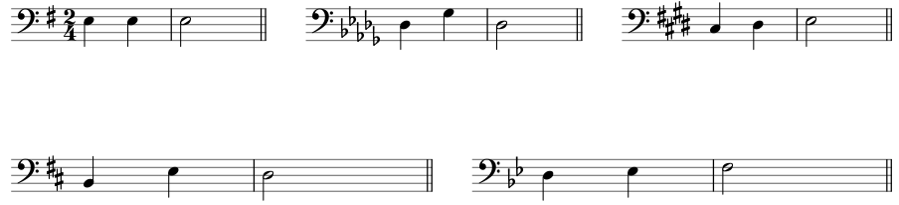

Part II. Analysis: Joseph Bologne, Six Concertante Quartets No. 4, II, mm. 54–61 (see attached score packet)
- Listen to the excerpt: a MuseScore recording is in the same place you found this assignment (no professional recording, unfortunately )
- Label the key
- Identify all cadences
- Provide a harmonic analysis of the entire passage
  - Follow the process from class where you scan the bass and take an educated guess about the progression based on where it’s located in the phrase and your knowledge of the common patterns we’ve been learning in class.
- Circle and label any embellishing tones in the violin 1 part (top staff).
- Measure 59 contains two harmonies, one for each bass note in that measure. The second harmony in the measure is missing a note that is seemingly very important! In the blank space below, please explain in writing: (1) What note is missing? (2) Why do you think Bologne left that note out? (3) How is it that we can still tell what the chord is?

Part III. Analysis: Hoffmeister, Clarinet Concerto in B, I, mm. 70–85 (see attached score packet)
- Listen to the excerpt below several times: https://open.spotify.com/track/71uhYCiH97bUYMR06ociiO?si=eead46e1d1344dfe (@ 2:05)
- This score is a transposed score meaning that the clarinet part is not written as it sounds. To determine the note the clarinet is playing, transpose the clarinet line down a major 2nd.
- Label the key
- Label all cadences
- Provide a harmonic analysis of mm. 70–85
- Identify how the phrase model operates using the labels Tb-PD-D-Te
Score Excerpts

Score for Part II. Joseph Bologne, Six Concertante Quartets No. 4, II, mm. 54–61.

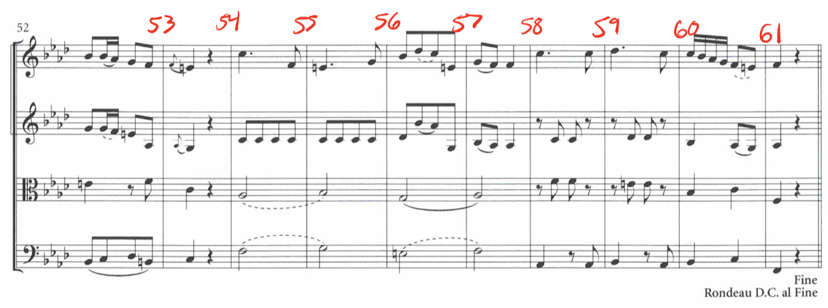

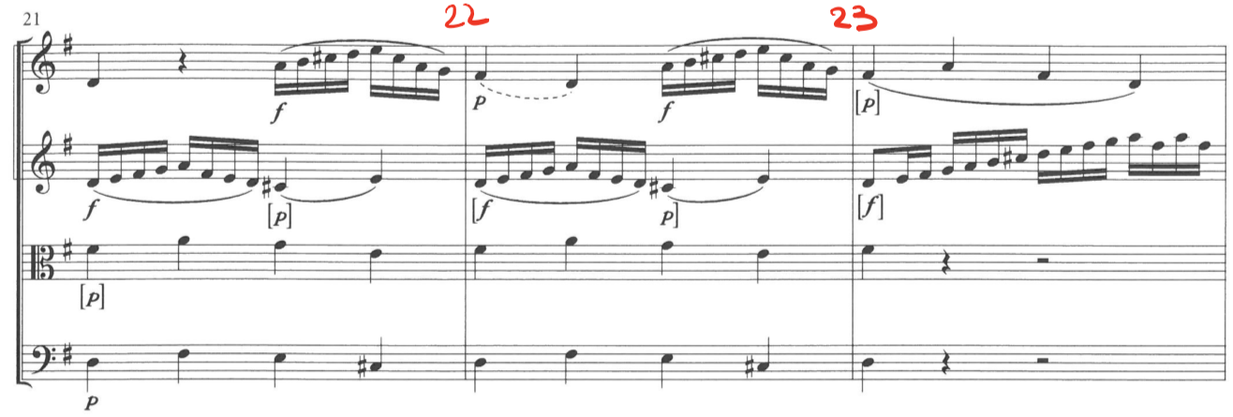

Score for Part III: Hoffmeister, Clarinet Concerto in B, I, mm. 70–85

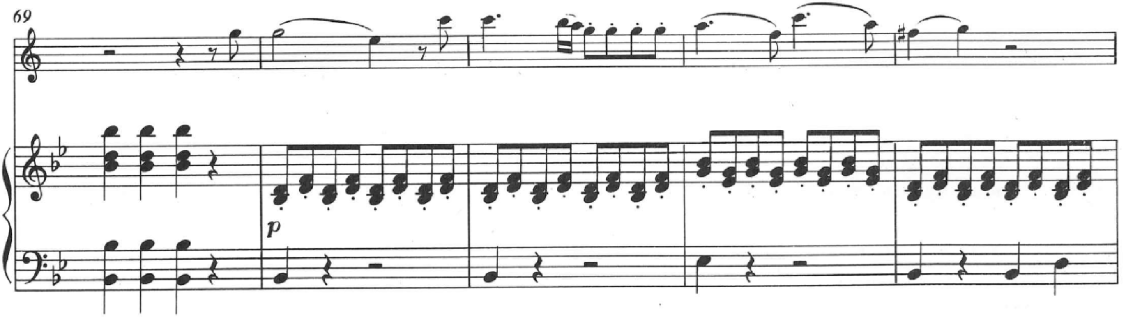
cl. (B)
Pno

