Binary Form – Model Composition
Instructions:
- Provide a harmonic analysis
- Create a melody to go with this waltz-style accompaniment
- Follow the given instructions as you write.
Write a sequence copy
Write a sequence model
Compose a sentence for mm. 1-8
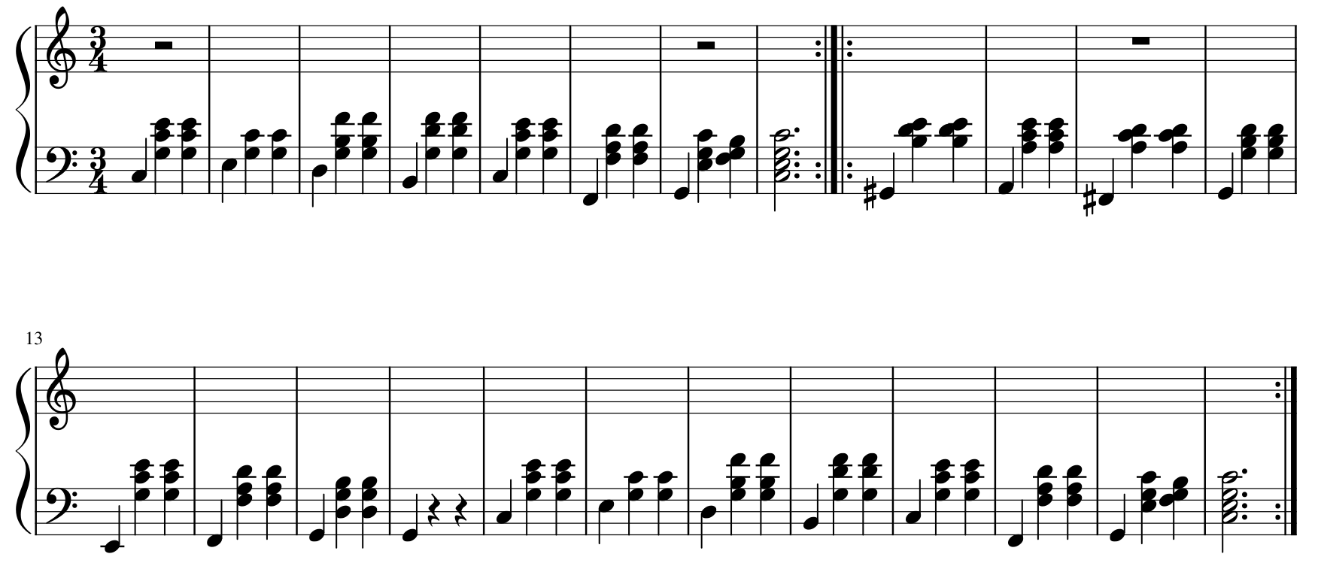
Repeat melody from mm. 1-8

