Augmented 6th Chords – Assignment 1
Part 1 – Converting Existing Chords
These chords are close to being augmented sixth chords but they need to be adjusted with accidentals to sound like augmented sixth chords. Convert them into the requested augmented 6th chords.

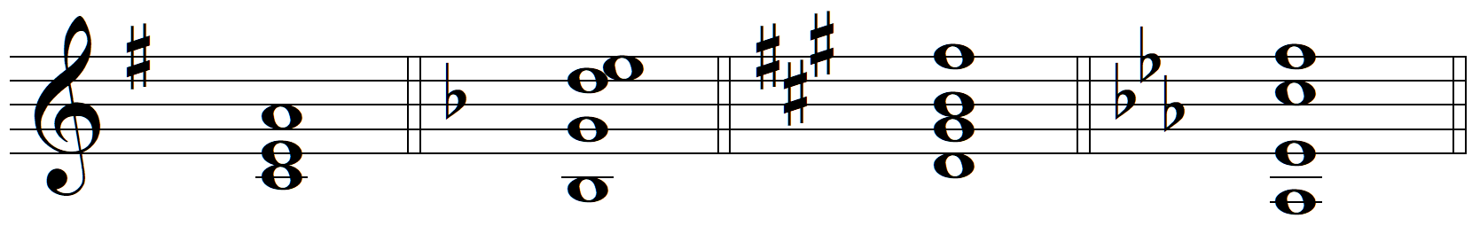
e: It⁺⁶ d: Fr⁺⁶ f#: Fr⁺⁶ c: Ger⁺⁶

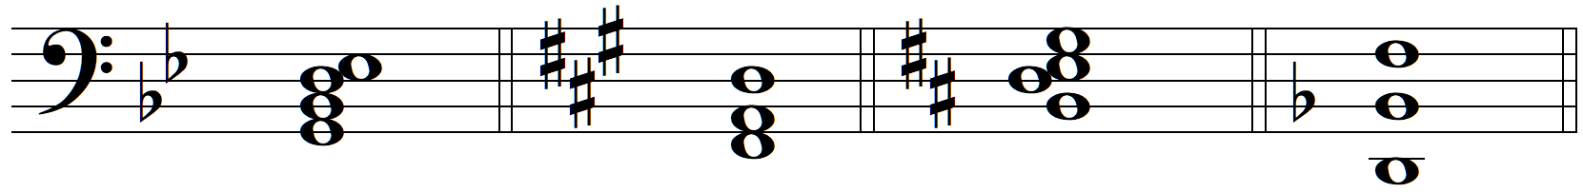
Bb: Ger⁺⁶ A: It⁺⁶ D: Fr⁺⁶ F: It⁺⁶

Part 2 – Creating Augmented 6th Chords from Scratch
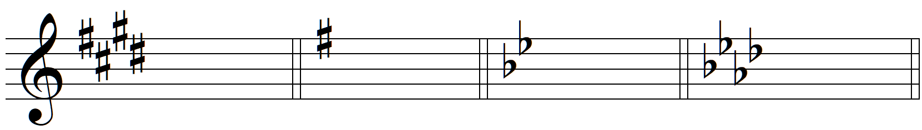
cs: Ger⁺⁶ G: It⁺⁶ Bb: Fr⁺⁶ f: It⁺⁶

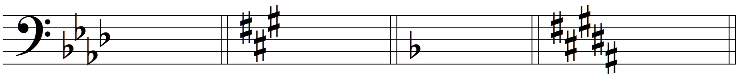
Ab: Fr⁺⁶ fs: It⁺⁶ F: Ger⁺⁶ B: Ger⁺⁶

Part 3 – Augmented 6^{ths} with Figured Bass
- Realize the figured bass in “keyboard style”

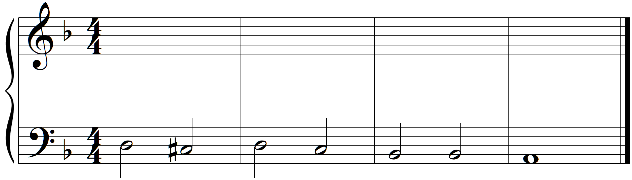
d: ^5 X $2 ^ X ^ $ Q Q Q Q Q Q X

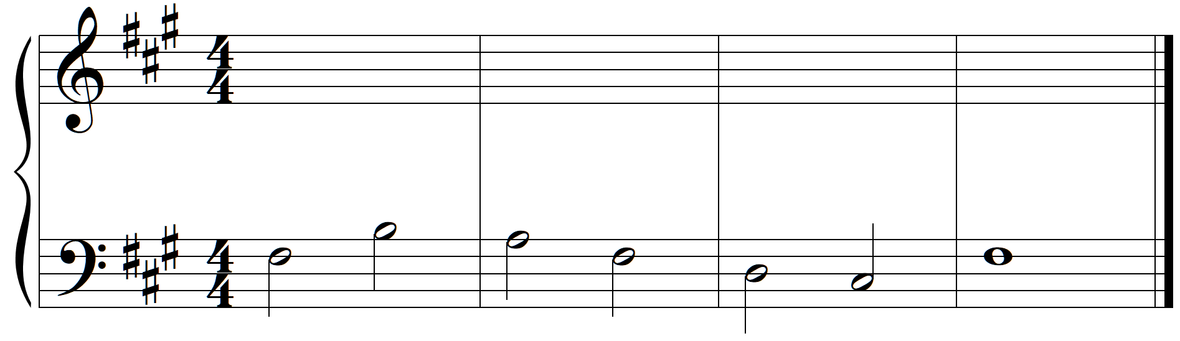
f>: X $2 ^ X ^4£ X

Part 4 – Four-Voice Part Writing
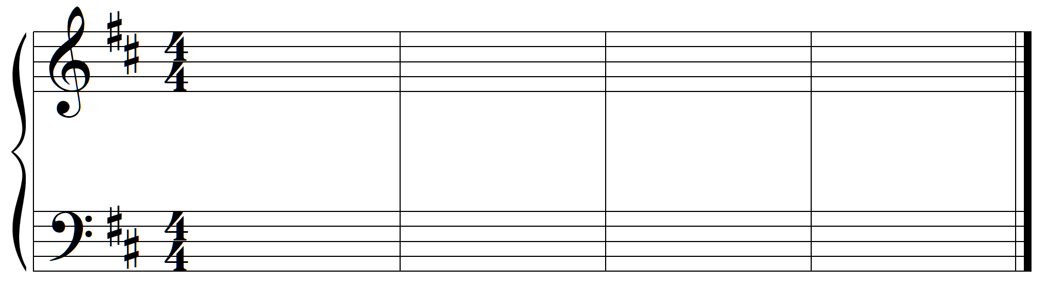
b: i ^ V$3 V^5 i Ger⁺⁶ V$ Q Q Q Q Q #
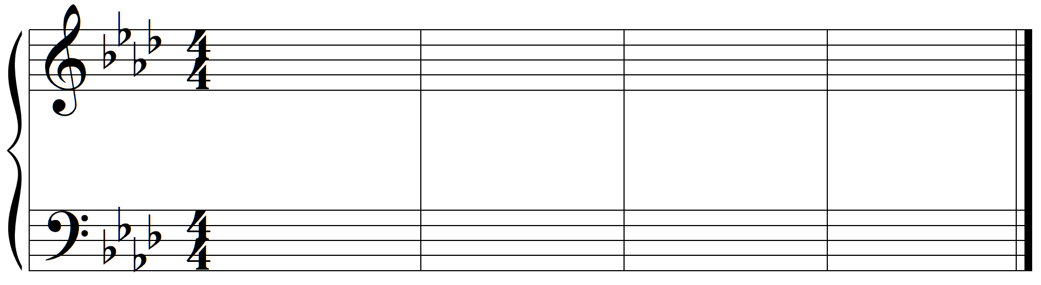
A<: I V$2 IV^ Ger+^ V*6¢ Qqœ Qqœ Qqœ Qqœ Qqœ &5£ I(7¢ Qqœ Qqœ Qqœ Qqœ Qqœ *8£񏦇

Part 5 – Analysis of Music with Augmented 6th Chords
- Frederic Chopin, Nocturne in C# minor, Op. posthumous (mm. 1-2)
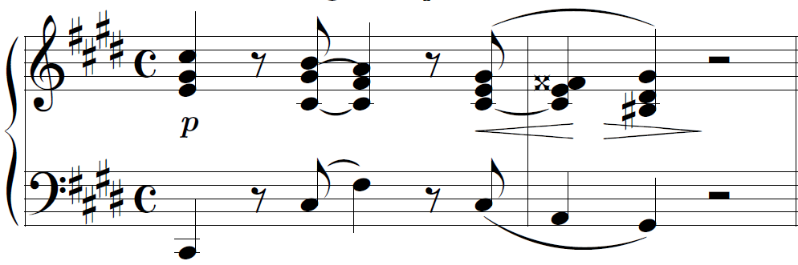

- Scott Joplin, “The Sycamore” A Concert Rag, mm. 29-36
